
American Battery Solutions Inc.

S32K344-MCAL
User Manual

Document ID: N/A | Release Date: 1/14/2025
Revision: 1.5 | Owner: ABS Software Team

(c) [2019] [American Battery Solutions]; all rights reserved. This document may contain proprietary information and may only be released to third parties with approval of management. Documents are uncontrolled unless otherwise marked; uncontrolled documents are not subject to update notification.

Table of Contents
1 Scope of this Document 5
2 Important Terms 6
3 Functional Overview 7
3.1 Block Diagram 8
3.2 Dependency 9
3.3 Interfaces 10
3.3.1 AUTOSAR Fee 11
3.3.1.1 Fee_Read 12
3.3.1.2 Fee_Write 13
3.3.1.3 Fee_Cancel 14
3.3.1.4 Fee_GetStatus 15
3.3.1.5 Fee_GetJobResult 16
3.3.1.6 Fee_InvalidateBlock 17
3.3.1.7 Fee_GetVersionInfo 18
3.3.1.8 Fee_EraseImmediateBlock 19
3.3.1.9 Fee_GetRunTimeInfo 20
3.3.1.10 Fee_ForceSwapOnNextWrite 21
3.3.2 Cache 22
3.3.2.1 Cache_Ip_Enable 23
3.3.2.2 Cache_Ip_Disable 24
3.3.2.3 Cache_Ip_Invalidate 25
3.3.2.4 Cache_Ip_Clean 26
3.3.2.5 Cache_Ip_InvalidateByAddr 27
3.3.2.6 Cache_Ip_CleanByAddr 28
3.3.3 Enhanced Direct Memory Access (eDMA) 29
3.3.3.1 Dma_Ip_SetLogicInstanceCommand 30
3.3.3.2 Dma_Ip_GetLogicInstanceStatus 31
3.3.3.3 Dma_Ip_LogicChannelInit 32
3.3.3.4 Dma_Ip_LogicChannelDeinit 33
3.3.3.5 Dma_Ip_SetLogicChannelCommand 34
3.3.3.6 Dma_Ip_GetLogicChannelStatus 35
3.3.3.7 Dma_Ip_SetLogicChannelGlobalList 36
3.3.3.8 Dma_Ip_SetLogicChannelTransferList 37
3.3.3.9 Dma_Ip_SetLogicChannelScatterGatherList 39
3.3.3.10 Dma_Ip_GetLogicChannelParam 40
3.3.3.11 Dma_Ip_SetLogicChannelScatterGatherConfig 41
3.3.3.12 Dma_Mux_Ip_Init 42
3.3.4 FlexCAN 43
3.3.4.1 FlexCAN_Ip_SetRxMaskType 44
3.3.4.2 FlexCAN_Ip_SetRxIndividualMask 45
3.3.4.3 FlexCAN_Ip_SetStartMode 46
3.3.4.4 FlexCAN_Ip_SetStopMode 47
3.3.4.5 FlexCAN_Ip_EnterFreezeMode 48
3.3.4.6 FlexCAN_Ip_ExitFreezeMode 49
3.3.4.7 FlexCAN_Ip_ConfigRxMb 50
3.3.4.8 FlexCAN_Ip_Init 51
3.3.4.9 FlexCAN_Ip_Deinit 52
3.3.4.10 FlexCAN_Ip_Receive 53
3.3.4.11 FlexCAN_Ip_Send 54
3.3.4.12 FlexCAN_Ip_MainFunctionWrite 55
3.3.4.13 FlexCAN_Ip_ClearBuffStatusFlag 56
3.3.4.14 FlexCAN_Ip_EnableInterrupts 57
3.3.4.15 FlexCAN_Ip_ConfigRxFifo 58
3.3.4.16 FlexCAN_Ip_RxFifo 58
3.3.5 Interrupt Controller (IntCtrl) 59
3.3.5.1 IntCtrl_Ip_Init 60
3.3.5.2 IntCtrl_Ip_InstallHandler 61
3.3.5.3 IntCtrl_Ip_EnableIrq 62
3.3.5.4 IntCtrl_Ip_DisableIrq 63
3.3.5.5 IntCtrl_Ip_SetPriority 64
3.3.5.6 IntCtrl_Ip_GetPriority 65
3.3.5.7 IntCtrl_Ip_ClearPending 66
3.3.5.8 IntCtrl_Ip_SetPending 67
3.3.5.9 IntCtrl_Ip_GetPending 68
3.3.5.10 IntCtrl_Ip_GetActive 69
3.3.6 Low-Power SPI (LPSPI) 70
3.3.6.1 Lpspi_Ip_SyncTransmit 71
3.3.6.2 Lpspi_Ip_AsyncTransmit 72
3.3.6.3 Lpspi_Ip_GetStatus 73
3.3.6.4 Lpspi_Ip_ManageBuffers 74
3.3.6.5 Lpspi_Ip_UpdateTransferParam 75
3.3.6.6 Lpspi_Ip_UpdateFrameSize 76
3.3.6.7 Lpspi_Ip_UpdateLsb 77
3.3.6.8 Lpspi_Ip_UpdateByteSwap 78
3.3.6.9 Lpspi_Ip_UpdateDefaultTransmitData 79
3.3.6.10 Lpspi_Ip_UpdateTransferMode 80
3.3.6.11 Lpspi_Ip_Cancel 81
3.3.7 System Integration Unit Lite2 (SIUL2) 82
3.3.7.1 Siul2_Port_Ip_SetPullSel 83
3.3.7.2 Siul2_Port_Ip_SetOuptutBuffer 84
3.3.7.3 Siul2_Port_Ip_SetInputBuffer 85
3.3.7.4 Siul2_Port_Ip_Init 86
3.3.7.5 Siul2_Port_Ip_SetPinDirection 87
3.3.7.6 Siul2_Port_Ip_RevertPinConfiguration 88
3.3.7.7 Siul2_Port_Ip_GetPinConfiguration 89
3.3.7.8 Siul2_Dio_Ip_WritePin 90
3.3.7.9 Siul2_Dio_Ip_SetGPDO 91
3.3.7.10 Siul2_Dio_Ip_ClearGPDO 92
3.3.7.11 Siul2_Dio_Ip_WritePins 93
3.3.7.12 Siul2_Dio_Ip_GetPinsOutput 94
3.3.7.13 Siul2_Dio_Ip_SetPins 95
3.3.7.14 Siul2_Dio_Ip_ClearPins 96
3.3.7.15 Siul2_Dio_Ip_TogglePins 97
3.3.7.16 Siul2_Dio_Ip_ReadPins 98
3.3.7.17 Siul2_Dio_Ip_MaskedWritePins 99
3.3.7.18 Siul2_Dio_Ip_ReadPin 100
3.3.7.19 Siul2_Icu_Ip_DeInit 101
3.3.7.20 Siul2_Icu_Ip_Initi 102
3.3.7.21 Siul2_Icu_Ip_SetActivationCondition 103
3.3.7.22 Siul2_Icu_Ip_GetInputState 104
3.3.7.23 Siul2_Icu_Ip_Enable Interrupt 105
3.3.7.24 Siul2_Icu_Ip_DisableInterrupt 106
3.3.7.25 Siul2_Icu_Ip_SetClockMode 107
3.3.7.26 Siul2_Icu_Ip_EnableNotification 108
3.3.7.27 Siul2_Icu_Ip_DisableNotification 109
3.3.8 ADC Successive Approximation Register (SAR) 111
3.3.8.1 Adc_Sar_Ip_GetDataAddress 112
3.3.8.2 Adc_Sar_Ip_ChainConfig 113
3.3.8.3 Adc_Sar_Ip_EnableChannel 114
3.3.8.4 Adc_Sar_Ip_DisableChannel 115
3.3.8.5 Adc_Sar_Ip_SetResolution 116
3.3.8.6 Adc_Sar_Ip_StartConversion 117
3.3.8.7 Adc_Sar_Ip_GetStatusFlags 118
3.3.8.8 Adc_Sar_Ip_ClearStatusFlags 119
3.3.8.9 Adc_Sar_Ip_GetConvDataToArray 120
3.3.8.10 Adc_Sar_Ip_GetConvResultsToArray 121
3.3.8.11 Adc_Sar_Ip_GetConvData 122
3.3.8.12 Adc_Sar_Ip_GetConvResult 123
3.3.8.13 Adc_Sar_Ip_DoCalibration 124
3.3.8.14 Adc_Sar_Ip_Powerup 125
3.3.8.15 Adc_Sar_Ip_Powerdown 126
3.3.8.16 Adc_Sar_Ip_EnableNotifications 127
3.3.8.17 Adc_Sar_Ip_DisableNotifications 128
3.3.8.18 Adc_Sar_Ip_EnableChannelNotifications 129
3.3.8.19 Adc_Sar_Ip_DisableChannelNotifications 130
3.3.8.20 Adc_Sar_Ip_SetClockMode 131
3.3.8.21 Adc_Sar_Ip_SetSampleTimes 132
3.3.8.22 Adc_Sar_Ip_SetAveraging 133
3.3.8.23 Adc_Sar_Ip_AbortConversion 134
3.3.8.24 Adc_Sar_Ip_AbortChain 135
3.3.8.25 Adc_Sar_Ip_SetPresamplingSource 136
3.3.8.26 Adc_Sar_Ip_EnableChannelPresampling 137
3.3.8.27 Adc_Sar_Ip_DisableChannelPresampling 138
3.3.8.28 Adc_Sar_Ip_EnablePresampleConversion 139
3.3.8.29 Adc_Sar_Ip_DisablePresampleConversion 140
3.3.8.30 Adc_Sar_Ip_EnableDma 141
3.3.8.31 Adc_Sar_Ip_DisableDma 142
3.3.8.32 Adc_Sar_Ip_EnableChannelDma 143
3.3.8.33 Adc_Sar_Ip_DisableChannelDma 144
3.3.8.34 Adc_Sar_Ip_DisableChannelDmaAll 145
3.3.8.35 Adc_Sar_Ip_SetDmaClearSource 146
3.3.8.36 Adc_Sar_Ip_SetWdgThreshold 147
3.3.8.37 Adc_Sar_Ip_SetConversionMode 148
3.3.8.38 Adc_Sar_Ip_SetCtuMode 149
3.3.8.39 Adc_Sar_Ip_SetExternalTrigger 150
3.3.8.40 Adc_Sar_Ip_SetUserGainAndOffset 151
3.3.9 Periodic Interrupt Timer 152
3.3.9.1 Pit_Ip_GetInterruptStatusFlag 153
3.3.9.2 Pit_Ip_GetLoadValue 154
3.3.9.3 Pit_Ip_Init 155
3.3.9.4 Pit_Ip_InitChannel 156
3.3.9.5 Pit_Ip_Deinit 157
3.3.9.6 Pit_Ip_StartChannel 158
3.3.9.7 Pit_Ip_StopChannel 159
3.3.9.8 Pit_Ip_GetCurrentTimer 160
3.3.9.9 Pit_Ip_EnableChannelInterrupt 161
3.3.9.10 Pit_Ip_DisableChannelInterrupt 162
3.3.9.11 Pit_Ip_SetLifetimeTimer 163
3.3.9.12 Pit_Ip_GetLifetimeTimer 164
3.4 Configuration 165
3.4.1 AUTOSAR Fee 166
3.4.2 Cache Ip 169
3.4.3 Dma Ip 170
3.4.4 IntCtrl Ip 174
3.4.5 FlexCAN Ip 175
3.4.5.1 FlexCAN Device name 175
3.4.5.2 FlexCAN Device 0 configuration 175
3.4.5.3 FlexCAN Device 1 configuration 177
3.4.5.4 FlexCAN Device 2 configuration 178
3.4.5.5 FlexCAN General 179
3.4.5.6 FlexCAN Timeout Configuration 179
3.4.6 Lpspi Ip 179
3.4.7 Rm 182
3.4.8 Siul2 Dio 185
3.4.9 Siul2 Port 186
3.4.10 Siul2_Icu 197
3.4.11 Pit 200
3.4.12 ADC SAR 202
3.4.13 Emios Mcl Ip 206
3.4.14 Emios PWM 207
3.5 Calibrations 209
3.6 Sequence Diagrams 210
4 Source File List and Description 211
4.1 Source Files 211
4.1.1 Directory: board 211
4.1.2 Directory: generate 212
4.1.3 Directory: mcal-base 212
4.1.4 Directory: Project_Settings 212
4.1.5 Directory: RTD 212
4.2 CMakeLists.txt 212
5 Build and Test 213
6 Integration Procedure 216
7 Resource Consumption 217
8 MISRA + BARR-C 218
9 References 219

- Scope of this Document
This document outlines a detailed description of the S32K344-MCAL software component. This outlines design details, key features, functionalities, and how to integrate this into an application.

- Important Terms
None

- Functional Overview
The S32K344-MCAL component provides application software with access to APIs that drive the MCU peripherals for a given target application.

  - Block Diagram

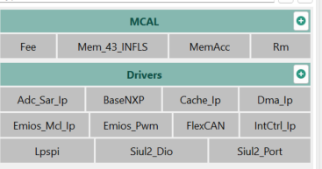

  - Dependency
This component requires the software components to be integrated alongside to be functional.
- absdef (https://bitbucket.org/americanbatterysolutions/absdef)
- S32K344-FreeRTOS (https://bitbucket.org/americanbatterysolutions/s32k344-freertos)

  - Interfaces
The following section will provide more details for the interfaces of the S32K344-MCAL component. The details include the function prototype, parameters, and return value description.

    - AUTOSAR Fee
Below is a component diagram of the AUTOSAR Fee:

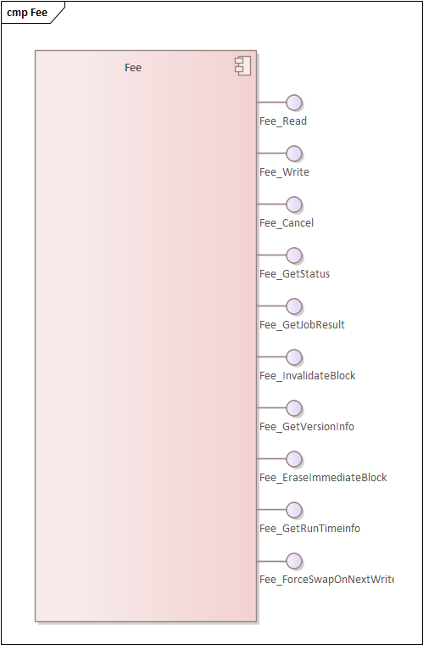
      - Fee_Read
Prototype:
Std_ReturnType Fee_Read(uint16 BlockNumber, uint16 BlockOffset, uint8 *DataBufferPtr, uint16 Length);

Description:
/**
* @brief Service to initiate a read job.
* @details The function Fee_Read shall take the block start address and
* offset and calculate the corresponding memory read address.
*
* @param[in] BlockNumber Number of logical block, also denoting
* start address of that block in flash memory.
* @param[in] BlockOffset Read address offset inside the block.
* @param[out] DataBufferPtr Pointer to data buffer.
* @param[in] Length Number of bytes to read.
*
* @pre The module must be initialized, not busy, uBlockNumber must be
* valid, uLength != 0, pDataBufferPtr != NULL_PTR, uBlockOffset and
* (uBlockOffset + uLength - 1) must be in range Length must be aligned with FEE_MINIMUM_READ_PAGE_SIZE.
* @post changes Fee_eModuleStatus module status and Fee_uJobBlockOffset,
* Fee_uJobBlockLength, Fee_uJobBlockIndex, Fee_pJobReadDataDestPtr,
* Fee_eJob, Fee_eJobResult job control internal variables.
*
* @return Std_ReturnType
* @retval E_OK The read job was accepted by the
* underlying memory driver.
* @retval E_NOT_OK The read job has not been accepted
* by the underlying memory driver.
* @note The function Autosar Service ID[hex]: 0x02.
* @note Asynchronous.
* @note Non Reentrant.
*
* @api
*
* @implements Fee_Read_Activity
*/

      - Fee_Write
Prototype:
Std_ReturnType Fee_Write(uint16 BlockNumber, const uint8 *DataBufferPtr);

Description:
/**
* @brief Service to initiate a write job.
* @details The function Fee_Write shall take the block start address and
* calculate the corresponding memory write address. The block
* address offset shall be fixed to zero.
* The function Fee_Write shall copy the given or computed
* parameters to module internal variables, initiate a write job,
* set the FEE module status to MEMIF_BUSY, set the job result to
* MEMIF_JOB_PENDING and return with E_OK.The FEE module shall
* execute the write job of the function Fee_Write
* asynchronously within the FEE module' s main function.
*
* @param[in] BlockNumber Number of logical block, also denoting
* start address of that block in emulated
* EEPROM.
* @param[out] DataBufferPtr Pointer to data buffer.
*
* @return Std_ReturnType
* @retval E_OK The write job was accepted by the
* underlying memory driver.
* @retval E_NOT_OK The write job has not been accepted by
* the underlying memory driver.
*
* @pre The module must be initialized, not busy, uBlockNumber must be
* valid, and pDataBufferPtr != NULL_PTR must be aligned with FEE_BUFFER_ALIGN_VALUE.
* Before call the function "Fee_Write" for immediate date must be
* called the function "Fee_EraseImmediateBlock".
* @post changes Fee_eModuleStatus module status and Fee_uJobBlockIndex,
* Fee_pJobWriteDataDestPtr, Fee_eJob, Fee_eJobResult job control internal
* variables.
* @note The function Autosar Service ID[hex]: 0x03.
* @note Asynchronous.
* @note Non Reentrant.
*
* @api
*
* @implements Fee_Write_Activity
*/

      - Fee_Cancel
Prototype:
void Fee_Cancel(void);

Description:
/**
* @brief Service to call the cancel function of the underlying flash
* driver.
* @details The function Fee_Cancel and the cancel function of the
* underlying flash driver are asynchronous w.r.t. an ongoing
* read, erase or write job in the flash memory.
*
* @pre The module must be initialized.
* @post Changes Fee_eModuleStatus module status and job result
* Fee_eJobResult internal variables.
* @note The function Autosar Service ID[hex]: 0x04.
* @note Synchronous.
* @note Non Reentrant.
*
* @api
*
* @implements Fee_Cancel_Activity
*/

      - Fee_GetStatus
Prototype:
MemIf_StatusType Fee_GetStatus(void);

Description:
/**
* @brief Return the Fee module state.
* @details Return the Fee module state synchronously.
*
* @note The function Autosar Service ID[hex]: 0x05.
* @note Synchronous
* @note Non Reentrant
*
* @return Fee_eModuleStatus
* @retval MEMIF_UNINIT Module has not been initialized (yet).
* @retval MEMIF_IDLE Module is currently idle.
* @retval MEMIF_BUSY Module is currently busy.
* @retval MEMIF_BUSY_INTERNAL Module is busy with internal management
* operations.
*
* @api
*
* @implements Fee_GetStatus_Activity
*/

      - Fee_GetJobResult
Prototype:
MemIf_JobResultType Fee_GetJobResult(void);

Description:
/**
* @brief Return the result of the last job.
* @details Return the result of the last job synchronously.
*
* @return MemIf_JobResultType
* @retval MEMIF_JOB_OK The job has been finished successfully.
* @retval MEMIF_JOB_FAILED The job has not been finished
* successfully.
* @retval MEMIF_JOB_PENDING The job has not yet been finished.
* @retval MEMIF_JOB_CANCELED The job has been canceled.
* @retval MEMIF_BLOCK_INCONSISTENT The requested block is inconsistent,
* it may contain corrupted data.
* @retval MEMIF_BLOCK_INVALID The requested block has been invalidated,
* the requested read operation can not be performed.
* @note The function Autosar Service ID[hex]: 0x06.
* @note Synchronous.
* @note Non Reentrant.
*
* @api
*
* @implements Fee_GetJobResult_Activity
*/

      - Fee_InvalidateBlock
Prototype:
Std_ReturnType Fee_InvalidateBlock(uint16 BlockNumber);

Description:
/**
* @brief Service to invalidate a logical block.
*
* @param[in] BlockNumber Number of logical block, also denoting
* start address of that block in flash memory
* @return Std_ReturnType
* @retval E_OK The job was accepted by the underlying
* memory driver.
* @retval E_NOT_OK The job has not been accepted by the
* underlying memory driver.
*
* @pre The module must be initialized, not busy, and uBlockNumber must be
* valid
*
* @post changes Fee_eModuleStatus module status and Fee_uJobBlockIndex,
* Fee_eJob, and Fee_eJobResult job control internal variables.
* EEPROM.
* @note The function Autosar Service ID[hex]: 0x07.
* @note Asynchronous.
* @note Non Reentrant.
*
* @api
*
* @implements Fee_InvalidateBlock_Activity
*/

      - Fee_GetVersionInfo
Prototype:
void Fee_GetVersionInfo(Std_VersionInfoType *VersionInfoPtr);

Description:
/**
* @brief Return the version information of the Fee module.
* @details The version information includes: Module Id, Vendor Id,
* Vendor specific version numbers.
*
* @param[out] VersionInfoPtr Pointer to where to store the version
* information of this module .
*
* @pre pVersionInfoPtr must not be NULL_PTR.
* @note The function Autosar Service ID[hex]: 0x08.
* @note Synchronous.
* @note Non Reentrant.
*
* @api
*
* @implements Fee_GetVersionInfo_Activity
*/

      - Fee_EraseImmediateBlock
Prototype:
Std_ReturnType Fee_EraseImmediateBlock(uint16 BlockNumber);

Description:
/**
* @brief Service to erase a logical block.
* @details The function Fee_EraseImmediateBlock shall take the block number
* and calculate the corresponding memory block address.
* The function Fee_EraseImmediateBlock shall ensure that the FEE
* module can write immediate data. Whether this involves
* physically erasing a memory area and therefore calling the erase
* function of the underlying driver depends on the implementation.
* If development error detection for the FEE module is enabled,
* the function Fee_EraseImmediateBlock shall check whether the
* addressed logical block is configured as containing immediate
* data (configuration parameter FeeImmediateData == TRUE).
* If not, the function Fee_EraseImmediateBlock
* shall report the error code FEE_E_INVALID_BLOCK_NO.
*
* @param[in] BlockNumber Number of logical block, also denoting.
*
* @return Std_ReturnType
* @retval E_OK The job was accepted by the underlying
* memory driver.
* @retval E_NOT_OK The job has not been accepted by the underlying
* memory driver.
* start address of that block in emulated EEPROM.
*
* @pre The module must be initialized, not busy, uBlockNumber must be
* valid, and type of Fee block must be immediate.
* @post changes Fee_eModuleStatus module status and Fee_uJobBlockIndex,
* Fee_eJob, and Fee_eJobResult job control internal variables.
*
* @note The function Autosar Service ID[hex]: 0x09.
* @note Asynchronous.
* @note Non Reentrant.
*
* @api
*
* @implements Fee_EraseImmediateBlock_Activity
*/

      - Fee_GetRunTimeInfo
Prototype:
void Fee_GetRunTimeInfo(uint8 ClrGrpIndex, Fee_ClusterGroupRuntimeInfoType *ClrGrpRTInfo);

Description:
/**
* @brief Service to read runtime information in the selected cluster.
*
* @param[in] ClrGrpIndex Index of the selected cluster group
* @param[in] ClrGrpRTInfo Pointer to point Fee cluster group run-time Information
*
* @return Fee_ClusterGroupRuntimeInfoType
* @retval ClusterTotalSpace current cluster total size
* @retval ClusterFreeSpace current cluster available space.
* @retval BlockHeaderOverhead the block header overhead (blk header, valid flag and inval flag),
* @retval VirtualPageSize the virtual page size (the size of an allocation unit)
* @retval NumberOfSwap number of cluster swap already performed
* @retval SectorInfo sector information from all clusters in the selected cluster group (in sector retirement mode only)
*
* @pre The module must be initialized, not busy and uClrGrpIndex must be valid
*
* @api
*
* @implements Fee_GetRunTimeInfo_Activity
*/

      - Fee_ForceSwapOnNextWrite
Prototype:
Std_ReturnType Fee_ForceSwapOnNextWrite(uint8 ClrGrpIndex);

Description:
/**
* @brief Service to prepare the driver for a cluster swap in the selected cluster group.
*
* @detailes While the computed amount of memory is allocated as a result of Fee_Write
* call for plain data blocks, for immediate data blocks memory gets completely
* pre-allocated through Fee_EraseImmediateBlock function (i.e. Fee_Write does
* not change the remaining space).
* As a result, swaps triggered by the planned Fee_ForceSwapOnNextWrite function
* behave the same way, or in other words, an operation that really activates the
* pysical swap must be either Fee_Write on plain FEE block or
* Fee_EraseImmediateBlock on immediate data block.
*
* @param[in] ClrGrpIndex Index of the selected cluster group

* @return Std_ReturnType
* @retval E_NOT_OK module is not initialized, busy or uClrGrpIndex is not in the
* valid range.
* @retval E_OK No more space available in the selected cluster.
*
* @pre The module must be initialized, not busy and uClrGrpIndex must be valid.
*
* @note As this API manipulates the internal driver state, it has to be claimed
* non-reentrant and colliding with other FEE ASR APIs
* @api
*
* @implements Fee_ForceSwapOnNextWrite_Activity
*/

    - Cache
Below is an illustration of the Cache (sub) component of the MCAL component:

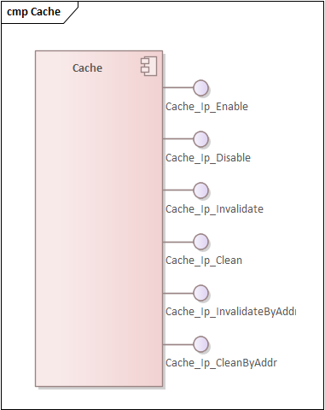

      - Cache_Ip_Enable
Prototype:
Std_ReturnType Cache_Ip_Enable(const Cache_Ip_Type CacheType,
const Cache_Ip_BusType BusType);

Description:
/**
* @brief This function enables the Cache Ip Driver.
* @details This service is a reentrant function that shall enable the Cache Ip driver.
*
* @param[in] CacheType Specifies the cache type.
* @param[in] BusType Specifies the bus type.
*
* @return E_OK is returned if the enable action finished correctly.
* E_NOT_OK is returned if the enable action finished incorrectly.
*
* @implements Cache_Ip_Enable_Activity
* */

      - Cache_Ip_Disable
Prototype:
Std_ReturnType Cache_Ip_Disable(const Cache_Ip_Type CacheType,
const Cache_Ip_BusType BusType);

Description:
/**
* @brief This function disables the Cache Ip Driver.
* @details This service is a reentrant function that shall disables the Cache Ip driver.
*
* @param[in] CacheType Specifies the cache type.
* @param[in] BusType Specifies the bus type.
*
* @return E_OK is returned if the disable action finished correctly.
* E_NOT_OK is returned if the disable action finished incorrectly.
*
* @implements Cache_Ip_Disable_Activity
* */

      - Cache_Ip_Invalidate
Prototype:
Std_ReturnType Cache_Ip_Invalidate(const Cache_Ip_Type CacheType,
const Cache_Ip_BusType BusType);

Description:
/**
* @brief This function Invalidates the Cache Ip Driver.
* @details This service is a reentrant function that shall Invalidates the Cache Ip driver.
* The Invalidate operation applies for the entire selected Cache Type.
*
* A cache invalidate operation ensures that updates made visible by observers that access memory at
* the point to which the invalidate is defined are made visible to an observer that controls the cache.
* This might result in the loss of updates to the locations affected by the invalidate operation that have
* been written by observers that access the cache. If the address of an entry on which the invalidate
* operates does not have a Normal Cacheable attribute, or if the cache is disabled, then an invalidate
* operation also ensures that this address is not present in the cache.
*
* @param[in] CacheType Specifies the cache type.
* @param[in] BusType Specifies the bus type.
*
* @return E_OK is returned if the invalidation finished correctly.
* E_NOT_OK is returned if the invalidation finished incorrectly.
*
* @implements Cache_Ip_Invalidate_Activity
* */

      - Cache_Ip_Clean
Prototype:
Std_ReturnType Cache_Ip_Clean(const Cache_Ip_Type CacheType,
const Cache_Ip_BusType BusType,
const boolean EnInvalidate);

Description:
/**
* @brief This function Clean the Cache Ip Driver.
* @details This service is a reentrant function that shall Clean the Cache Ip driver.
* The Clean operation applies for the entire selected Cache Type.
*
* A cache clean operation ensures that updates made by an observer that controls the cache are made
* visible to other observers that can access memory at the point to which the operation is performed.
* Once the Clean has completed, the new memory values are guaranteed to be visible to the point to
* which the operation is performed, for example to the point of unification. The cleaning of a cache
* entry from a cache can overwrite memory that has been written by another observer only if the entry
* contains a location that has been written to by an observer in the shareability domain of that memory
* location.
*
* A cache clean and invalidate operation behaves as the execution of a clean operation followed
* immediately by an invalidate operation. Both operations are performed to the same location.
*
* @param[in] CacheType Specifies the cache type.
* @param[in] BusType Specifies the bus type.
* @param[in] enInvalidate Specifies to execute operation Clean&Invalidate.
*
* @return E_OK is returned if the cleaning finished correctly.
* E_NOT_OK is returned if the cleaning finished incorrectly.
*
* @implements Cache_Ip_Clean_Activity
* */

      - Cache_Ip_InvalidateByAddr
Prototype:
Std_ReturnType Cache_Ip_InvalidateByAddr(const Cache_Ip_Type CacheType,
const Cache_Ip_BusType BusType,
const uint32 Addr,
const uint32 Length);

Description:
/**
* @brief This function Invalidates By Address the Cache Ip Driver.
* @details This service is a reentrant function that shall Invalidates By Address the Cache Ip driver.
* The Invalidate By Address operation applies for the memory segment specified by the
* start Address and Length. The operation Invalidates only multiple of Cache Line Size, thus the
* specified memory segment shall be aligned and multiple of the Cache Line Size.
*
* A cache invalidate operation ensures that updates made visible by observers that access memory at
* the point to which the invalidate is defined are made visible to an observer that controls the cache.
* This might result in the loss of updates to the locations affected by the invalidate operation that have
* been written by observers that access the cache. If the address of an entry on which the invalidate
* operates does not have a Normal Cacheable attribute, or if the cache is disabled, then an invalidate
* operation also ensures that this address is not present in the cache.
*
* @param[in] CacheType Specifies the cache type.
* @param[in] BusType Specifies the bus type.
* @param[in] Addr Specifies the memory segment start address.
* @param[in] Length Specifies the memory segment length.
*
* @return E_OK is returned if the invalidation finished correctly.
* E_NOT_OK is returned if the invalidation finished incorrectly.
*
* @implements Cache_Ip_InvalidateByAddr_Activity
* */

      - Cache_Ip_CleanByAddr
Prototype:
Std_ReturnType Cache_Ip_CleanByAddr(const Cache_Ip_Type CacheType,
const Cache_Ip_BusType BusType,
const boolean EnInvalidate,
const uint32 Addr,
const uint32 Length);

Description:
/**
* @brief This function Clean By Address the Cache Ip Driver.
* @details This service is a reentrant function that shall Clean By Address the Cache Ip driver.
* The Clean By Address operation applies for the memory segment specified by the
* start Address and Length. The operation Cleans only multiple of Cache Line Size, thus the
* specified memory segment shall be aligned and multiple of the Cache Line Size.
*
* A cache clean operation ensures that updates made by an observer that controls the cache are made
* visible to other observers that can access memory at the point to which the operation is performed.
* Once the Clean has completed, the new memory values are guaranteed to be visible to the point to
* which the operation is performed, for example to the point of unification. The cleaning of a cache
* entry from a cache can overwrite memory that has been written by another observer only if the entry
* contains a location that has been written to by an observer in the shareability domain of that memory
* location.
*
* A cache clean and invalidate operation behaves as the execution of a clean operation followed
* immediately by an invalidate operation. Both operations are performed to the same location.
*
* @param[in] CacheType Specifies the cache type.
* @param[in] BusType Specifies the bus type.
* @param[in] enInvalidate Specifies to execute operation Clean&Invalidate.
* @param[in] Addr Specifies the memory segment start address.
* @param[in] Length Specifies the memory segment length.
*
* @return E_OK is returned if the cleaning finished correctly.
* E_NOT_OK is returned if the cleaning finished incorrectly.
*
* @implements Cache_Ip_CleanByAddr_Activity
* */

    - Enhanced Direct Memory Access (eDMA)
Below is an illustration of the eDMA and DMA MUX (sub) components of the MCAL component:

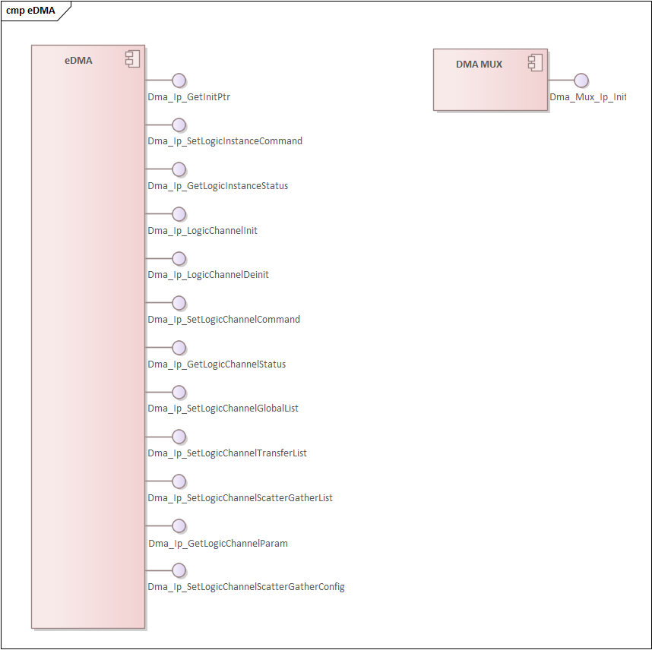

      - Dma_Ip_SetLogicInstanceCommand
Prototype:
Dma_Ip_ReturnType Dma_Ip_SetLogicInstanceCommand(const uint32 LogicInst,
const Dma_Ip_LogicInstanceCmdType Command);

Description:
/**
* @brief This function sets Dma Ip Instance Command.
* @details This service is a reentrant function that shall command the Dma Instance.
* The command shall trigger specific functionalities of the Dma Instance.
*
* @param[in] LogicInst Selection value of the Logic Instance.
* @param[in] Command The command for the Logic Instance.
*
* @return Dma_Ip_ReturnType DMA_IP_STATUS_SUCCESS is returned if the command finished ok.
*
* @implements Dma_Ip_SetLogicInstanceCommand_Activity
* */

      - Dma_Ip_GetLogicInstanceStatus
Prototype:
Dma_Ip_ReturnType Dma_Ip_GetLogicInstanceStatus(const uint32 LogicInst,
Dma_Ip_LogicInstanceStatusType * const Status);

Description:
/**
* @brief This function gets Dma Ip Instance Status.
* @details This service is a reentrant function that shall get the Dma Instance status.
* The command shall read specific functionalities of the Dma Instance.
*
* @param[in] LogicInst Selection value of the Logic Instance.
* @param[out] Status Pointer to the Dma Instance status.
*
* @return Dma_Ip_ReturnType DMA_IP_STATUS_SUCCESS is returned if the get status finished ok.
*
* @implements Dma_Ip_GetLogicInstanceStatus_Activity
* */

      - Dma_Ip_LogicChannelInit
Prototype:
Dma_Ip_ReturnType Dma_Ip_LogicChannelInit(const uint32 LogicCh);

Description:
/**
* @brief This function initializes the Dma Ip Logic Channel.
* @details This service is a non reentrant function that shall initialize the Dma Ip Logic Channel.
*
* @param[in] LogicCh Selection value of the Logic Channel.
*
* @return Dma_Ip_ReturnType DMA_IP_STATUS_SUCCESS is returned if the initialization finished ok.
* DMA_IP_STATUS_WRONG_STATE is returned if the Dma Ip Channel state is
* not Dma_Ip_Ch_ResetState.
*
* @implements Dma_Ip_LogicChannelInit_Activity
* */

      - Dma_Ip_LogicChannelDeinit
Prototype:
Dma_Ip_ReturnType Dma_Ip_LogicChannelDeinit(const uint32 LogicCh);

Description:
/**
* @brief This function deinitializes the Dma Ip Logic Channel.
* @details This service is a non reentrant function that shall deinitialize the Dma Ip Logic Channel.
*
* @param[in] LogicCh Selection value of the Logic Channel.
*
* @return Dma_Ip_ReturnType DMA_IP_STATUS_SUCCESS is returned if the deinitialization finished ok.
*
* @implements Dma_Ip_LogicChannelDeinit_Activity
* */

      - Dma_Ip_SetLogicChannelCommand
Prototype:
Dma_Ip_ReturnType Dma_Ip_SetLogicChannelCommand(const uint32 LogicCh,
const Dma_Ip_LogicChannelCmdType Command);

Description:
/**
* @brief This function sets Dma Ip Logic Channel Command.
* @details This service is a reentrant function that shall command the Dma Channel.
* The command shall trigger specific functionalities of the Dma Channel.
*
* @param[in] LogicCh Selection value of the Logic Channel.
* @param[in] Command The command for the Logic Channel.
*
* @return Dma_Ip_ReturnType DMA_IP_STATUS_SUCCESS is returned if the initialization finished ok.
* DMA_IP_STATUS_WRONG_STATE is returned if the Dma Ip Channel state is
* not Dma_Ip_Ch_ReadyState.
*
* @implements Dma_Ip_SetLogicChannelCommand_Activity
* */

      - Dma_Ip_GetLogicChannelStatus
Prototype:
Dma_Ip_ReturnType Dma_Ip_GetLogicChannelStatus(const uint32 LogicCh,
Dma_Ip_LogicChannelStatusType * const ChStatus);

Description:
/**
* @brief This function gets Dma Ip Logic Channel Status.
* @details This service is a reentrant function that shall get the Dma Channel status.
* The command shall read specific functionalities of the Dma Channel.
*
* @param[in] LogicCh Selection value of the Logic Channel.
* @param[out] Status Pointer to the Dma Channel status.
*
* @return Dma_Ip_ReturnType DMA_IP_STATUS_SUCCESS is returned if the get status finished ok.
*
* @implements Dma_Ip_GetLogicChannelStatus_Activity
* */

      - Dma_Ip_SetLogicChannelGlobalList
Prototype:
Dma_Ip_ReturnType Dma_Ip_SetLogicChannelGlobalList(const uint32 LogicCh,
const Dma_Ip_LogicChannelGlobalListType List[],
const uint32 ListDimension);

Description:
/**
* @brief This function sets Dma Ip Logic Channel Global List settings.
* @details This service is a reentrant function that shall set the Dma Ip Logic Channel
* global parameters list.
* The list is composed of an array of Dma Ip Logic Channel global parameters settings.
* The settings list(array) is defined by the user needs: it contains the
* desired parameters to be configured, in any desired order.
*
* How to use this interface:
* 1. Use the "Dma_Ip_LogicChannelGlobalListType" to create a list(array) with the desired
* paramaters to configure (see parameters: "Dma_Ip_LogicChannelGlobalParamType")
* The list can declared globally or locally:
* A. Global example:
* Dma_Ip_LogicChannelGlobalListType global_Dma_Ip_ChannelGlobalList0[NUMBER_OF_PARAMETERS] = {...};
* B. Local example:
* Dma_Ip_LogicChannelGlobalListType Dma_Ip_ChannelGlobalList[NUMBER_OF_PARAMETERS];
* Dma_Ip_ChannelGlobalList[PARAMETER0].Param = DMA_IP_CH_SET_EN_PREEMPTION_PRIORITY;
* Dma_Ip_ChannelGlobalList[PARAMETER0].Value = TRUE;
* Dma_Ip_ChannelGlobalList[PARAMETER1].Param = ...;
* Dma_Ip_ChannelGlobalList[PARAMETER1].Value = ...;
* 2. Call the "Dma_Ip_SetLogicChannelGlobalList()" interface:
* Dma_Ip_SetLogicChannelGlobalList(LOGIC_CHANNELx, Dma_Ip_ChannelGlobalList, NUMBER_OF_PARAMETERS);
*
* @param[in] Channel Specifies the Logic Channel Id.
* @param[in] List Pointer to the Global List Array.
* @param[in] ListDimension Number of entries in the List.
*
* @return Dma_Ip_ReturnType DMA_IP_STATUS_SUCCESS is returned if the initialization finished ok.
* DMA_IP_STATUS_WRONG_STATE is returned if the Dma Ip Channel state is
* not Dma_Ip_Ch_ReadyState.
*
* @implements Dma_Ip_SetLogicChannelGlobalList_Activity
* */

      - Dma_Ip_SetLogicChannelTransferList
Prototype:
Dma_Ip_ReturnType Dma_Ip_SetLogicChannelTransferList(const uint32 LogicCh,
const Dma_Ip_LogicChannelTransferListType List[],
const uint32 ListDimension);

Description:
/**
* @brief This function sets Dma Ip Logic Channel Transfer List settings.
* @details -> This service is a reentrant function that shall set the Dma Ip Logic Channel
* transfer parameters list.
* -> The "Transfer List" loads the configuration directly into the Hardware TCD and disables
* the ScatterGather for the Hardware TCD.
* -> The list is composed of an array of Dma Ip Logic Channel transfer parameters settings.
* -> The settings array is defined by the user needs: it contains entries for each desired
* parameter to be configured, in any suitable order.
*
* -> How to use this interface: <-
* 1. Use the "Dma_Ip_LogicChannelTransferListType" to create a list(array) with the desired
* paramaters to configure (see parameters: "Dma_Ip_LogicChannelTransferParamType")
* The list can declared globally or locally:
* Global example:
* #define DMA_IP_TRANSFER_LIST0_DIMENSION ((uint32)2U)
* Dma_Ip_LogicChannelTransferListType global_Dma_Ip_ChannelTransferList0[DMA_IP_TRANSFER_LIST0_DIMENSION] = {...};
* Local example:
* #define DMA_IP_TRANSFER_LIST0_DIMENSION ((uint32)2U)
* Dma_Ip_LogicChannelTransferListType Dma_Ip_ChannelTransferList0[DMA_IP_TRANSFER_LIST0_DIMENSION];
* Dma_Ip_ChannelTransferList0[PARAMETER0].Param = DMA_IP_CH_SET_VAL_SOURCE_ADDRESS;
* Dma_Ip_ChannelTransferList0[PARAMETER0].Value = &SourceBuffer;
* Dma_Ip_ChannelTransferList0[PARAMETER1].Param = DMA_IP_CH_SET_DESTINATION_ADDRESS;
* Dma_Ip_ChannelTransferList0[PARAMETER1].Value = &DestinationBuffer;
* 2. Call the "Dma_Ip_SetLogicChannelTransferList()" interface:
* Dma_Ip_SetLogicChannelTransferList(LOGIC_CHANNELx, Dma_Ip_ChannelTransferList0, DMA_IP_TRANSFER_LIST0_DIMENSION);
*
* -> Coding Example: <-
* -> The user shall create the desired configuration list for his specific application.
* "UserDefinedFileName.h"
* #define DMA_IP_TRANSFER_LIST0_DIMENSION ((uint32)8U)
* #define DMA_IP_SET_TRANSFER_TYPE0(CHANNEL, DIMENSION, SADDR, SOFF, SSIZE, DADDR, DOFF, DSIZE, MINOR_SIZE, MAJOR_COUNT) \
* Dma_Ip_LogicChannelTransferListType Dma_Ip_ChannelTransferList0[DIMENSION]; \
* Dma_Ip_ChannelTransferList0[0U].Param = DMA_IP_CH_SET_VAL_SOURCE_ADDRESS; \
* Dma_Ip_ChannelTransferList0[0U].Value = SADDR; \
* Dma_Ip_ChannelTransferList0[1U].Param = DMA_IP_CH_SET_SOURCE_SIGNED_OFFSET; \
* Dma_Ip_ChannelTransferList0[1U].Value = SOFF; \
* Dma_Ip_ChannelTransferList0[2U].Param = DMA_IP_CH_SET_SOURCE_TRANSFER_SIZE; \
* Dma_Ip_ChannelTransferList0[2U].Value = SSIZE; \
* Dma_Ip_ChannelTransferList0[3U].Param = DMA_IP_CH_SET_DESTINATION_ADDRESS; \
* Dma_Ip_ChannelTransferList0[3U].Value = DADDR; \
* Dma_Ip_ChannelTransferList0[4U].Param = DMA_IP_CH_SET_DESTINATION_SIGNED_OFFSET; \
* Dma_Ip_ChannelTransferList0[4U].Value = DOFF; \
* Dma_Ip_ChannelTransferList0[5U].Param = DMA_IP_CH_SET_DESTINATION_TRANSFER_SIZE; \
* Dma_Ip_ChannelTransferList0[5U].Value = DSIZE; \
* Dma_Ip_ChannelTransferList0[6U].Param = DMA_IP_CH_SET_MINORLOOP_SIZE; \
* Dma_Ip_ChannelTransferList0[6U].Value = MINOR_SIZE; \
* Dma_Ip_ChannelTransferList0[7U].Param = DMA_IP_CH_SET_MAJORLOOP_COUNT; \
* Dma_Ip_ChannelTransferList0[7U].Value = MAJOR_COUNT; \
* Dma_Ip_SetLogicChannelTransferList(CHANNEL, Dma_Ip_ChannelTransferList0, DIMENSION);
*
* "ApplicationFileName.c"
* void ConfigureDmaChannel(ConfigType * pxConfig)
* {
* uint32 MinorLoopSize = 2U;
* uint32 MajorLoopCount;
* if(pxConfig->MajorLoopCondition == TRUE)
* {
* MajorLoopCount = 8U;
* }
* else
* {
* MajorLoopCount = 24U;
* }
* DMA_IP_SET_TRANSFER_TYPE0(pxConfig->LogicChannel,
* DMA_IP_TRANSFER_LIST0_DIMENSION,
* pxConfig->SourceBuffer,
* 2U,
* DMA_IP_TRANSFER_SIZE_2_BYTE,
* &RegisterAddress,
* 0U,
* DMA_IP_TRANSFER_SIZE_2_BYTE,
* MinorLoopSize,
* MajorLoopCount);
* }
*
* @param[in] Channel Specifies the Logic Channel Id.
* @param[in] List Pointer to the Transfer List Array.
* @param[in] ListDimension Number of entries in the List.
*
* @return Dma_Ip_ReturnType DMA_IP_STATUS_SUCCESS is returned if the initialization finished ok.
* DMA_IP_STATUS_WRONG_STATE is returned if the Dma Ip Channel state is
* not Dma_Ip_Ch_ReadyState.
*
* @implements Dma_Ip_SetLogicChannelTransferList_Activity
* */

      - Dma_Ip_SetLogicChannelScatterGatherList
Prototype:
Dma_Ip_ReturnType Dma_Ip_SetLogicChannelScatterGatherList(const uint32 LogicCh,
const uint32 Element,
const Dma_Ip_LogicChannelScatterGatherListType List[],
const uint32 ListDimension);

Description:
/**
* @brief This function sets Dma Ip Logic Channel Scatter/Gather List settings.
* @details -> This service is a reentrant function that shall set the Dma Ip Logic Channel
* scatter/gather parameters list.
* -> The "Scatter/Gather List" configures Logic Elements belonging to the same
* Dma Logic Channel.
* -> The "Scatter/Gather List" loads the configuration into the Software TCD.
* The Software TCD has the Scatter/Gather Enable set (ESG bit) and the Next Software
* TCD Address already loaded during the configuration generation process.
* -> The "Scatter/Gather List" shall not be able to modify the Scatter/Gather Element
* linkage (reorder of elements in the chain). The linkage of the elements is set only
* during the configuration process.
* -> The settings array is defined by the user needs: it contains entries for
* each desired parameter to be configured, in any suitable order.
* -> This service does not load the Logic Element into the Hardware TCD. This functionality
* is covered by Dma_Ip_SetLogicChannelScatterGatherConfig.
*
* How to use this interface:
* 1. Use the "Dma_Ip_LogicChannelScatterGatherListType" to create a list(array) with the desired
* paramaters to configure (see parameters: "Dma_Ip_LogicChannelTransferParamType")
* The list can declared globally or locally:
* Global example:
* Dma_Ip_LogicChannelScatterGatherListType global_Dma_Ip_ChannelScatterGatherList0[NUMBER_OF_PARAMETERS] = {...};
* Local example:
* Dma_Ip_LogicChannelScatterGatherListType Dma_Ip_ChannelScatterGatherList[NUMBER_OF_PARAMETERS];
* Dma_Ip_ChannelScatterGatherList[PARAMETER0].Param = DMA_IP_CH_SET_VAL_SOURCE_ADDRESS;
* Dma_Ip_ChannelScatterGatherList[PARAMETER0].Value = &SourceBuffer;
* Dma_Ip_ChannelScatterGatherList[PARAMETER1].Param = DMA_IP_CH_SET_DESTINATION_ADDRESS;
* Dma_Ip_ChannelScatterGatherList[PARAMETER1].Value = &DestinationBuffer;
* 2. Call the "Dma_Ip_SetLogicChannelScatterGatherList()" interface:
* Dma_Ip_SetLogicChannelScatterGatherList(LOGIC_CHANNELx, LOGIC_ELEMENTy, Dma_Ip_ChannelScatterGatherList, NUMBER_OF_PARAMETERS);
*
* @return Dma_Ip_ReturnType DMA_IP_STATUS_SUCCESS is returned if the initialization finished ok.
* DMA_IP_STATUS_WRONG_STATE is returned if the Dma Ip Channel state is
* not Dma_Ip_Ch_ReadyState.
*
* @implements Dma_Ip_SetLogicChannelScatterGatherList_Activity
* */

      - Dma_Ip_GetLogicChannelParam
Prototype:
Dma_Ip_ReturnType Dma_Ip_GetLogicChannelParam(const uint32 LogicCh,
const Dma_Ip_LogicChannelInfoParamType Param,
uint32 * const Value);

Description:
/**
* @brief This function gets the Dma Ip Logic Channel Parameter value.
* @details This service is a reentrant function that shall get the Dma Channel
* parameters value.
*
* @param[in] LogicCh Selection value of the Logic Channel.
* @param[in] Param Selection parameter.
* @param[out] Value Pointer to the parameter value.
*
* @return Dma_Ip_ReturnType DMA_IP_STATUS_SUCCESS is returned if the get information finished ok.
*
* @implements Dma_Ip_GetLogicChannelParam_Activity
* */

      - Dma_Ip_SetLogicChannelScatterGatherConfig
Prototype:
Dma_Ip_ReturnType Dma_Ip_SetLogicChannelScatterGatherConfig(const uint32 LogicCh,
const uint32 Element);

Description:
/**
* @brief This function configures the Dma Ip Logic Channel Scatter/Gather.
* @details This service is a reentrant function that shall configure the Dma Channel
* scatter/gather functionality.
* The specified Logic Element (corresponding to a Software TCD) shall be loaded
* into the Dma Logic Channel's Hardware TCD.
* The Logic Elements (describing the Software TCDs) form a simple chained list
* and the "Element" parameter represents the lists's head.
*
* @param[in] LogicCh Selection value of the Logic Channel.
* @param[in] Element Selection value of the Logic Element representing the
* list's head.
*
* @return Dma_Ip_ReturnType DMA_IP_STATUS_SUCCESS is returned if the initialization finished ok.
* DMA_IP_STATUS_WRONG_STATE is returned if the Dma Ip Channel state is
* not Dma_Ip_Ch_ReadyState.
* DMA_IP_STATUS_ERROR is returned if the Dma Ip Channel contains an error.
*
* @implements Dma_Ip_SetLogicChannelScatterGatherConfig_Activity
* */

      - Dma_Mux_Ip_Init
Prototype:
void Dma_Mux_Ip_Init(const Dma_Mux_Ip_ConfigType * pConfig);

Description:
/**
* @brief Initializes the Memory Protection Unit general parameters and
* region configurations
*
* @details This function is non-reentrant
*
* @param[in] pConfig: pointer to configuration structure for DMA_MUX.
* @return void
*
* @pre None
*
**/

    - FlexCAN
Below is an illustration of the FlexCAN Controller component provided interfaces:

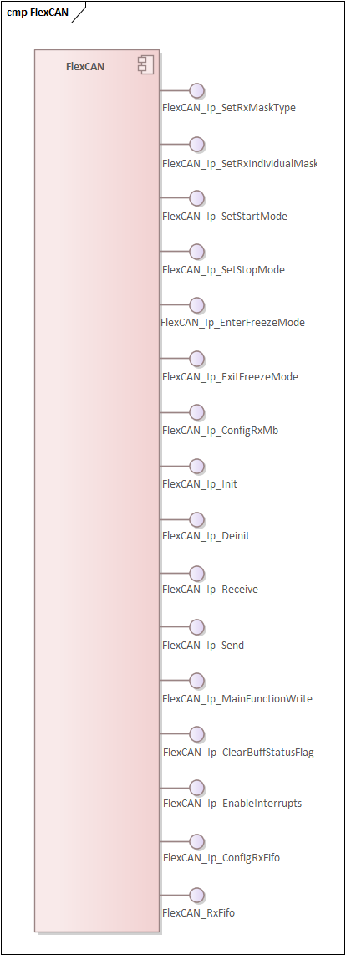
      - FlexCAN_Ip_SetRxMaskType
Prototype:
Flexcan_Ip_StatusType FlexCAN_Ip_SetRxMaskType(instance, type);

Description:
/**
* @brief Set RX masking type
* @details This function will set RX masking type as RX global mask or RX individual mask
* @param[in] instance: A FlexCAN instance number
* @param[in] type: FlexCAN Rx mask type
* @note This function should be called from StopMode or FreezeMode.
* @return FLEXCAN_STATUS_SUCCESS if successful<br>
* FLEXCAN_STATUS_ERROR if controller is not in freeze mode<br>
*
*/

      - FlexCAN_Ip_SetRxIndividualMask
Prototype:
Flexcan_Ip_StatusType FlexCAN_Ip_SetRxIndividualMask(instance, mb_idx, mask);

Description:
/**
* @brief Sets the FlexCAN Rx individual mask
* @details This function will set directly the mask value as is provided.
* @param[in] instance A FlexCAN instance number
* @param[in] mb_idx Index of the message buffer
* @param[in] mask Mask value
* @note This function should be called from StopMode or FreezeMode.
* @return FLEXCAN_STATUS_SUCCESS if successful;<br>
* FLEXCAN_STATUS_BUFF_OUT_OF_RANGE if the index of a message buffer is invalid.
*
*/

      - FlexCAN_Ip_SetStartMode
Prototype:
Flexcan_Ip_StatusType FlexCAN_Ip_SetStartMode(instance);

Description:
/**
* @brief Set the FlexCAN instance in START mode
* @details Set the FlexCAN instance in START mode, allowing to participate to bus transfers.
* @param[in] instance A FlexCAN instance number
* @return FLEXCAN_STATUS_SUCCESS if successful;<br>
* FLEXCAN_STATUS_TIMEOUT if fail to configure in configured timeout value.<br>
*/

      - FlexCAN_Ip_SetStopMode
Prototype:
Flexcan_Ip_StatusType FlexCAN_Ip_SetStopMode(instance);

Description:
/**
* @brief Set the FlexCAN instance in STOP mode
* @details Set the FlexCAN instance in STOP mode, this will prevent instance to participate to
* bus transactions and disable module clocks.
* @param[in] instance A FlexCAN instance number
* @return FLEXCAN_STATUS_SUCCESS if successful;<br>
* FLEXCAN_STATUS_TIMEOUT if fail to configure in configured timeout value.<br>
*
*/

      - FlexCAN_Ip_EnterFreezeMode
Prototype:
Flexcan_Ip_StatusType FlexCAN_Ip_EnterFreezeMode(instance);

Description:
/**
* @brief Enter FlexCAN Module in Freeze Mode.
* @details This function will suspend bus activity of FlexCAN module and
* set it to Freeze Mode to allow module configuration.
* @param[in] instance A FlexCAN instance number
* @return FLEXCAN_STATUS_SUCCESS if successful;<br>
* FLEXCAN_STATUS_TIMEOUT if fail to configure in the configured timeout value.<br>
*
*/

      - FlexCAN_Ip_ExitFreezeMode
Prototype:
Flexcan_Ip_StatusType FlexCAN_Ip_ExitFreezeMode(instance);

Description:
/**
* @brief Exit FlexCAN Module from Freeze Mode.
* @details This function will allow FlexCAN module to participate to the BUS activity and
* restore normal opertaion of the driver.
* @param[in] instance A FlexCAN instance number
* @note This function should be called from FreezeMode.
* @return FLEXCAN_STATUS_SUCCESS if successful;<br>
* FLEXCAN_STATUS_TIMEOUT if fail to configure in the configured timeout value.<br>
*
*/

      - FlexCAN_Ip_ConfigRxMb
Prototype:
Flexcan_Ip_StatusType FlexCAN_Ip_ConfigRxMb(uint8 instance, uint8 mb_idx, const Flexcan_Ip_DataInfoType * rx_info, uint32 msg_id);

Description:
/**
* @brief FlexCAN receive message buffer field configuration
* @details This function will config receive parameters form Flexcan_Ip_DataInfoType and
* the message Id, and can overwritte another MB status.
* @param[in] instance A FlexCAN instance number
* @param[in] mb_idx Index of the message buffer
* @param[in] rx_info Data info
* @param[in] msg_id ID of the message to transmit
* @return FLEXCAN_STATUS_SUCCESS if successful;<br>
* FLEXCAN_STATUS_BUFF_OUT_OF_RANGE if the index of a message buffer is invalid.
*
*/

      - FlexCAN_Ip_Init
Prototype:
Flexcan_Ip_StatusType FlexCAN_Ip_Init(Flexcan_Ip_u8Instance, Flexcan_Ip_pState, Flexcan_Ip_pData);

Description:
/**
* @brief Initializes the FlexCAN peripheral.
* @details This function will config FlexCAN module and will leave the module in freeze mode.
* @param[in] Flexcan_Ip_u8Instance A FlexCAN instance number
* @param[in\out] Flexcan_Ip_pState Pointer to the FlexCAN driver state structure.
* @param[in] Flexcan_Ip_pData The FlexCAN platform configuration data
* @return FLEXCAN_STATUS_SUCCESS if successfull;<br>
* FLEXCAN_STATUS_ERROR if other error occurred;<br>
* FLEXCAN_STATUS_BUFF_OUT_OF_RANGE if the index of a message buffer is invalid;<br>
* FLEXCAN_STATUS_TIMEOUT if fail to configure in configured timeout value.<br>
* @note In case of the enable option of Remote Request Store by setting corresponding bit for FLEXCAN_IP_REM_STORE_U32
* in the ctrlOptions structure member of the Flexcan platform configuration data, will disable Automatic Response Request,
* in this case is not allowed use of the function FlexCAN_Ip_ConfigRemoteResponseMb
*/

      - FlexCAN_Ip_Deinit
Prototype:
Flexcan_Ip_StatusType FlexCAN_Ip_Deinit(instance);

Description:
/**
* @brief DeInitilize the FlexCAN instance driver
* @details This function will make future operataions of FlexCAN instance imposibile and will restore
* it's state to default value as before initialization.
* @param[in] instance A FlexCAN instance number
* @return FLEXCAN_STATUS_SUCCESS if successful;<br>
* FLEXCAN_STATUS_TIMEOUT if fail to configure in configured timeout value.<br>
*
*/

      - FlexCAN_Ip_Receive
Prototype:
Flexcan_Ip_StatusType FlexCAN_Ip_Receive(uint8 instance, uint8 mb_idx, Flexcan_Ip_MsgBuffType * data, boolean isPolling);

Description:
/**
* @brief Receives a CAN frame using the specified message buffer.
* @details This function receives a CAN frame using a configured message buffer. The function
* returns immediately.
* @param[in] instance A FlexCAN instance number
* @param[in] mb_idx Index of the message buffer
* @param[out] data The FlexCAN receive message buffer data.
* @param[in] isPolling If the message will be send using pooling(true) or interrupt(false).
* @return FLEXCAN_STATUS_SUCCESS if successfull operation;<br>
* FLEXCAN_STATUS_BUFF_OUT_OF_RANGE if the index of a message buffer is invalid;<br>
* FLEXCAN_STATUS_BUSY if the message buffer is used for other operation.<br>
*
*/

      - FlexCAN_Ip_Send
Prototype:
Flexcan_Ip_StatusType FlexCAN_Ip_Send(uint8 instance, uint8 mb_idx, const Flexcan_Ip_DataInfoType * tx_info, uint32 msg_id, const uint8 * mb_data);

Description:
/**
* @brief Sends a CAN frame using the specified message buffer.
* @details This function configure parameters form Flexcan_Ip_DataInfoType, ID and sends data as CAN frame using a message buffer.
* @param[in] instance A FlexCAN instance number
* @param[in] mb_idx Index of the message buffer
* @param[in] tx_info Data info
* @param[in] msg_id ID of the message to transmit
* @param[in] mb_data Data Bytes of the FlexCAN message.
* @return FLEXCAN_STATUS_BUFF_OUT_OF_RANGE if the index of a message buffer is invalid;<br>
* FLEXCAN_STATUS_BUSY if the message buffer is used for other operation;<br>
* FLEXCAN_STATUS_SUCCESS if successfull.<br>
*/

      - FlexCAN_Ip_MainFunctionWrite
Prototype:
void FlexCAN_Ip_MainFunctionWrite(uint8 instance, uint8 mb_idx);

Description:
/**
* @brief Check a Transmission event.
* @details This function will check a specific MB have been sent of FlexCAN module and
* if was sent will reset the status of Mb and clear the status flag.
* @param[in] instance A FlexCAN instance number
* @param[in] mb_idx message buffer number
*
*/

      - FlexCAN_Ip_ClearBuffStatusFlag
Prototype:
boolean FlexCAN_Ip_GetBuffStatusFlag(uint8 instance, uint8 msgBuffIdx);

Description:
/**
* @brief Clear Message Buffer Status Flag
* @details This function will clear the status of the message buffer
* @param[in] instance A FlexCAN instance number
* @param[in] msgBuffIdx Index of the message buffer
*
*/

      - FlexCAN_Ip_EnableInterrupts
Prototype:
Flexcan_Ip_StatusType FlexCAN_Ip_EnableInterrupts(u8Instance);

Description:
/**
* @brief Enable all interrupts configured.
* @details Enable all interrupts configured.
* @param[in] u8Instance A FlexCAN instance number
* @return FLEXCAN_STATUS_SUCCESS if successful<br>
* FLEXCAN_STATUS_ERROR if fail to set<br>
*/

      - FlexCAN_Ip_ConfigRxFifo

Prototype:
FlexCAN_Ip_ConfigRxFifo(instance, id_format, id_filter_table)

Description:
/*!
* @brief FlexCAN Enhanced Rx FIFO field configuration
*
* @note The number of elements in the ID filter table is defined by the
* following types:
* - Type 1:ID filter element with filter + mask scheme
* - Type 2: ID filter element with range scheme
* - Type 3: ID filter element with 2-filter scheme
* The user must provide the exact number of elements in order to avoid
* any misconfiguration.
* This function should be called from StopMode or FreezeMode.
* Each element in the ID filter table specifies an ID to be used as
* acceptance criteria for the Enhanced Rx FIFO as follows:
* - for type 1: In the standard frame format, bits 26 to 16 of the ID
* are used for frame identification and bits 10 to 0 are used for ID mask.
* In the extended frame format, bits 28 to 0 are used for frame identification and
* bits 28 to 0 of next work are used for ID mask.
* - for type 2: In the standard frame format, bits 26 to 16 and bits 10 to 0 of the ID
* are used for frame identification. The filter scheme is based on range.
* In the extended frame format, bits 28 to 0 and bits 28 to 0 of next work
* are used for frame identification. The filter scheme is based on range.
* - for type 3: In the standard frame format, bits 26 to 16 and bits 10 to 0 of the ID
* are used for frame identification.
* In the extended frame format, bits 28 to 0 and bits 28 to 0 of next work
* are used for frame identification.

* @param instance A FlexCAN instance number
* @param id_filter_table The ID filter table elements which contain Enhanced Rx FIFO
* filter type, RTR bit, IDE bit, and Rx message ID
*
* @return FLEXCAN_STATUS_SUCCESS if successful;<br>
* FLEXCAN_STATUS_ERROR if fail to set;<br>
* FLEXCAN_STATUS_TIMEOUT if fail to configure in configured timeout value.<br>
*/

      - FlexCAN_Ip_RxFifo

Prototype:
Flexcan_Ip_StatusType FlexCAN_Ip_RxFifo(uint8 instance, Flexcan_Ip_MsgBuffType * data)

Description:
/*!
* @brief Receives a CAN frame using the message FIFO, in a blocking manner.
*
* This function receives a CAN frame using the Rx FIFO or
* Enhanced Rx FIFO (if available and enabled). If using Enhanced Rx FIFO, the size of
* the data array will be considered the same as the configured FIFO watermark.
* The function blocks until either a frame was received, or the specified timeout expired.
* FlexCAN_Ip_RxFifoBlocking/FlexCAN_Ip_RxFifo must not be called in callback invocation
* while FlexCAN_Ip_RxFifoBlocking is running to avoid unexpected behaviour.
*
* @param instance A FlexCAN instance number
* @param data The FlexCAN receive message buffer data.
* @param timeout A timeout for the transfer in milliseconds.
* @return FLEXCAN_STATUS_SUCCESS if successful;
* FLEXCAN_STATUS_BUSY if a resource is busy;
* FLEXCAN_STATUS_TIMEOUT if the timeout is reached;
* FLEXCAN_STATUS_ERROR if other error occurred
*/

    - Interrupt Controller (IntCtrl)
Below is an illustration of the Interrupt Controller component provided interfaces:
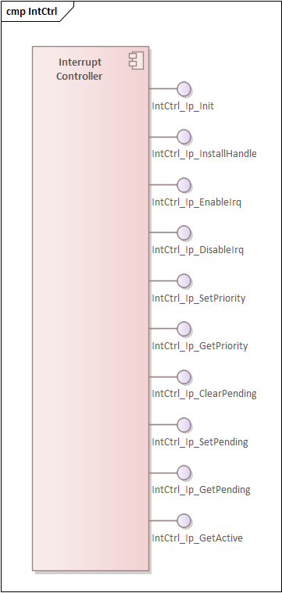

      - IntCtrl_Ip_Init
Prototype:
IntCtrl_Ip_StatusType IntCtrl_Ip_Init(const IntCtrl_Ip_CtrlConfigType *pIntCtrlCtrlConfig);

Description:
/**
* @brief Initializes the configured interrupts at interrupt controller level.
*
* @details This function is non-reentrant and initializes the interrupts.
*
* @param[in] pIntCtrlCtrlConfig: pointer to configuration structure for interrupts.
* @return IntCtrl_Ip_StatusType: error code.
*
* @api
*
* */

      - IntCtrl_Ip_InstallHandler
Prototype:
void IntCtrl_Ip_InstallHandler(IRQn_Type eIrqNumber,
const IntCtrl_Ip_IrqHandlerType pfNewHandler,
IntCtrl_Ip_IrqHandlerType* const pfOldHandler);

Description:
/**
* @brief Installs a handler for an IRQ.
*
* @details This function is non-reentrant; it installs an new ISR for an interrupt line.
* @note This function works only when the interrupt vector table resides in RAM.
*
* @param[in] eIrqNumber: interrupt number.
* @param[in] pfNewHandler: function pointer for the new handler.
* @param[out] pfOldHandler: stores the address of the old interrupt handler.
* @return void.
*
* @api
*
* */

      - IntCtrl_Ip_EnableIrq
Prototype:
void IntCtrl_Ip_EnableIrq(IRQn_Type eIrqNumber);

Description:
/**
* @brief Enables an interrupt request.
*
* @details This function is non-reentrant; it enables the interrupt request at
* interrupt controller level.
*
* @param[in] eIrqNumber: interrupt number to be enabled.
* @return void.
*
* @api
*
* */

      - IntCtrl_Ip_DisableIrq
Prototype:
void IntCtrl_Ip_DisableIrq(IRQn_Type eIrqNumber);

Description:
/**
* @brief Disables an interrupt request.
*
* @details This function is non-reentrant; it disables the interrupt request at
* interrupt controller level.
*
* @param[in] eIrqNumber: interrupt number to be disabled.
* @return void.
*
* @api
*
* */

      - IntCtrl_Ip_SetPriority
Prototype:
void IntCtrl_Ip_SetPriority(IRQn_Type eIrqNumber, uint8 u8Priority);

Description:
/**
* @brief Sets the priority for an interrupt request.
*
* @details This function is non-reentrant; it sets the priority for the
* interrupt request.
*
* @param[in] eIrqNumber: interrupt number for which the priority is set.
* @param[in] u8Priority: the priority to be set.
* @return void.
*
* @api
*
* */

      - IntCtrl_Ip_GetPriority
Prototype:
uint8 IntCtrl_Ip_GetPriority(IRQn_Type eIrqNumber);

Description:
/**
* @brief Gets the priority for an interrupt request.
*
* @details This function is non-reentrant; it retrieves the priority for the
* interrupt request.
*
* @param[in] eIrqNumber: interrupt number for which the priority is set.
* @return uint8: the priority of the interrupt.
*
* @api
*
* */

      - IntCtrl_Ip_ClearPending
Prototype:
void IntCtrl_Ip_ClearPending(IRQn_Type eIrqNumber);

Description:
/**
* @brief Clears the pending flag for an interrupt request.
*
* @details This function is reentrant; it clears the pending flag for the
* interrupt request.
*
* @param[in] eIrqNumber: interrupt number for which the pending flag is cleared.
* @return void.
*
* @api
*
* */

      - IntCtrl_Ip_SetPending
Prototype:
void IntCtrl_Ip_SetPending(IRQn_Type eIrqNumber);

Description:
/**
* @brief Sets the pending flag for an interrupt request.
*
* @details This function is reentrant; it sets the pending flag for the
* interrupt request.
*
* @param[in] eIrqNumber: interrupt number for which the pending flag is set.
* @return void.
*
* @api
*
* */

      - IntCtrl_Ip_GetPending
Prototype:
boolean IntCtrl_Ip_GetPending(IRQn_Type eIrqNumber);

Description:
/**
* @brief Gets the pending flag for an interrupt request.
*
* @details This function is reentrant; it retrieves the pending flag for the
* interrupt request.
*
* @param[in] eIrqNumber: interrupt number for which the pending flag is returned.
* @return boolean: TRUE - pending flag set, FALSE - pending flag cleared.
*
* @api
*
* */

      - IntCtrl_Ip_GetActive
Prototype:
boolean IntCtrl_Ip_GetActive(IRQn_Type eIrqNumber);

Description:
/**
* @brief Gets the active flag for an interrupt request.
*
* @details This function is reentrant; it retrieves the active flag for the
* interrupt request.
*
* @param[in] eIrqNumber: interrupt number for which the active flag is returned.
* @return boolean: TRUE - active flag set, FALSE - active flag cleared.
*
* @api
*
* */

    - Low-Power SPI (LPSPI)
Below is an illustration of the LPSPI component provided interfaces:

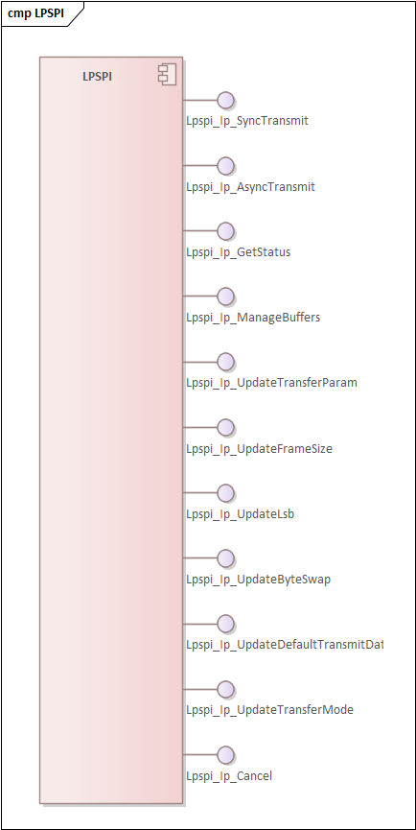

      - Lpspi_Ip_SyncTransmit
Prototype:
Lpspi_Ip_StatusType Lpspi_Ip_SyncTransmit(const Lpspi_Ip_ExternalDeviceType *ExternalDevice,
const uint8 *TxBuffer,
uint8 *RxBuffer,
uint16 Length,
uint32 TimeOut);

Description:
/**
* @brief LPSPI synchronous transmission.
* @details This function initializes a synchronous transfer using the bus parameters provided
* by external device.
*
* @param[in] ExternalDevice - pointer to the external device where data is transmitted.
* @param[in] TxBuffer - pointer to transmit buffer.
* @param[in,out] RxBuffer - pointer to receive buffer.
* @param[in] Length - number of bytes to be sent.
* @param[in] TimeOut - duration for sending one frame.
*
* @return LPSPI_IP_STATUS_SUCCESS: Transmission command has been accepted.
* LPSPI_IP_FIFO_ERROR: Overflow or underflow error occurred.
* LPSPI_IP_STATUS_FAIL: Transmission command has not been accepted.
* LPSPI_IP_TIMEOUT: Timeout error occurred.
*
* @implements Lpspi_Ip_SyncTransmit_Activity
*/

      - Lpspi_Ip_AsyncTransmit
Prototype:
Lpspi_Ip_StatusType Lpspi_Ip_AsyncTransmit(const Lpspi_Ip_ExternalDeviceType *ExternalDevice,
const uint8 *TxBuffer,
uint8 *RxBuffer,
uint16 Length,
Lpspi_Ip_CallbackType EndCallback);

Description:
/**
* @brief LPSPI asynchronous transmission.
* @details This function initializes an asynchronous transfer using the bus parameters provided
* by external device. After Lpspi_Ip_Init function is called, LPSPI_IP_POLLING
* mode is set as default to change the default mode Lpspi_Ip_UpdateTransferMode should be called.
*
* @param[in] ExternalDevice - pointer to the external device where data is transmitted
* @param[in] TxBuffer - pointer to transmit buffer.
* @param[in,out] RxBuffer - pointer to receive buffer.
* @param[in] Length - number of bytes to be sent.
* @param[in] EndCallback - callback function is called at the end of transfer.
*
* @return LPSPI_IP_STATUS_SUCCESS: Transmission command has been accepted.
* LPSPI_IP_STATUS_FAIL: Transmission command has not been accepted.
* @implements Lpspi_Ip_AsyncTransmit_Activity
*/

      - Lpspi_Ip_GetStatus
Prototype:
Lpspi_Ip_HwStatusType Lpspi_Ip_GetStatus(uint8 Instance);

Description:
/**
* @brief Get status of HW unit.
* @details This function returns the status of the specified SPI Hardware microcontroller peripheral.
*
* @param[in] Instance - SPI peripheral instance number.
*
* @return Lpspi_Ip_HwStatusType
* @implements Lpspi_Ip_GetStatus_Activity
*/

      - Lpspi_Ip_ManageBuffers
Prototype:
void Lpspi_Ip_ManageBuffers(uint8 Instance);

Description:
/**
* @brief Process transfer in POLLING mode.
* @details This function shall polls the SPI interrupts linked to SPI peripheral instance allocated to
* the transmission of data to enable the evolution of transmission state machine.
*
* @param[in] Instance - SPI peripheral instance number.
* @implements Lpspi_Ip_ManageBuffers_Activity
*/

      - Lpspi_Ip_UpdateTransferParam
Prototype:
Lpspi_Ip_StatusType Lpspi_Ip_UpdateTransferParam(const Lpspi_Ip_ExternalDeviceType *ExternalDevice,
const Lpspi_Ip_TransferAdjustmentType *Param);

Description:
/**
* @brief Adjust transfer based on external conditions
* @details Use parameters to improve transfer
*
* @param[in] ExternalDevice - External device where data is transmitted
* @param[in] Param - Parameter with adjustments
*
* @return LPSPI_IP_STATUS_SUCCESS: Setting command has been accepted.
* LPSPI_IP_STATUS_FAIL: Setting command has not been accepted.
*/

      - Lpspi_Ip_UpdateFrameSize
Prototype:
Lpspi_Ip_StatusType Lpspi_Ip_UpdateFrameSize(const Lpspi_Ip_ExternalDeviceType *ExternalDevice,
uint16 FrameSize);

Description:
/**
* @brief LPSPI change frame size.
* @details This function updates frame size of specific external device configuration for next transfers.
*
* @param[in] ExternalDevice - pointer to the external device configuration.
* @param[in] FrameSize - Frame size.
*
* @return LPSPI_IP_STATUS_SUCCESS: Setting command has been accepted.
* LPSPI_IP_STATUS_FAIL: Setting command has not been accepted.
* @implements Lpspi_Ip_UpdateFrameSize_Activity
*/

      - Lpspi_Ip_UpdateLsb
Prototype:
Lpspi_Ip_StatusType Lpspi_Ip_UpdateLsb(const Lpspi_Ip_ExternalDeviceType *ExternalDevice,
boolean Lsb);

Description:
/**
* @brief LPSPI change bit order.
* @details This function updates bits order LSB or MSB of specific external device configuration for next transfer.
*
* @param[in] ExternalDevice - pointer to the external device configuration.
* @param[in] Lsb - Data is transferred LSB first or not.
*
* @return LPSPI_IP_STATUS_SUCCESS: Setting command has been accepted.
* LPSPI_IP_STATUS_FAIL: Setting command has not been accepted.
* @implements Lpspi_Ip_UpdateLsb_Activity
*/

      - Lpspi_Ip_UpdateByteSwap
Prototype:
Lpspi_Ip_StatusType Lpspi_Ip_UpdateByteSwap(const Lpspi_Ip_ExternalDeviceType *ExternalDevice,
boolean ByteSwap);

Description:
/**
* @brief LPSPI change byte swap.
* @details This function updates to enable byte swap on each 32-bit word when transmitting and receiving
data.
*
* @param[in] ExternalDevice - pointer to the external device configuration.
* @param[in] ByteSwap - Data is transferred with byte swap feature or not.
*
* @return LPSPI_IP_STATUS_SUCCESS: Setting command has been accepted.
* LPSPI_IP_STATUS_FAIL: Setting command has not been accepted.
* @implements Lpspi_Ip_UpdateByteSwap_Activity
*/

      - Lpspi_Ip_UpdateDefaultTransmitData
Prototype:
Lpspi_Ip_StatusType Lpspi_Ip_UpdateDefaultTransmitData(const Lpspi_Ip_ExternalDeviceType *ExternalDevice,
uint32 DefaultData);

Description:
/**
* @brief LPSPI change default transmit data.
* @details This function updates default transmit data of specific external device configuration for next transfer.
*
* @param[in] ExternalDevice - pointer to the external device configuration.
* @param[in] DefaultData - New default transmit data.
*
* @return LPSPI_IP_STATUS_SUCCESS: Setting command has been accepted.
* LPSPI_IP_STATUS_FAIL: Setting command has not been accepted.
* @implements Lpspi_Ip_UpdateDefaultTransmitData_Activity
*/

      - Lpspi_Ip_UpdateTransferMode
Prototype:
Lpspi_Ip_StatusType Lpspi_Ip_UpdateTransferMode(uint8 Instance,
Lpspi_Ip_ModeType Mode);

Description:
/**
* @brief LPSPI change transfer mode.
* @details This function updates the asynchronous mechanism mode for the specified SPI Hardware microcontroller peripheral.
*
* @param[in] Instance - SPI peripheral instance number.
* @param[in] Mode - new mode (interrupt or polling).
*
* @return LPSPI_IP_STATUS_SUCCESS: Setting command has been accepted.
* LPSPI_IP_STATUS_FAIL: Setting command has not been accepted.
* @implements Lpspi_Ip_UpdateTransferMode_Activity
*/

      - Lpspi_Ip_Cancel
Prototype:
void Lpspi_Ip_Cancel(uint8 Instance);

Description:
/**
* @brief LPSPI cancel current asynchronous transmission.
* @details This function cancels an asynchronous transmission in progress for the specified SPI Hardware microcontroller peripheral.
*
* @param[in] Instance - SPI peripheral instance number.
* @implements Lpspi_Ip_Cancel_Activity
*/

    - System Integration Unit Lite2 (SIUL2)
Below is an illustration of the provided interfaces for the SIUL2 component:

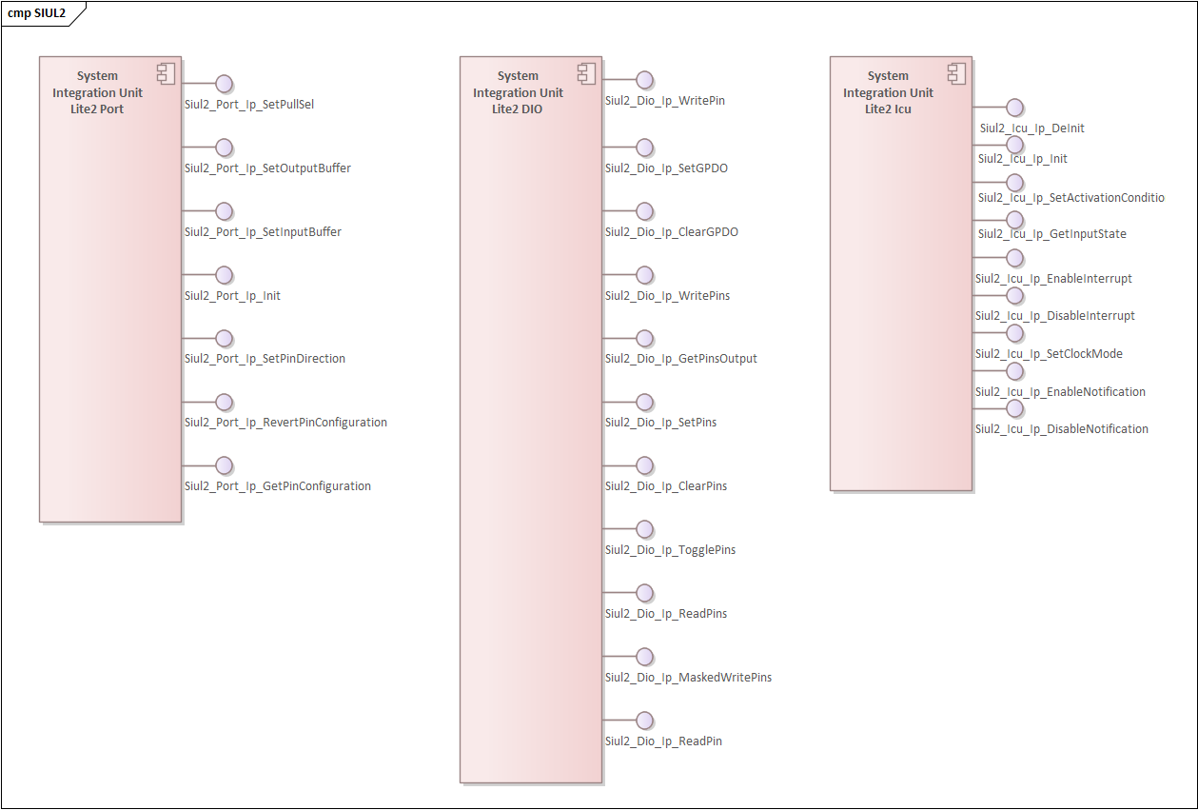

      - Siul2_Port_Ip_SetPullSel
Prototype:
void Siul2_Port_Ip_SetPullSel(Siul2_Port_Ip_PortType * const base,
uint16 pin,
Siul2_Port_Ip_PortPullConfig pullConfig);

Description:
/*!
* @brief Configures the internal resistor.
*
* This function configures the internal resistor.
*
* @param[in] base Port base pointer (PORTA, PORTB, PORTA_AE, etc.)
* @param[in] pin Port pin number
* @param[in] pullConfig The pull configuration
*/

      - Siul2_Port_Ip_SetOuptutBuffer
Prototype:
void Siul2_Port_Ip_SetOutputBuffer(Siul2_Port_Ip_PortType * const base,
uint16 pin,
boolean enable,
Siul2_Port_Ip_PortMux mux);

Description:
/*!
* @brief Configures the output buffer and output signal.
*
* This function configures the output buffer for the pin
* and the path for output signal from module to pin
*
* @param[in] base Port base pointer (PORTA, PORTB, PORTA_AE, etc.)
* @param[in] pin Port pin number
* @param[in] enable Enable output buffer
* @param[in] mux Pin muxing slot selection
*/

      - Siul2_Port_Ip_SetInputBuffer
Prototype:
void Siul2_Port_Ip_SetInputBuffer(Siul2_Port_Ip_PortType * const base,
uint16 pin,
boolean enable,
uint32 inputMuxReg,
Siul2_Port_Ip_PortInputMux inputMux);

Description:
/*!
* @brief Configures the input buffer and input signal.
*
* This function configures the input buffer for the pin
* and the path for input signal from pin to module
*
* @param[in] base Port base pointer (PORTA, PORTB, PORTA_AE, etc.),
* NULL if disabling inputMux only
* @param[in] pin Port pin number
* @param[in] enable Enable input buffer
* @param[in] inputMuxReg Pin muxing register slot selection
* @param[in] inputMux Pin muxing slot selection
*
* @note: There are some pins controlled by both SIUL2_0, SIUL2_1, SIUL2_3, SIUL2_4 and SIUL2_5 instances
* In order to configure correctly and be consistent with other platforms, the
* inputMuxReg parameter of SIUL2_3 instance must be added 512 units.
* For example: The actual inputMuxReg is 10 then the value there must be (10 + 512)
*/

      - Siul2_Port_Ip_Init
Prototype:
Siul2_Port_Ip_PortStatusType Siul2_Port_Ip_Init(uint32 pinCount,
const Siul2_Port_Ip_PinSettingsConfig config[]);

Description:
/*!
* @brief Initializes the pins with the given configuration structure
*
* This function configures the pins with the options provided in the
* provided structure.
*
* @param[in] pinCount The number of configured pins in structure
* @param[in] config The configuration structure
* @return The status of the operation
*/

      - Siul2_Port_Ip_SetPinDirection
Prototype:
void Siul2_Port_Ip_SetPinDirection(Siul2_Port_Ip_PortType * const base,
uint16 pin,
Siul2_Port_Ip_PortDirectionType direction);

Description:
/*!
* @brief Configures the pin with the values form the configuration structure
*
* This function configures the pin configuration with the values form the configuration structure
*
* @param[in] base Port base pointer
* @param[in] pin Port pin number
* @param[in] direction The direction of pin
* @return void
*/

      - Siul2_Port_Ip_RevertPinConfiguration
Prototype:
uint32 Siul2_Port_Ip_RevertPinConfiguration(const Siul2_Port_Ip_PortType * const base,
uint16 pin);

Description:
/*!
* @brief This function configures the pin configuration with the values from the configuration structure
*
* This function configures the pin configuration with the values from the configuration structure
*
* @param[in] base Port base pointer
* @param[in] pin Port pin number
* @return MSCR register value
*/

      - Siul2_Port_Ip_GetPinConfiguration
Prototype:
void Siul2_Port_Ip_GetPinConfiguration(const Siul2_Port_Ip_PortType * const base,
Siul2_Port_Ip_PinSettingsConfig * config,
uint16 pin);

Description:
/*!
* @brief This function shall return the value of the pin configuration register.
*
* This function shall return the value of the pin configuration register.
*
* @param[in] base Port base pointer
* @param[in] pin Port pin number
* @param[out] config->pointer to output configuration structure information
* @return MSCR register value
*/

      - Siul2_Dio_Ip_WritePin
Prototype:
void Siul2_Dio_Ip_WritePin(Siul2_Dio_Ip_GpioType * const base,
Siul2_Dio_Ip_PinsChannelType pin,
Siul2_Dio_Ip_PinsLevelType value);

Description:
/*!
* @brief Write a pin of a port with a given value
*
* This function writes the given pin from a port, with the given value
* ('0' represents LOW, '1' represents HIGH).
*
* @param base GPIO base pointer (PTA, PTB, PTC, etc.)
* @param pin pin number to be written
* @param value pin value to be written
* - 0: corresponding pin is set to LOW
* - 1: corresponding pin is set to HIGH
*/

      - Siul2_Dio_Ip_SetGPDO
Prototype:
void Siul2_Dio_Ip_SetGPDO(const uint8 u8Siul2Instance,
const uint16 GPDOnum);

Description:
/*!
* @brief Write the GPDO register a pin of a port with a given value
*
* This function sets the GPDO register for a given Siul2 Instance and GPDO register number
*
* @param u8Siul2Instance number of Siul2Instance
* @param GPDOnum number of GPDO
*/

      - Siul2_Dio_Ip_ClearGPDO
Prototype:
void Siul2_Dio_Ip_ClearGPDO(const uint8 u8Siul2Instance,
const uint16 GPDOnum);

Description:
/**
* @brief LPSPI cancel current asynchronous transmission.
* @details This function cancels an asynchronous transmission in progress for the specified SPI Hardware microcontroller peripheral.
*
* @param[in] Instance - SPI peripheral instance number.
* @implements Lpspi_Ip_Cancel_Activity
*/

      - Siul2_Dio_Ip_WritePins
Prototype:
void Siul2_Dio_Ip_WritePins(Siul2_Dio_Ip_GpioType * const base,
Siul2_Dio_Ip_PinsChannelType pins);

Description:
/*!
* @brief Write all pins of a port
*
* This function writes all pins configured as output with the values given in
* the parameter pins. '0' represents LOW, '1' represents HIGH.
*
* @param[in] base GPIO base pointer (PTA, PTB, PTC, etc.)
* @param[in] pins Pin mask to be written
* - 0: corresponding pin is set to LOW
* - 1: corresponding pin is set to HIGH
*/

      - Siul2_Dio_Ip_GetPinsOutput
Prototype:
Siul2_Dio_Ip_PinsChannelType Siul2_Dio_Ip_GetPinsOutput(const Siul2_Dio_Ip_GpioType * const base);

Description:
/*!
* @brief Get the current output from a port
*
* This function returns the current output that is written to a port. Only pins
* that are configured as output will have meaningful values.
*
* @param[in] base GPIO base pointer (PTA, PTB, PTC, etc.)
* @return GPIO outputs. Each bit represents one pin (LSB is pin 0, MSB is pin
* 31). For each bit:
* - 0: corresponding pin is set to LOW
* - 1: corresponding pin is set to HIGH
*/

      - Siul2_Dio_Ip_SetPins
Prototype:
void Siul2_Dio_Ip_SetPins(Siul2_Dio_Ip_GpioType * const base,
Siul2_Dio_Ip_PinsChannelType pins);

Description:
/*!
* @brief Write pins with 'Set' value
*
* This function configures output pins listed in parameter pins (bits that are
* '1') to have a value of 'set' (HIGH). Pins corresponding to '0' will be
* unaffected.
*
* @param[in] base GPIO base pointer (PTA, PTB, PTC, etc.)
* @param[in] pins Pin mask of bits to be set. Each bit represents one pin (LSB is
* pin 0, MSB is pin 31). For each bit:
* - 0: corresponding pin is unaffected
* - 1: corresponding pin is set to HIGH
*/

      - Siul2_Dio_Ip_ClearPins
Prototype:
void Siul2_Dio_Ip_ClearPins(Siul2_Dio_Ip_GpioType * const base,
Siul2_Dio_Ip_PinsChannelType pins);

Description:
/*!
* @brief Write pins to 'Clear' value
*
* This function configures output pins listed in parameter pins (bits that are
* '1') to have a 'cleared' value (LOW). Pins corresponding to '0' will be
* unaffected.
*
* @param[in] base GPIO base pointer (PTA, PTB, PTC, etc.)
* @param[in] pins Pin mask of bits to be cleared. Each bit represents one pin (LSB
* is pin 0, MSB is pin 31). For each bit:
* - 0: corresponding pin is unaffected
* - 1: corresponding pin is cleared(set to LOW)
*/

      - Siul2_Dio_Ip_TogglePins
Prototype:
void Siul2_Dio_Ip_TogglePins(Siul2_Dio_Ip_GpioType * const base,
Siul2_Dio_Ip_PinsChannelType pins);

Description:
/*!
* @brief Toggle pins value
*
* This function toggles output pins listed in parameter pins (bits that are
* '1'). Pins corresponding to '0' will be unaffected.
*
* @param[in] base GPIO base pointer (PTA, PTB, PTC, etc.)
* @param[in] pins Pin mask of bits to be toggled. Each bit represents one pin (LSB
* is pin 0, MSB is pin 31). For each bit:
* - 0: corresponding pin is unaffected
* - 1: corresponding pin is toggled
*/

      - Siul2_Dio_Ip_ReadPins
Prototype:
Siul2_Dio_Ip_PinsChannelType Siul2_Dio_Ip_ReadPins(const Siul2_Dio_Ip_GpioType * const base);

Description:
/*!
* @brief Read input pins
*
* This function returns the current input values from a port. Only pins
* configured as input will have meaningful values.
*
* @param[in] base GPIO base pointer (PTA, PTB, PTC, etc.)
* @return GPIO inputs. Each bit represents one pin (LSB is pin 0, MSB is pin
* 31). For each bit:
* - 0: corresponding pin is read as LOW
* - 1: corresponding pin is read as HIGH
*/

      - Siul2_Dio_Ip_MaskedWritePins
Prototype:
void Siul2_Dio_Ip_MaskedWritePins(uint8 u8Siul2Instance,
uint8 u8PortId,
Siul2_Dio_Ip_PinsChannelType pins,
Siul2_Dio_Ip_PinsChannelType mask);

Description:
/*!
* @brief Write Port using MPGPDO
*
* This function writes the masked pins configured as output with the values given in the parameter pins.
* '0' represents LOW, '1' represents HIGH.
*
* @param[in] u8Siul2Instance: instance number
* @param[in] u8PortId: id of port need to be written (corresponds with index number of GPIO base (0-PTA, 1-PTB, etc))
* @param[in] pins: Pin mask of bits to be cleared. Each bit represents one pin (LSB is pin 0, MSB is pin 31). For each bit: 0: corresponding
* pin is unaffected. 1: corresponding pin is cleared(set to LOW).
* @param[in] mask: mask for the affected pins
* @return none
*/

      - Siul2_Dio_Ip_ReadPin
Prototype:
Siul2_Dio_Ip_PinsLevelType Siul2_Dio_Ip_ReadPin(const Siul2_Dio_Ip_GpioType * const base,
Siul2_Dio_Ip_PinsChannelType pin);

Description:
/*!
* @brief Read input pin
*
* This function returns the current input value of the given pin from port. Only pin
* configured as input will have meaningful value.
*
* @param[in] base GPIO base pointer (PTA, PTB, PTC, etc.)
* @param[in] pin Pin index (0,1,2,3,..,15)
* @return GPIO input value for coressponding pin
* - 0: corresponding pin is read as LOW
* - 1: corresponding pin is read as HIGH
*/

      - Siul2_Icu_Ip_DeInit
Prototype:
Siul2_Icu_Ip_StatusType Siul2_Icu_Ip_DeInit(uint8 instance);

Description:
/**
* @brief Driver function that de-initializes SIUL hardware channel.
* @details This function:
* - Restore to reset values SIUL2 registers used on init.
*
* @param[in] instance - Instance number used
* @return Siul2_Icu_Ip_StatusType - The status of DeInit
*/

      - Siul2_Icu_Ip_Initi
Prototype:
Siul2_Icu_Ip_StatusType Siul2_Icu_Ip_Init(uint8 instance, const Siul2_Icu_Ip_ConfigType* userConfig);

Description:
/**
* @brief Driver function that de-initializes SIUL hardware channel.
* @details This function:
* - Restore to reset values SIUL2 registers used on init.
*
* @param[in] instance - Instance number used
* @return Siul2_Icu_Ip_StatusType - The status of DeInit
*/

      - Siul2_Icu_Ip_SetActivationCondition
Prototype:
void Siul2_Icu_Ip_SetActivationCondition(uint8 instance, uint8 hwChannel, Siul2_Icu_Ip_EdgeType edge);

Description:
/**
* @brief
* @details This function enables the requested activation condition (rising, falling or both
* edges) for corresponding SIUL2 channels.
*
* @param[in] instance Hardware instance of SIUL2 used.
* @param[in] hwChannel Hardware channel of SIUL2 used.
* @param[in] edge Edge activation type used.
*/

      - Siul2_Icu_Ip_GetInputState
Prototype:
boolean Siul2_Icu_Ip_GetInputState(uint8 instance, uint8 hwChannel);
Description:
/**
* @brief ICU driver function that sets activation condition of SIUL2 channel.
*
* @param[in] instance Hardware instance of SIUL2 used.
* @param[in] hwChannel Hardware channel of SIUL2 used.
* @return boolean Input state.
*/

      - Siul2_Icu_Ip_Enable Interrupt
Prototype:
void Siul2_Icu_Ip_EnableInterrupt(uint8 instance, uint8 hwChannel);
Description:
/**
* @brief ICU driver function that enables the interrupt of SIUL2 channel.
* @details This function enables SIUL2 Channel Interrupt.
*
* @param[in] instance Hardware instance of SIUL2 used.
* @param[in] hwChannel Hardware channel of SIUL2 used.
* @return void
*/

      - Siul2_Icu_Ip_DisableInterrupt
Prototype:
void Siul2_Icu_Ip_DisableInterrupt(uint8 instance, uint8 hwChannel);
Description:
/**
* @brief ICU driver function that disables the interrupt of SIUL2 channel.
* @details This function disables SIUL2 Channel Interrupt.
*
* @param[in] instance Hardware instance of SIUL2 used.
* @param[in] hwChannel Hardware channel of SIUL2 used.
* @return void
*/

      - Siul2_Icu_Ip_SetClockMode
Prototype:
void Siul2_Icu_Ip_SetClockMode(uint8 instance, Siul2_Icu_Ip_ClockModeType mode);
Description:
/**
* @brief Icu driver function used to set the global prescaler of a SIUL2 module.
* @details This function:
* - Sets IFCPR register with a prescaler value
*
* @param[in] instance Hardware instance of SIUL2 used.
* @param[in] mode Global prescaler for the SIUL2 module.
* @return void
*/

      - Siul2_Icu_Ip_EnableNotification
Prototype:
void Siul2_Icu_Ip_EnableNotification(uint8 instance, uint8 hwChannel);
Description:
/**
* @brief Driver function Enable Notification for timestamp.
*
* @param[in] instance Hardware instance of FTM used.
* @param[in] hwChannel Hardware channel of FTM used.
* @return void
*/

      - Siul2_Icu_Ip_DisableNotification
Prototype:
void Siul2_Icu_Ip_DisableNotification(uint8 instance, uint8 hwChannel);

Description:
/**
* @brief Driver function Disable Notification for timestamp.
*
* @param[in] instance Hardware instance of FTM used.
* @param[in] hwChannel Hardware channel of FTM used.
* @return void
*/

    - ADC Successive Approximation Register (SAR)
Below is an illustration of the provided interfaces for the ADC SAR component:

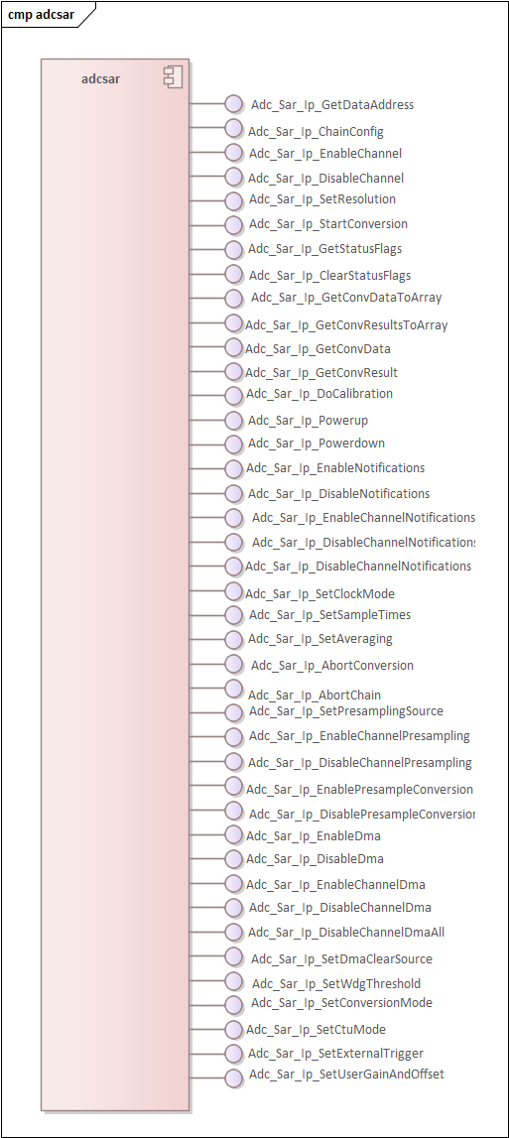

      - Adc_Sar_Ip_GetDataAddress
Prototype:
uint32 Adc_Sar_Ip_GetDataAddress(uint32 u32Instance,
uint32 u32ChannelIndex);

Description:
/*!
* @brief Return the address of the specified data register
*
* This function returns the address of the specified data register
*
* @param[in] u32Instance - ADC instance number
* @param[in] u32ChannelIndex - adc channel of the Hw unit
* @return status:
* - value of the address of the data for the specified channel
*/

      - Adc_Sar_Ip_ChainConfig
Prototype:
void Adc_Sar_Ip_ChainConfig(const uint32 u32Instance,
const Adc_Sar_Ip_ChansIdxMaskType * const pChansIdxMask,
const Adc_Sar_Ip_ConvChainType pChainType);

Description:
/*!
* @brief Configures the converter chains the given configuration structure
*
* This function configures the ADC Normal and Injected Chains with the options
* provided in the structure.
*
* @param[in] u32Instance - ADC instance number
* @param[in] pChansIdxMask - channel configuration structure
* @param[in] pChainType - conversion chain (Normal or Injected)
* @return void
*/

      - Adc_Sar_Ip_EnableChannel
Prototype:
void Adc_Sar_Ip_EnableChannel(const uint32 u32Instance,
const Adc_Sar_Ip_ConvChainType pChainType,
const uint32 u32ChnIdx);

Description:
/*!
* @brief Enable a channel
*
* This function enables a channel in a specified conversion chain
*
* @param[in] u32Instance - ADC instance number
* @param[in] pChainType - conversion chain (Normal or Injected)
* @param[in] u32ChnIdx - channel index(channel number in the RM)
* @return void
*/

      - Adc_Sar_Ip_DisableChannel
Prototype:
void Adc_Sar_Ip_DisableChannel(const uint32 u32Instance,
const Adc_Sar_Ip_ConvChainType pChainType,
const uint32 u32ChnIdx);

Description:
/*!
* @brief Disable a channel
*
* This function disables a channel in a specified conversion chain
*
* @param[in] u32Instance - ADC instance number
* @param[in] pChainType - conversion chain (Normal or Injected)
* @param[in] u32ChnIdx - channel index(channel number in the RM)
* @return void
*/

      - Adc_Sar_Ip_SetResolution
Prototype:
void Adc_Sar_Ip_SetResolution(const uint32 u32Instance,
const Adc_Sar_Ip_Resolution eResolution);

Description:
/*!
* @brief Set conversion resolution
*
* This function sets the conversion resolution (number of bits per conversion data)
*
* @param[in] u32Instance - ADC instance number
* @param[in] eResolution - conversion resolution
* @return void
*/

      - Adc_Sar_Ip_StartConversion
Prototype:
void Adc_Sar_Ip_StartConversion(const uint32 u32Instance,
const Adc_Sar_Ip_ConvChainType pChainType);

Description:
/*!
* @brief Start conversion
*
* This function starts a conversion channel (Normal or Injected)
*
* @param[in] u32Instance - ADC instance number
* @param[in] pChainType - conversion chain (Normal or Injected)
* @return void
*/

      - Adc_Sar_Ip_GetStatusFlags
Prototype:
uint32 Adc_Sar_Ip_GetStatusFlags(const uint32 u32Instance);

Description:
/*!
* @brief Get the status flags
*
* This function returns the status flags of the ADC.
*
* @param[in] u32Instance - ADC instance number
* @return the status flag bit-mask
*/

      - Adc_Sar_Ip_ClearStatusFlags
Prototype:
void Adc_Sar_Ip_ClearStatusFlags(const uint32 u32Instance,
const uint32 u32Mask);

Description:
/*!
* @brief Clear the status flags
*
* This function clears the status flags of the ADC.
*
* @param[in] u32Instance - ADC instance number
* @param[in] u32Mask - bit-mask of flags to clear
* @return void
*/

      - Adc_Sar_Ip_GetConvDataToArray
Prototype:
uint32 Adc_Sar_Ip_GetConvDataToArray(const uint32 u32Instance,
const Adc_Sar_Ip_ConvChainType pChainType,
const uint32 u32Length,
uint16 * const pResults);

Description:
/*!
* @brief Get conversion results for a conversion chain
*
* This function gets the conversion results for the selected Conversion Chain.
*
* @param[in] u32Instance - ADC instance numberAdc_Sar_Ip_DoCalibration
* @param[in] pChainType - conversion chain (Normal, Injected or CTU)
* @param[in] u32Length - the length of the buffer
* @param[out] pResults - the output buffer
* @return the number of values written in the buffer (max length)
*/

      - Adc_Sar_Ip_GetConvResultsToArray
Prototype:
uint32 Adc_Sar_Ip_GetConvResultsToArray(const uint32 u32Instance,
const Adc_Sar_Ip_ConvChainType pChainType,
const uint32 u32Length,
Adc_Sar_Ip_ChanResultType * const pResults);

Description:
/*!
* @brief Get conversion results for a conversion chain with extended information
*
* This function gets the conversion results for the selected Conversion Chain, with
* extended information about each conversion result (channel index, valid an overwritten
* properties and conversion data). This function should be used in case of configurations
* with overlapping channel lists in different chains, resulting in overwrite of conversion
* data when a higher priority chain is executed before all data was read.
*
* @param[in] u32Instance - ADC instance number
* @param[in] pChainType - conversion chain (Normal, Injected or CTU)
* @param[in] u32Length - the length of the buffer
* @param[out] pResults - the output buffer
* @return the number of values written in the buffer (max length)
*/

      - Adc_Sar_Ip_GetConvData
Prototype:
uint16 Adc_Sar_Ip_GetConvData(const uint32 u32Instance,
const uint32 u32ChnIdx);

Description:
/*!
* @brief Return the result of the conversion
*
* This function returns the result of the conversion for a single channel
*
* @param [in] u32Instance - ADC instance number
* @param [in] u32ChnIdx - channel index(channel number in the RM)
* @return conversion data
*/

      - Adc_Sar_Ip_GetConvResult
Prototype:
void Adc_Sar_Ip_GetConvResult(const uint32 u32Instance,
const uint32 u32ChnIdx,
const Adc_Sar_Ip_ConvChainType pChainType,
Adc_Sar_Ip_ChanResultType * const pResult);

Description:
/*!
* @brief Return the result and the status of the conversion
*
* This function returns the result and the status of the conversion
* for a single channel
*
* @param [in] u32Instance - ADC instance number
* @param [in] u32ChnIdx - channel index(channel number in the RM)
* @param [in] pChainType - conversion chain (Normal, Injected or CTU)
* @param [out] pResult - pointer to the buffer where the result will be written
* @return void
*/

      - Adc_Sar_Ip_DoCalibration
Prototype:
Adc_Sar_Ip_StatusType Adc_Sar_Ip_DoCalibration(const uint32 u32Instance);

Description:
/*!
* @brief Perform Calibration of the ADC
*
* This function performs a calibration of the ADC. The maximum input clock
* frequency for the ADC is 80 MHz, checked with assertions if DEV_ASSERT is
* enabled. After calibration, the ADC is left in Powerup state (PWDN bit is clear).
* Note: If asynchronous calibration mode is enabled and a calibration is started,
* other APIs should not be called until the calibration is complete.
*
* @param[in] u32Instance - ADC instance number
* @return the calibration result
* - ADC_SAR_IP_STATUS_SUCCESS: calibration successful
* - ADC_SAR_IP_STATUS_TIMEOUT: calibration step timed out
* - ADC_SAR_IP_STATUS_ERROR: calibration failed
* - ADC_SAR_IP_STATUS_CAL_ONGOING: calibration is ongoing (if async mode is active)
*/

      - Adc_Sar_Ip_Powerup
Prototype:
Adc_Sar_Ip_StatusType Adc_Sar_Ip_Powerup(const uint32 u32Instance);

Description:
/*!
* @brief Power up the ADC
*
* This function enables the ADC (disables the Power Down feature).
*
* @param[in] u32Instance - ADC instance number
* @return status:
* - ADC_SAR_IP_STATUS_SUCCESS: power up successful
* - ADC_SAR_IP_STATUS_TIMEOUT: power up failed
*/

      - Adc_Sar_Ip_Powerdown
Prototype:
Adc_Sar_Ip_StatusType Adc_Sar_Ip_Powerdown(const uint32 u32Instance);

Description:
/*!
* @brief Power down the ADC
*
* This function disables the ADC (enables the Power Down feature).
*
* @param[in] u32Instance - ADC instance number
* @return status:
* - ADC_SAR_IP_STATUS_SUCCESS: power down successful
* - ADC_SAR_IP_STATUS_TIMEOUT: power down failed
*/

      - Adc_Sar_Ip_EnableNotifications
Prototype:
void Adc_Sar_Ip_EnableNotifications(const uint32 u32Instance,
const uint32 u32NotificationMask);

Description:
/*!
* @brief Enable ADC interrupts
*
* This function enables ADC interrupts.
*
* @param[in] u32Instance - ADC instance number
* @param[in] u32NotificationMask - mask of interrupts to enable (of status flags)
* @return void
*/

      - Adc_Sar_Ip_DisableNotifications
Prototype:
void Adc_Sar_Ip_DisableNotifications(const uint32 u32Instance,
const uint32 u32NotificationMask);

Description:
/*!
* @brief Disable ADC interrupts
*
* This function disables ADC interrupts.
*
* @param[in] u32Instance - ADC instance number
* @param[in] u32NotificationMask - mask of interrupts to disable (of status flags)
* @return void
*/

      - Adc_Sar_Ip_EnableChannelNotifications
Prototype:
void Adc_Sar_Ip_EnableChannelNotifications(const uint32 u32Instance,
const uint32 u32ChnIdx,
const uint32 u32Mask);

Description:
/*!
* @brief Enable ADC interrupt for a channel
*
* This function enables interrupt generation on End of Conversion and watchdog
* events for a single channel.
* The mask parameter can be set using the defines provided in the driver header
* file that have the pattern ADC_SAR_IP_CHAN_NOTIF_... e.g. ADC_SAR_IP_CHAN_NOTIF_EOC.
*
* @param[in] u32Instance - ADC instance number
* @param[in] u32ChnIdx - channel index(channel number in the RM)
* @param[in] u32Mask - mask selecting targeted events
* @return void
*/

      - Adc_Sar_Ip_DisableChannelNotifications
Prototype:
void Adc_Sar_Ip_DisableChannelNotifications(const uint32 u32Instance,
const uint32 u32ChnIdx,
const uint32 u32Mask);

Description:
/*!
* @brief Disable ADC interrupt for a channel
*
* This function disables interrupt generation on End of Conversion and watchdog
* events for a single channel.
* The mask parameter can be set using the defines provided in the driver header
* file that have the pattern ADC_SAR_IP_CHAN_NOTIF_... e.g. ADC_SAR_IP_CHAN_NOTIF_EOC.
*
* @param[in] u32Instance - ADC instance number
* @param[in] u32ChnIdx - channel index(channel number in the RM)
* @param[in] u32Mask - mask selecting targeted events
* @return void
*/

      - Adc_Sar_Ip_SetClockMode
Prototype:
Adc_Sar_Ip_StatusType Adc_Sar_Ip_SetClockMode(const uint32 u32Instance,
const Adc_Sar_Ip_ClockConfigType * const pConfig);

Description:
/*!
* @brief Set the ADC clocks
*
* This function initializes the ADC clock configuration.
*
* @param[in] u32Instance - ADC instance number
* @param[in] pConfig - the clock configuration
* @return status:
* - ADC_SAR_IP_STATUS_SUCCESS: set successful
* - ADC_SAR_IP_STATUS_TIMEOUT: power up or down sequence timed out
*/

      - Adc_Sar_Ip_SetSampleTimes
Prototype:
void Adc_Sar_Ip_SetSampleTimes(const uint32 u32Instance,
const uint8 * const aSampleTimes);

Description:
/*!
* @brief Set the sample times
*
* This function sets the sample times for each channnel group.
* Note: aSampleTimes must contain the sample times in order of the channel
* groups, e.g. sample time for the channel group 1 must be on the first position.
*
* @param[in] u32Instance - ADC instance number
* @param[in] aSampleTimes - array with size ADC_SAR_IP_NUM_GROUP_CHAN containing sample times for each channel group
* @return void
*/

      - Adc_Sar_Ip_SetAveraging
Prototype:
void Adc_Sar_Ip_SetAveraging(const uint32 u32Instance,
const boolean bAvgEn,
const Adc_Sar_Ip_AvgSelectType eAvgSel);

Description:
/*!
* @brief Configure averaging
*
* This function enables averaging and selects the number of conversions to average.
* The mask parameter should be set using the Adc_Sar_Ip_AvgSelectType enum elements
* that have the pattern ADC_SAR_IP_AVG_... e.g. ADC_SAR_IP_AVG_4_CONV.
*
* @param[in] u32Instance - ADC instance number
* @param[in] bAvgEn - enable or disable averaging
* @param[in] eAvgSel - selects number of conversions to average
* @return void
*/

      - Adc_Sar_Ip_AbortConversion
Prototype:
void Adc_Sar_Ip_AbortConversion(const uint32 u32Instance);

Description:
/*!
* @brief Abort ongoing conversion
*
* This function aborts an ongoing conversion.
*
* @param[in] u32Instance - ADC instance number
* @return void
*/

      - Adc_Sar_Ip_AbortChain
Prototype:
Adc_Sar_Ip_StatusType Adc_Sar_Ip_AbortChain(const uint32 u32Instance,
const boolean bBlocking,
const boolean bAllowRestart);

Description:
/*!
* @brief Abort ongoing chain conversion
*
* This function aborts an ongoing chain of conversions.
* If scan(continuos) mode is selected, then bAllowRestart selects whether
* the abort command restarts the chain or stops it. For one shot conversion,
* this should be FALSE.
*
* @param[in] u32Instance - ADC instance number
* @param[in] bBlocking - wait and check that the ongoing conversion has stopped
* @param[in] bAllowRestart - restart continuos conversion instead of aborting
* @return status:
* - ADC_SAR_IP_STATUS_SUCCESS: abort successful
* - ADC_SAR_IP_STATUS_TIMEOUT: ongoing conversion could not be stopped
* @return void
*/

      - Adc_Sar_Ip_SetPresamplingSource
Prototype:
void Adc_Sar_Ip_SetPresamplingSource(const uint32 u32Instance,
const Adc_Sar_Ip_ChanGroupType pChanGroup,
const Adc_Sar_Ip_PresamplingSourceType pPresampleSource);

Description:
/*!
* @brief Set the Presampling Source for the channel group
*
* This function configures the Presampling Source for a channel group.
*
* @param[in] u32Instance - ADC instance number
* @param[in] pChanGroup - the channel group
* @param[in] pPresampleSource - the presampling source
* @return void
*/

      - Adc_Sar_Ip_EnableChannelPresampling
Prototype:
void Adc_Sar_Ip_EnableChannelPresampling(const uint32 u32Instance,
const uint32 u32ChnIdx);

Description:
/*!
* @brief Enable Presampling on one channel
*
* This function enables the Presampling on one channel of the ADC.
*
* @param[in] u32Instance - ADC instance number
* @param[in] u32ChnIdx - channel index(channel number in the RM)
* @return void
*/

      - Adc_Sar_Ip_DisableChannelPresampling
Prototype:
void Adc_Sar_Ip_DisableChannelPresampling(const uint32 u32Instance,
const uint32 u32ChnIdx);

Description:
/*!
* @brief Disable Presampling on one channel
*
* This function disables the Presampling on one channel of the ADC.
*
* @param[in] u32Instance - ADC instance number
* @param[in] u32ChnIdx - channel index(channel number in the RM)
* @return void
*/

      - Adc_Sar_Ip_EnablePresampleConversion
Prototype:
void Adc_Sar_Ip_EnablePresampleConversion(const uint32 u32Instance);

Description:
/*!
* @brief Enable Conversion Presampled Data
*
* This function enables bypass of the Sampling Phase, resulting in a conversion
* of the presampled data. This is available only for channels that have presampling
* enabled.
*
* @param[in] u32Instance - ADC instance number
* @return void
*/

      - Adc_Sar_Ip_DisablePresampleConversion
Prototype:
void Adc_Sar_Ip_DisablePresampleConversion(const uint32 u32Instance);

Description:
/*!
* @brief Disable Conversion of Presampled Data
*
* This function disables Sampling Phase bypass.
*
* @param[in] u32Instance - ADC instance number
* @return void
*/

      - Adc_Sar_Ip_EnableDma
Prototype:
void Adc_Sar_Ip_EnableDma(const uint32 u32Instance);

Description:
/*!
* @brief Enable DMA Requests
*
* This function enables requests to DMA from ADC
*
* @param[in] u32Instance - ADC instance number
* @return void
*/

      - Adc_Sar_Ip_DisableDma
Prototype:
void Adc_Sar_Ip_DisableDma(const uint32 u32Instance);

Description:
/*!
* @brief Disable DMA Requests
*
* This function disables requests to DMA from ADC
*
* @param[in] u32Instance - ADC instance number
* @return void
*/

      - Adc_Sar_Ip_EnableChannelDma
Prototype:
void Adc_Sar_Ip_EnableChannelDma(const uint32 u32Instance,
const uint32 u32ChnIdx);

Description:
/*!
* @brief Enable DMA on one channel
*
* This function enables DMA requests triggered by End of Conversion event from
* a selected channel.
*
* @param[in] u32Instance - ADC instance number
* @param[in] u32ChnIdx - channel index(channel number in the RM)
* @return void
*/

      - Adc_Sar_Ip_DisableChannelDma
Prototype:
void Adc_Sar_Ip_DisableChannelDma(const uint32 u32Instance,
const uint32 u32ChnIdx);

Description:
/*!
* @brief Disable DMA on one channel
*
* This function disables DMA requests triggered by End of Conversion event from
* a selected channel.
*
* @param[in] u32Instance - ADC instance number
* @param[in] u32ChnIdx - channel index(channel number in the RM)
* @return void
*/

      - Adc_Sar_Ip_DisableChannelDmaAll
Prototype:
void Adc_Sar_Ip_DisableChannelDmaAll(const uint32 u32Instance);

Description:
/*!
* @brief Disable DMA on all channels
*
* This function disables DMA requests triggered by End of Conversion event from
* all channels.
*
* @param[in] u32Instance - ADC instance number
* @return void
*/

      - Adc_Sar_Ip_SetDmaClearSource
Prototype:
void Adc_Sar_Ip_SetDmaClearSource(const uint32 u32Instance,
const Adc_Sar_Ip_ClearSourceType pDmaClear);

Description:
/*!
* @brief Set DMA Request Clear Source
*
* This function selects the DMA Request Flag Clear Source.
*
* @param[in] u32Instance - ADC instance number
* @param[in] pDmaClear - the clear source for DMA Requests (Ack from DMA Controller or
read of data registers)
* @return void
*/

      - Adc_Sar_Ip_SetWdgThreshold
Prototype:
void Adc_Sar_Ip_SetWdgThreshold(const uint32 u32Instance,
const uint8 u8RegisterIdx,
const Adc_Sar_Ip_WdgThresholdType * const pThresholdValues);

Description:
/*!
* @brief Configure watchdog threshold register
*
* This function configures the high/low thresholds for a certain register.
*
* @param [in] u32Instance - ADC instance number
* @param [in] u8RegisterIdx - the index of the register
* @param [in] pThresholdValues - the threshold values
* @return void
*/

      - Adc_Sar_Ip_SetConversionMode
Prototype:
void Adc_Sar_Ip_SetConversionMode(const uint32 u32Instance,
const Adc_Sar_Ip_ConvModeType eConvMode);

Description:
/*!
* @brief Configure conversion mode
*
* This function configures the used conversion mode.
* Note: The selected ADC instance must be in the IDLE state.
*
* @param [in] u32Instance - ADC instance number
* @param [in] eConvMode - selected conversion mode
* @return void
*/

      - Adc_Sar_Ip_SetCtuMode
Prototype:
Adc_Sar_Ip_StatusType Adc_Sar_Ip_SetCtuMode(const uint32 u32Instance,
const Adc_Sar_Ip_CtuModeType eCtuMode);

Description:
/*!
* @brief Configure CTU mode
*
* This function configures the CTU mode and enable.
*
* @param [in] u32Instance - ADC instance number
* @param [in] eCtuMode - selected CTU mode
* @return status:
* - ADC_SAR_IP_STATUS_SUCCESS: set successful
* - ADC_SAR_IP_STATUS_TIMEOUT: power up or down sequence timed out
*/

      - Adc_Sar_Ip_SetExternalTrigger
Prototype:
void Adc_Sar_Ip_SetExternalTrigger(const uint32 u32Instance,
const Adc_Sar_Ip_ExtTriggerEdgeType eTriggerEdge,
const Adc_Sar_Ip_ExtTriggerSourceType eTrggerSrc);

Description:
/*!
* @brief Configure external trigger
*
* This function configures the external trigger.
*
* @param [in] u32Instance - ADC instance number
* @param [in] eTriggerEdge - selected external trigger type
* @param [in] eTrggerSrc - selects normal, auxiliary normal or injected trigger
* @return void
*/

      - Adc_Sar_Ip_SetUserGainAndOffset
Prototype:
void Adc_Sar_Ip_SetUserGainAndOffset(const uint32 Instance,
const uint16 Gain,
const uint8 Offset);

Description:
/*!
* @brief Configure user gain and offset
*
* This function applies user gain and offset.
*
* @param [in] Instance - ADC instance number
* @param [in] Gain - Gain value
* @param [in] Offset - Offset value
* @return void
*/

    - Periodic Interrupt Timer

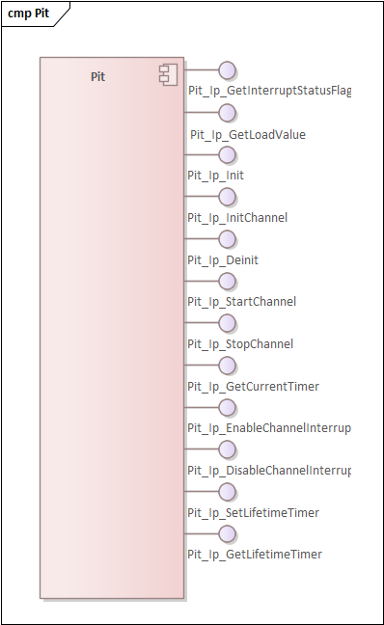

      - Pit_Ip_GetInterruptStatusFlag

Prototype:
boolean Pit_Ip_GetInterruptStatusFlag(uint8 instance, uint8 channel);

Description:
/*!
* @brief This function updates the value of UCRegB. It may be used to change duty cycle, phase shift or inserted dead time buffer with minimum overhead.
* @param Instance eMIOS hardware module index
* @param Channel The Channel in this eMIOS group
* @param Value The value to set
* @return void
*/

      - Pit_Ip_GetLoadValue

Prototype:
uint32 Pit_Ip_GetLoadValue(uint8 instance, uint8 channel);

Description: N/A

      - Pit_Ip_Init

Prototype:
void Pit_Ip_Init(uint8 instance, const Pit_Ip_InstanceConfigType *config);

Description:
/**
* @brief Function Name : Pit_Ip_Init
* @details Driver initialization function. This function is called for each PIT hw Instance and
* - enables the functional clock for PIT Instance or for RTI_PIT
* - Sets PIT operation in Debug mode
*
* @param[in] instance PIT hw instance number
* @param[in] configPtr Pointer to a selected configuration structure
* @return void
* @pre The data structure including the configuration set required for initializing the driver
*/

      - Pit_Ip_InitChannel

Prototype:
void Pit_Ip_InitChannel(uint8 instance, const Pit_Ip_ChannelConfigType *chnlConfig);

Description:
/**
* @brief Function Name : Pit_Ip_InitChannel
* @details Initializes the PIT channels. This function should be called for each PIT hw channel and:
* - stops channel
* - disable interrupts
* - clears pending interrupts
* - initializes the state sructure for common process interrupt
*
* @param[in] instance PIT hw instance number
* @param[in] chnlConfig Pointer to a selected configuration structure.
* @return void
* @pre The data structure including the configuration set required for initializing the driver.
*/

      - Pit_Ip_Deinit

Prototype:
void Pit_Ip_Deinit(uint8 instance);

Description:
/**
* @brief Pit_Ip_DeInit
* @details De-Initializes the PIT instances. This functions is called for each PIT Instance and
* - resets all channels to default
*
* @param[in] instance Pit hw instance
* @return void
* @pre The data structure including the configuration set required for initializing the GPT driver.
*
*/

      - Pit_Ip_StartChannel

Prototype:
Pit_Ip_StatusType Pit_Ip_StartChannel(uint8 instance, uint8 channel, uint32 countValue);

Description:
/**
* @brief Function Name : Pit_Ip_StartChannel
* @details This function is called for starting the Pit timer channel.
* - sets the timeout value into the PIT timer channel register
* - enables the PIT channel
*
* @param[in] instance Pit hw instance
* @param[in] channel Pit hw channel
* @param[in] countValue channel timeout value
* @return void
* @pre The driver needs to be initialized. This function is called for starting the Pit timer channel.
*/

      - Pit_Ip_StopChannel

Prototype:
void Pit_Ip_StopChannel(uint8 instance, uint8 channel);

Description:
/**
* @brief Function Name : Pit_Ip_StopChannel
* @details This function is called for stopping the Pit counter. This function disables the PIT channel and:
* - stops PIT counter
* - clears interrupt flag
*
* @param[in] instance Pit hw instance
* @param[in] channel Pit hw channel
* @return void
* @pre The driver needs to be initialized. Pit_Ip_StartChannel must be call before.
*/

      - Pit_Ip_GetCurrentTimer

Prototype:
uint64 Pit_Ip_GetCurrentTimer(uint8 instance, uint8 channel);

Description:
/**
* @brief Function Name : Pit_Ip_GetCurrentTimer
* @details Gets counter value from CVAL Register.
* The period range depends on the frequency of the PIT source clock
*
*
* @param[in] instance Pit hw instance
* @param[in] channel Pit hw channel
*
* @return counterValue counter value
* @pre The driver needs to be initialized.
*/

      - Pit_Ip_EnableChannelInterrupt

Prototype:
void Pit_Ip_EnableChannelInterrupt(uint8 instance, uint8 channel);

Description:
/**
* @brief Function Name : Pit_Ip_EnableChannelInterrupt
* @details This function enables the IRQ corresponding to the Pit timer channel
*
*
* @param[in] instance Pit hw instance
* @param[in] channel Pit hw channel
* @return void
* @pre The driver needs to be initialized.
*/

      - Pit_Ip_DisableChannelInterrupt

Prototype:
void Pit_Ip_DisableChannelInterrupt(uint8 instance, uint8 channel);

Description:
/**
* @brief Function Name : Pit_Ip_DisableChannelInterrupt
* @details This function disables the IRQ corresponding to the Pit timer channel
*
*
* @param[in] instance Pit hw instance
* @param[in] channel Pit hw channel
* @return void
* @pre The driver needs to be initialized.
*/

      - Pit_Ip_SetLifetimeTimer

Prototype:
void Pit_Ip_SetLifetimeTimer(uint8 instance);

Description:
/**
* @brief Function Name : Pit_Ip_SetLifetimeTimer
* @details Build the 64-bit lifetimer.
* The lifetime timer is a 64-bit timer which chains timer channel 0 and timer channel 1 together
* with the start value of both channels is set to the maximum value(0xFFFFFFFF).
* The period of lifetime timer is equal to the "period of
* timer 0 * period of timer 1".
*
* @param[in] instance Pit hw instance
* @return void
* @pre The driver needs to be initialized.
*/

      - Pit_Ip_GetLifetimeTimer

Prototype:
uint64 Pit_Ip_GetLifetimeTimer(uint8 instance);

Description:
/**
* @brief Function Name : Pit_Ip_GetLifetimeTimer
* @details Read current lifefime counter value.
* The Lifetime timer is 64-bit timer which chains timer 0 and timer 1 together.
* The period of lifetime timer equals to "period of timer 0 * period of timer 1".
* This feature returns an absolute time stamp in count. The time stamp
* value does not exceed the timer period. The timer is down-counting.
*
*
*
* @param[in] instance Pit hw instance
*
* @return lifeTimeValue
* @pre The driver needs to be initialized.
*/

  - Configuration
This section will illustrate the GUI settings for the NXP Configuration Tool which brings in the components available using NXP’s RTD SDK for the S32K344 SoC.

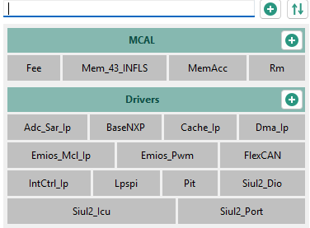

    - AUTOSAR Fee
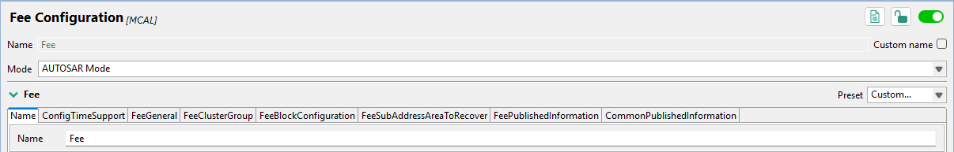

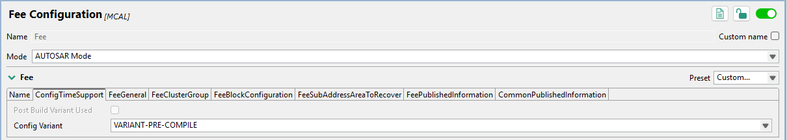

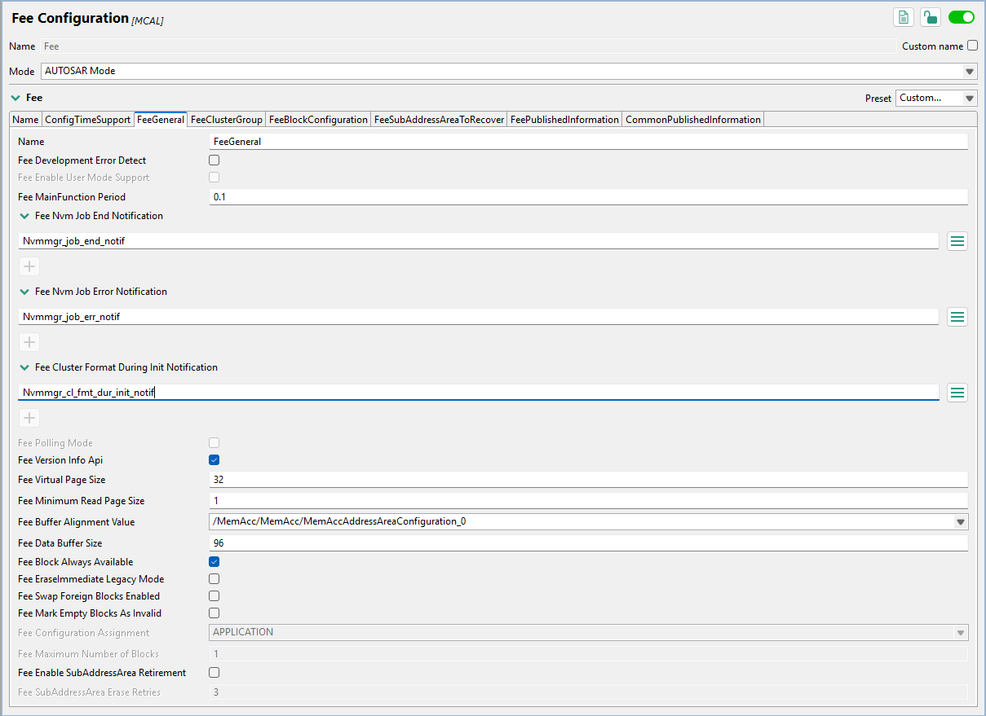

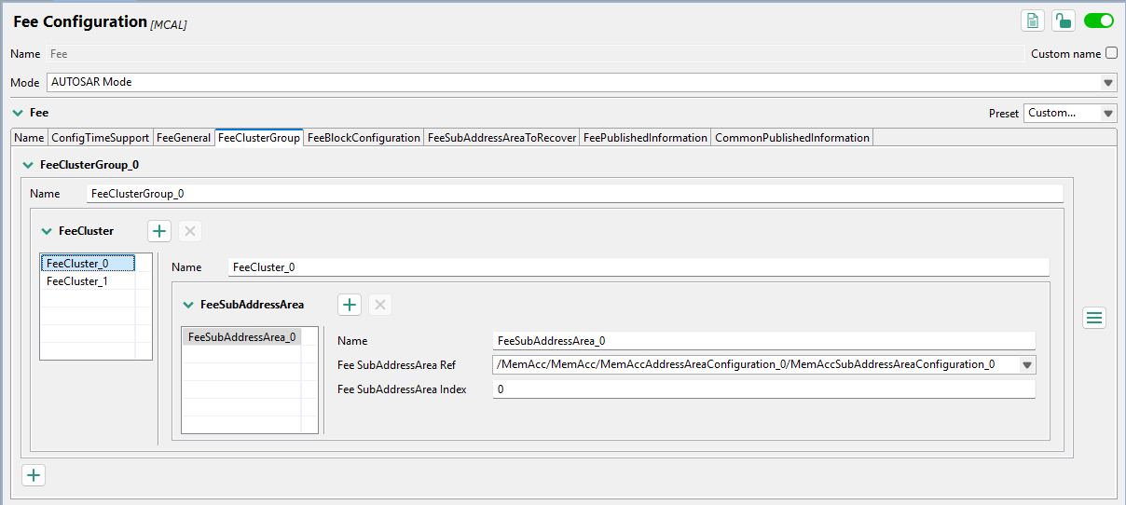

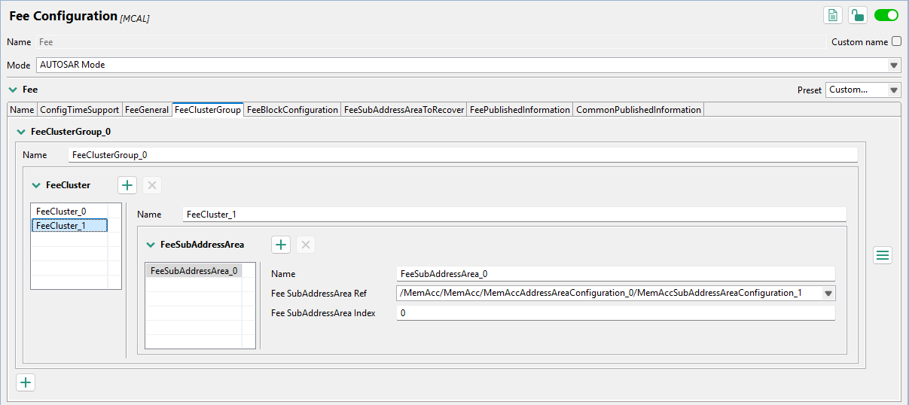

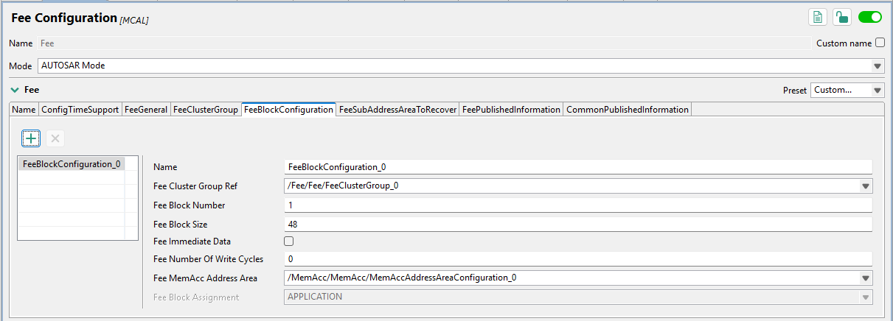

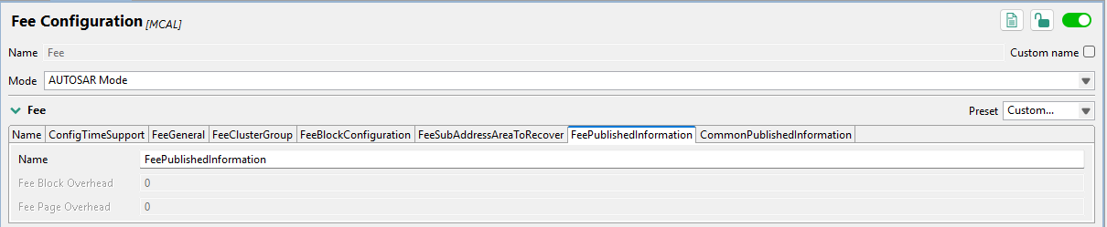

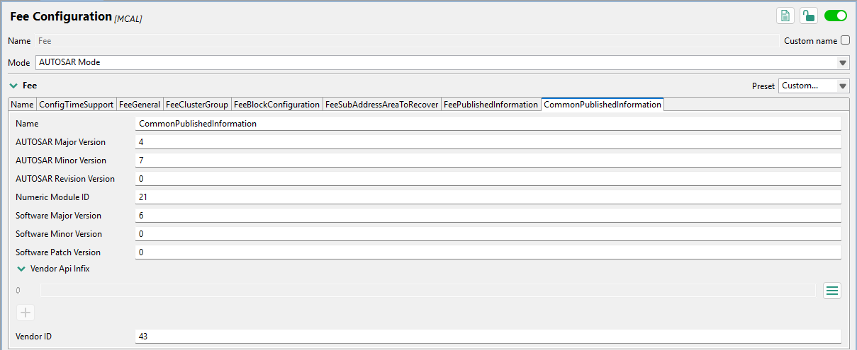

    - Cache Ip
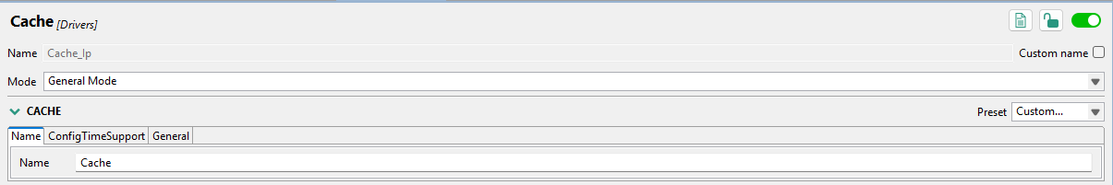

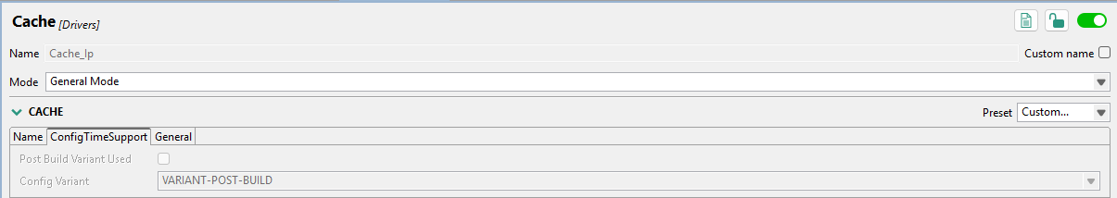

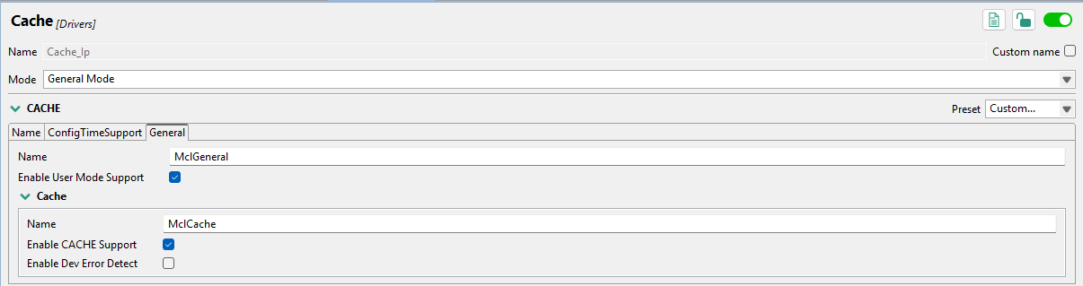

    - Dma Ip
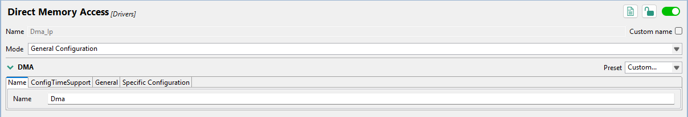

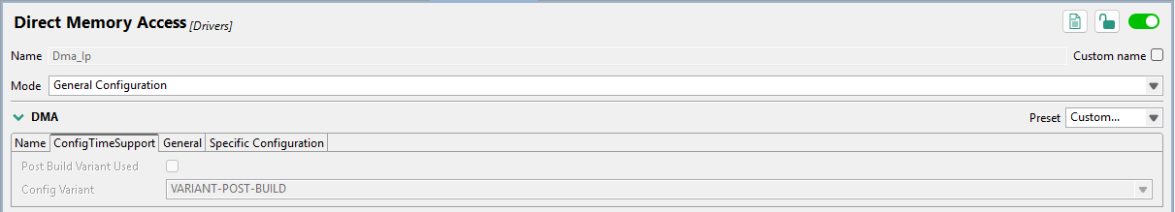

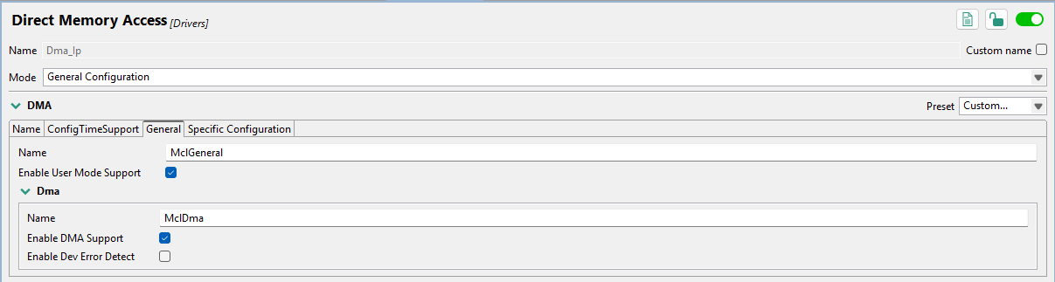

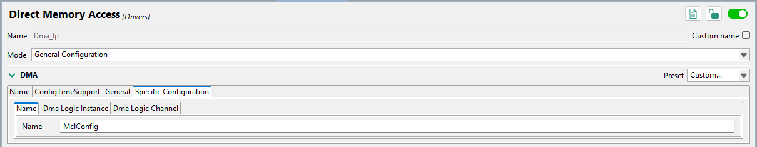

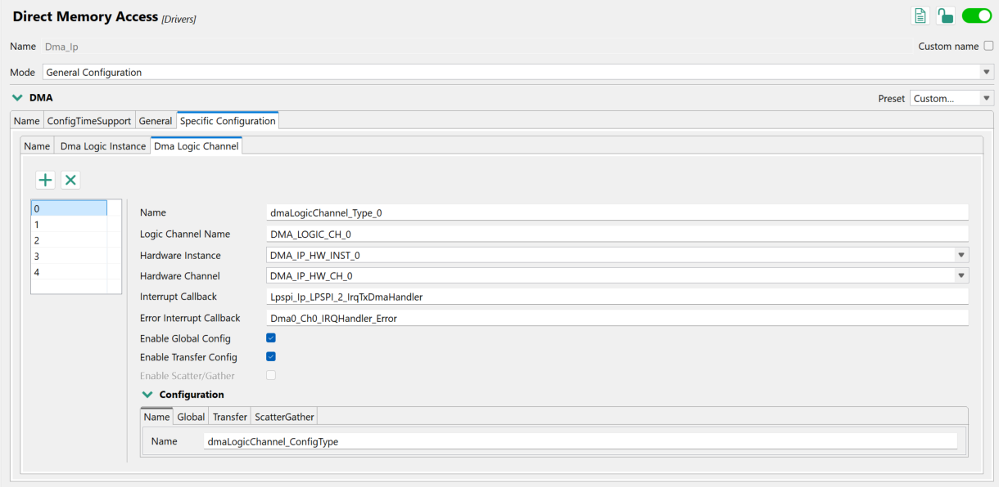

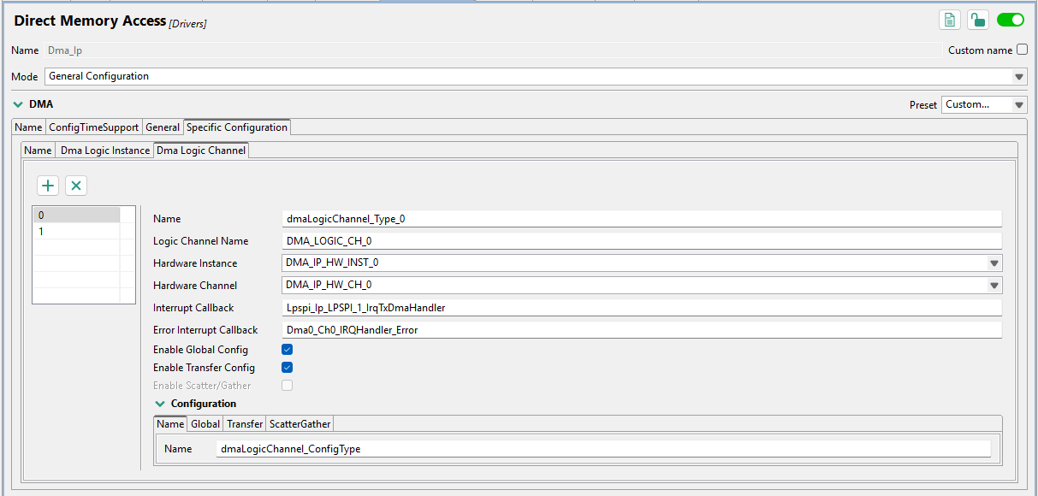

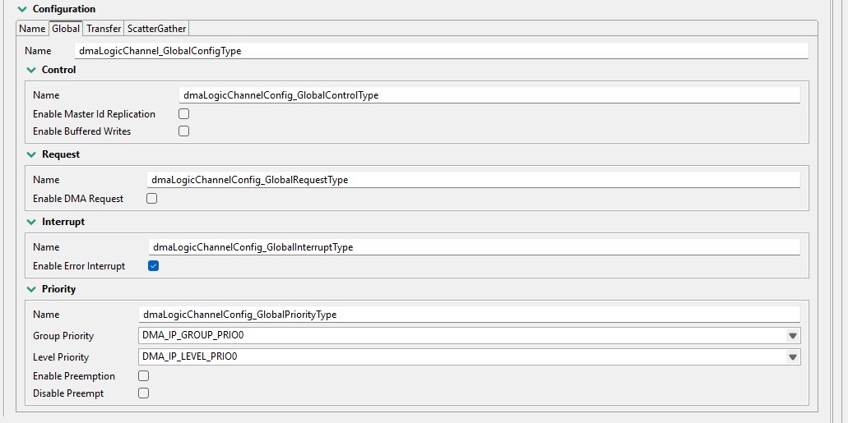

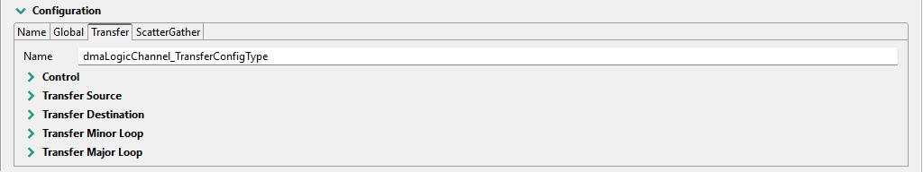

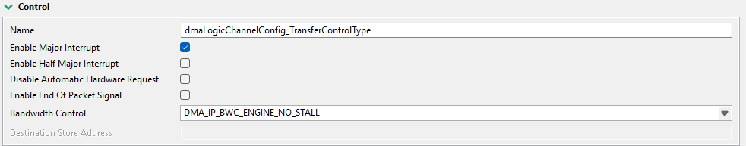

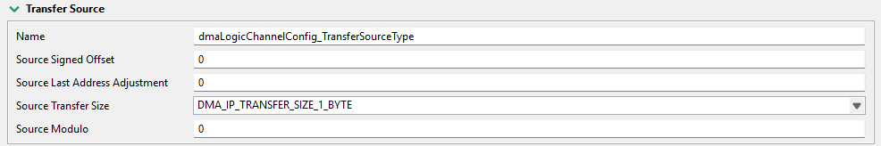

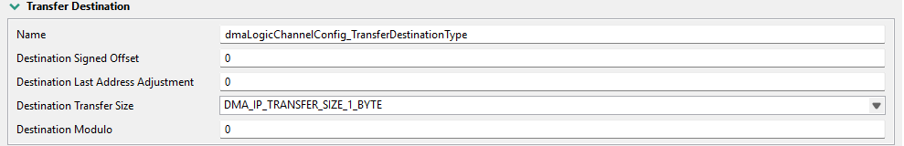

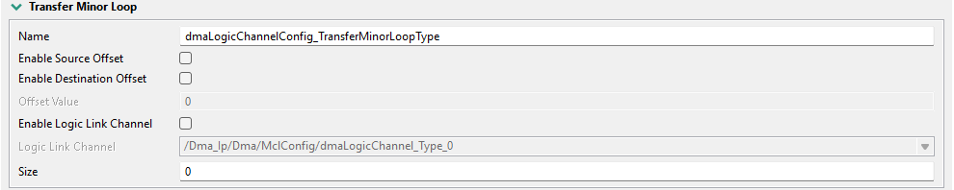

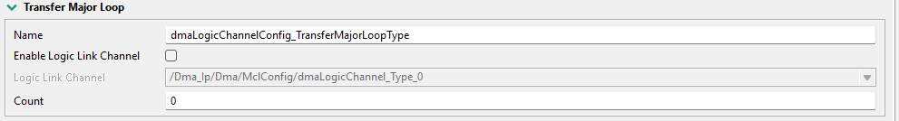

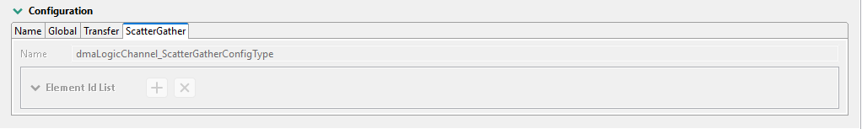

    - IntCtrl Ip
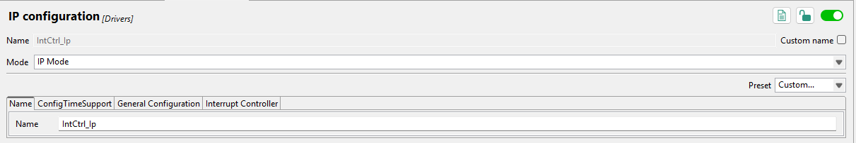

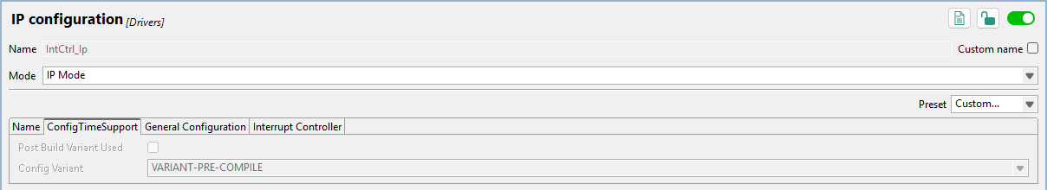

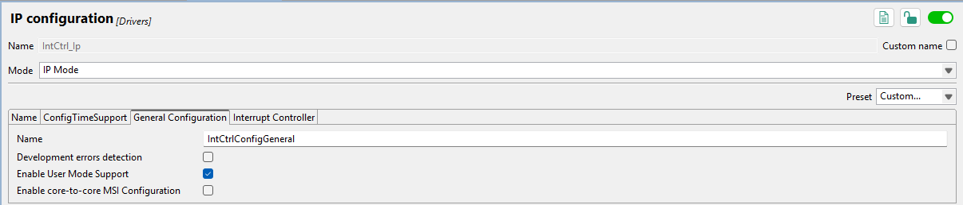

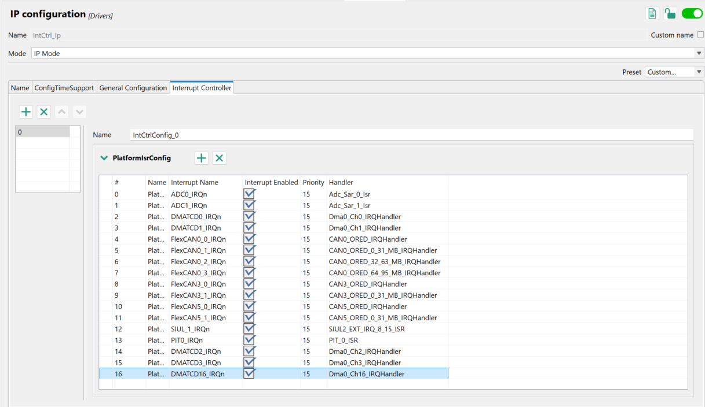
    - FlexCAN Ip
      - FlexCAN Device name
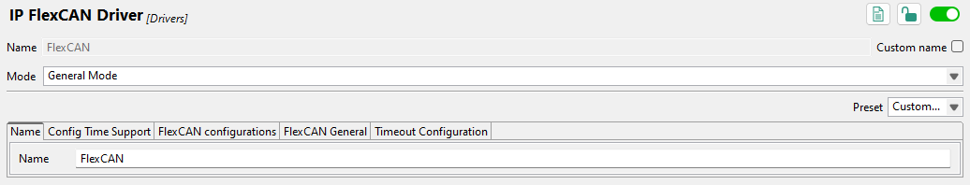

      - FlexCAN Device 0 configuration
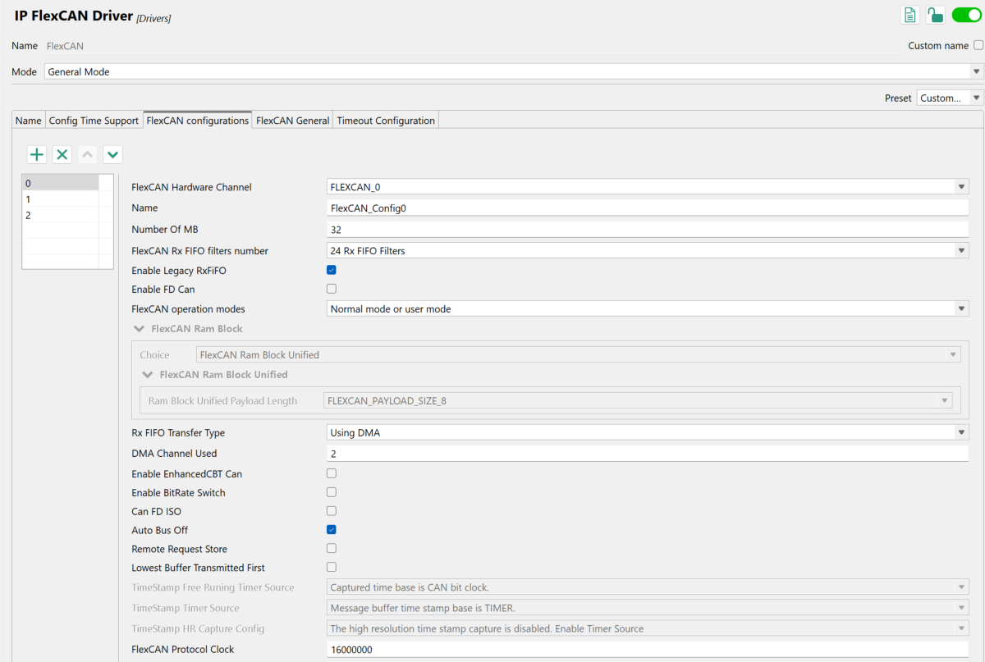

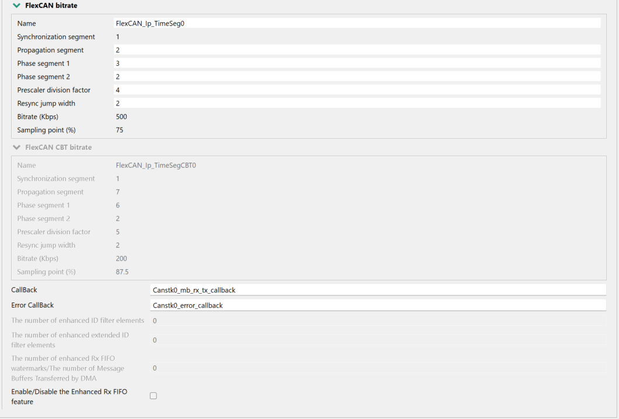

      - FlexCAN Device 1 configuration
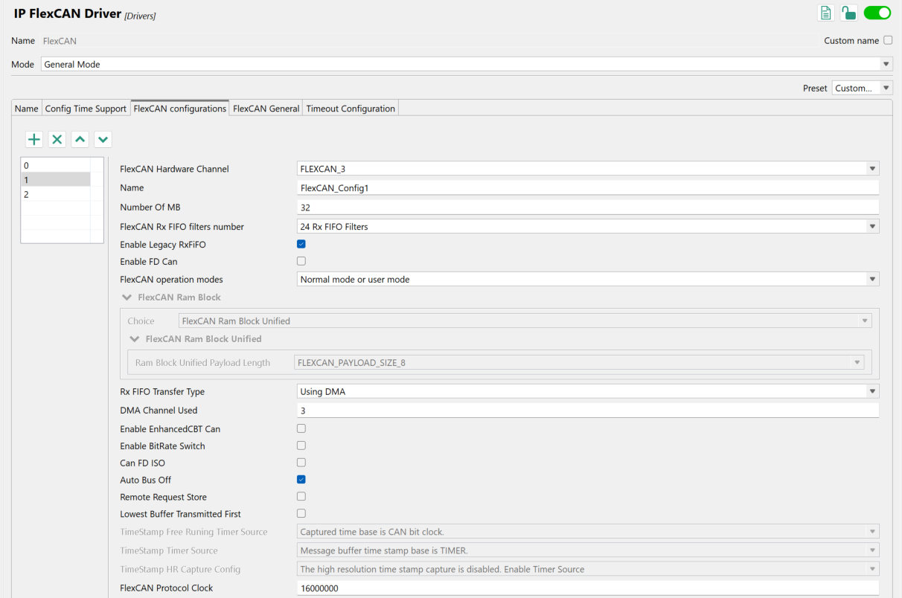
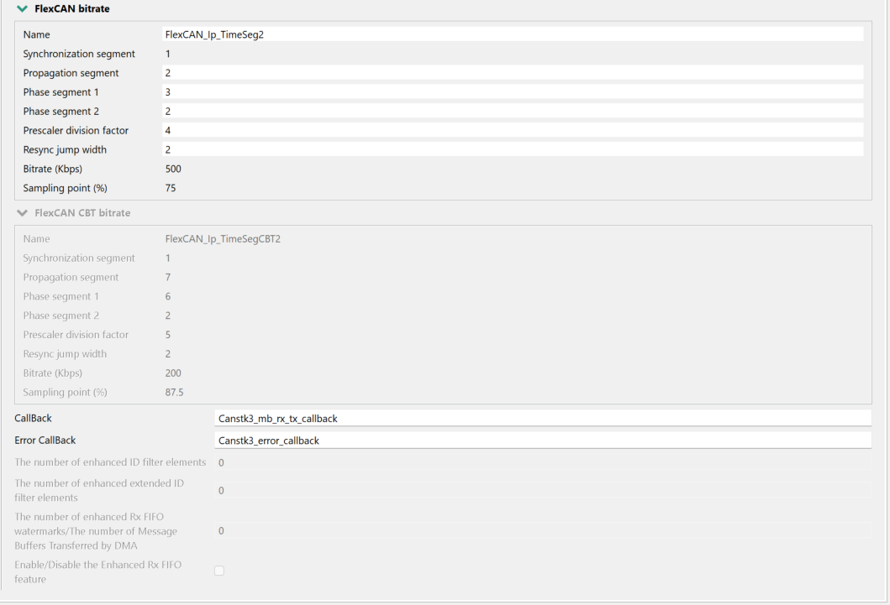
      - FlexCAN Device 2 configuration
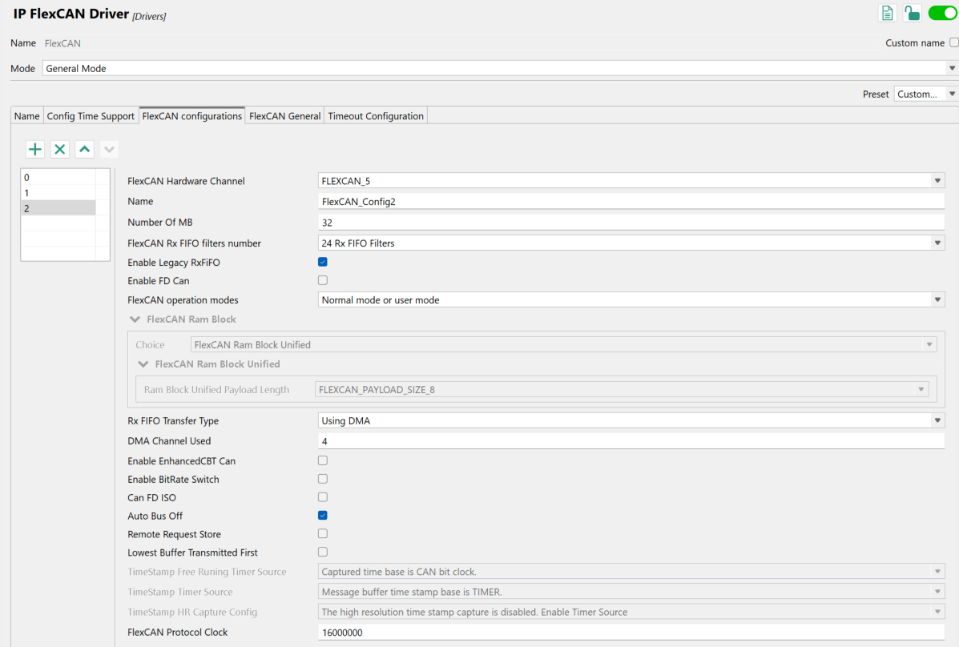
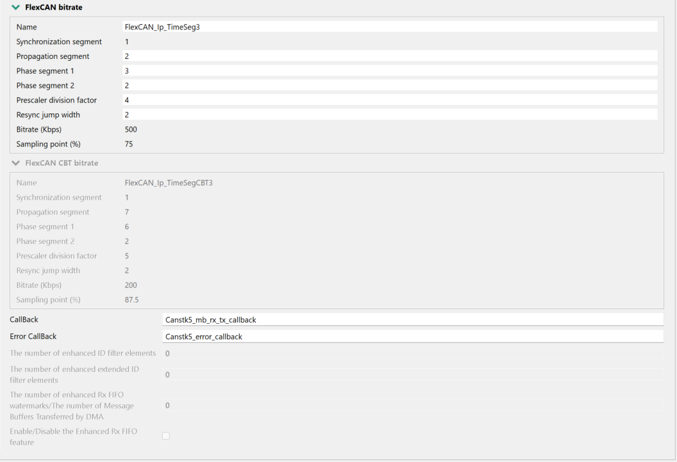
      - FlexCAN General
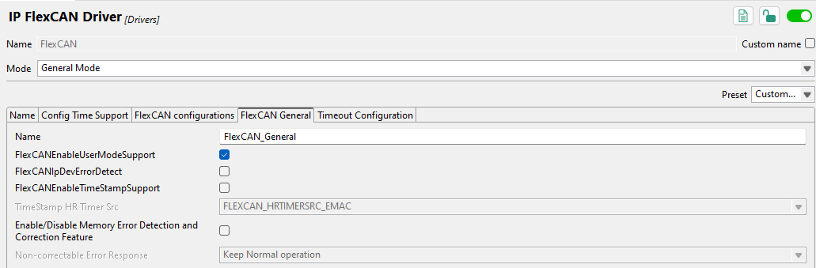

      - FlexCAN Timeout Configuration
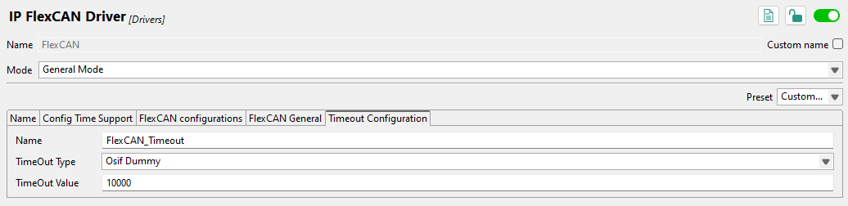

    - Lpspi Ip
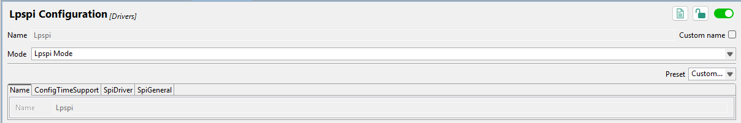

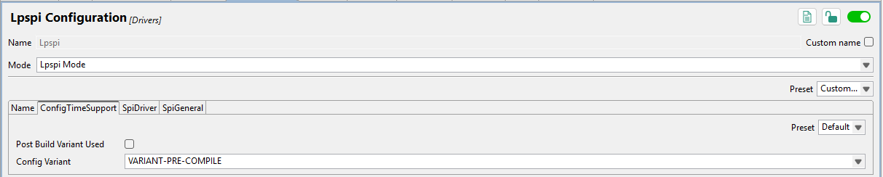

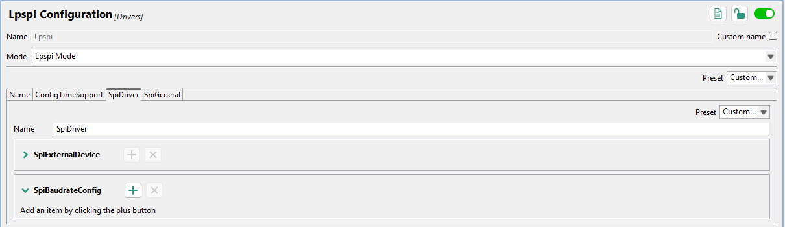

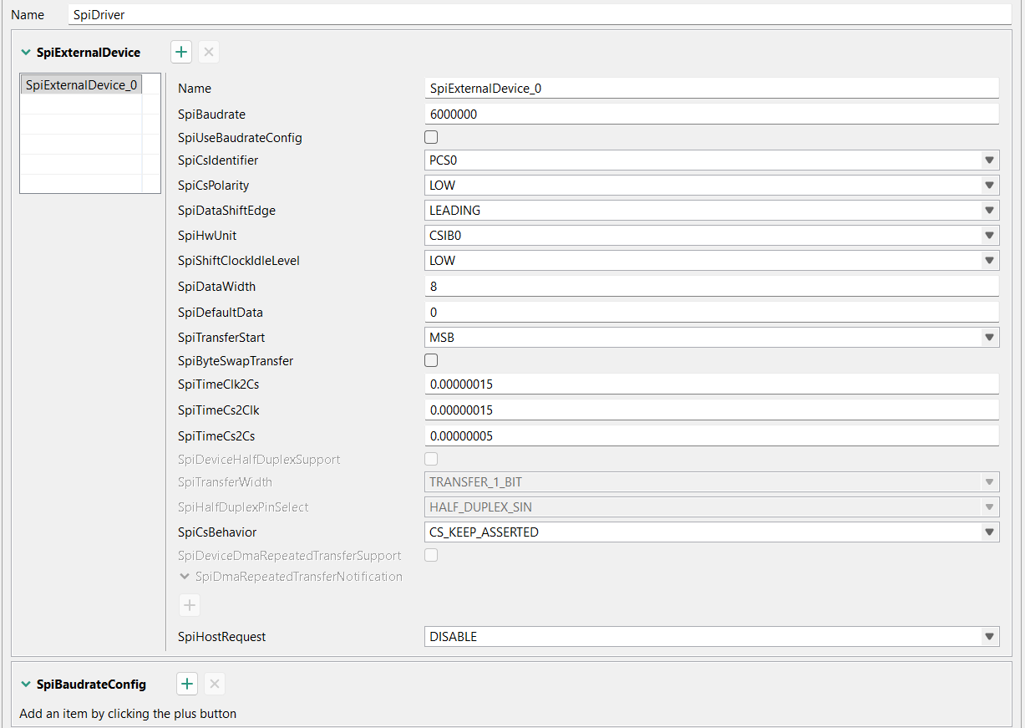

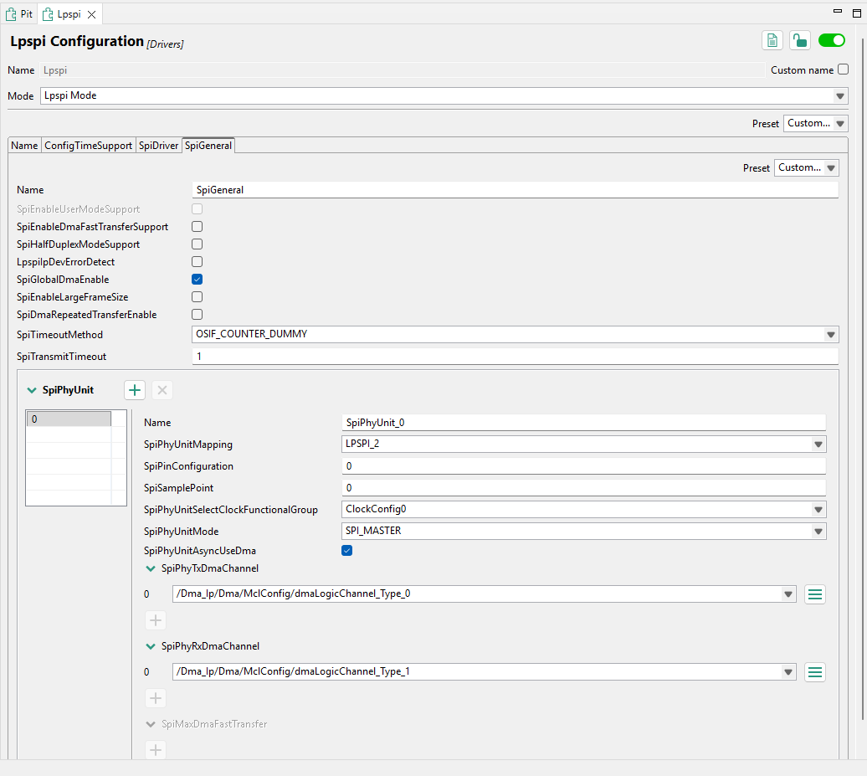

    - Rm
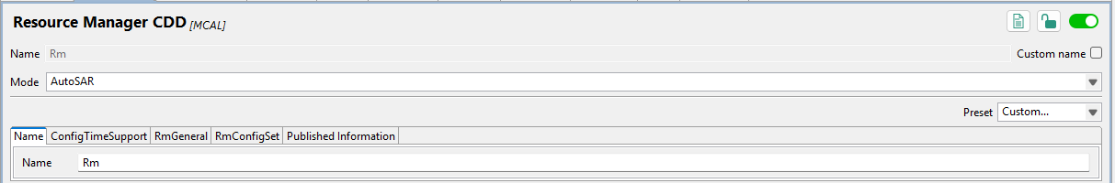

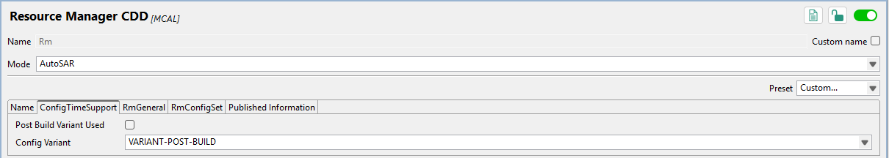

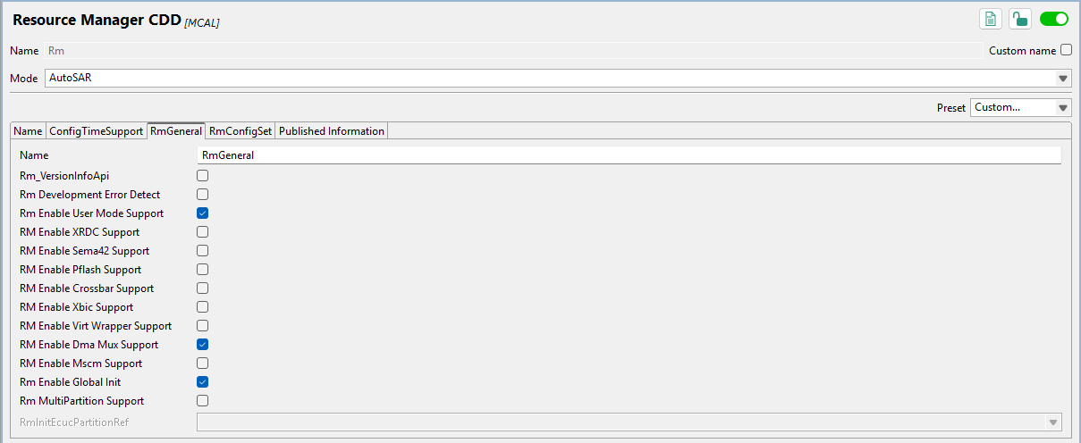

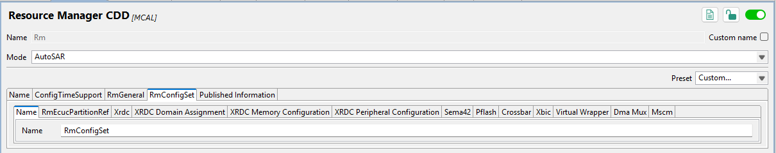

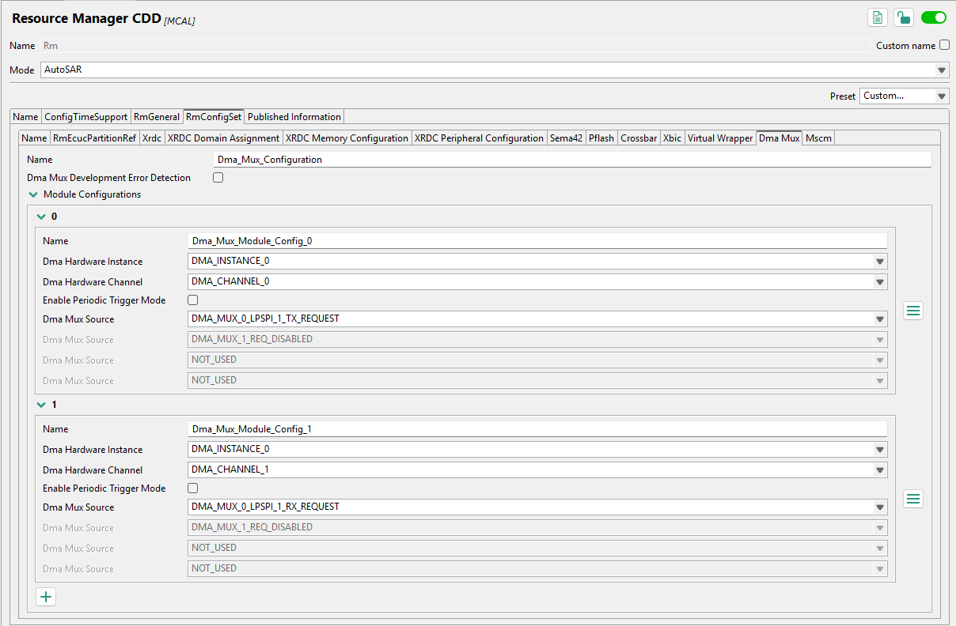

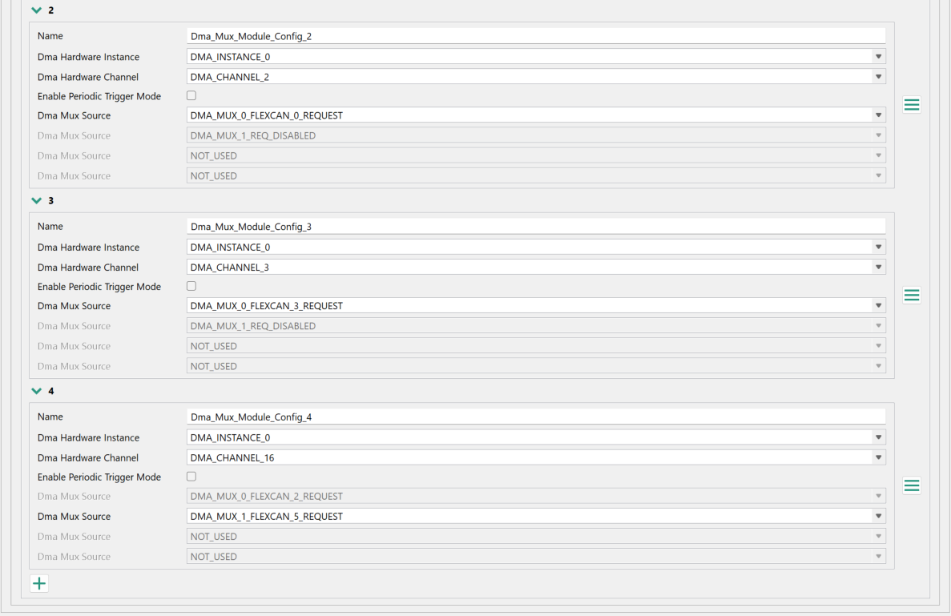
All other RmConfigSet tabs are “default” settings – not important. The Rm component is primarily used to configure the DMA MUX to connect the eDMA to various sources.

    - Siul2 Dio
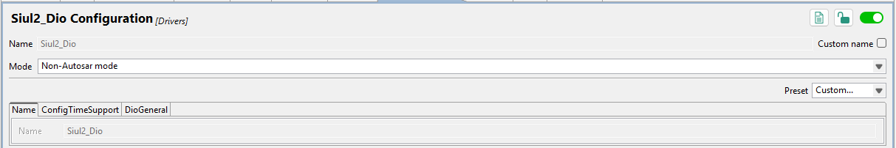

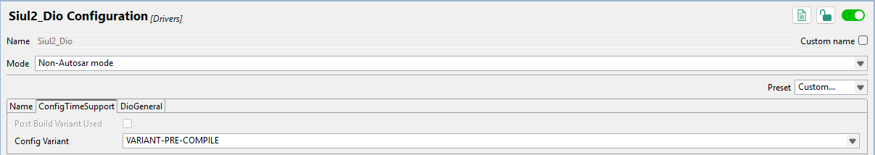

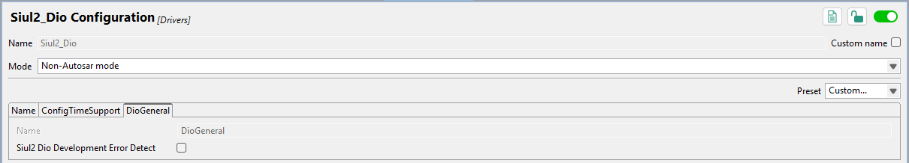

    - Siul2 Port
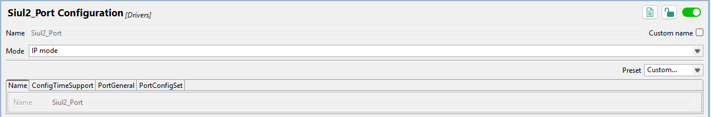

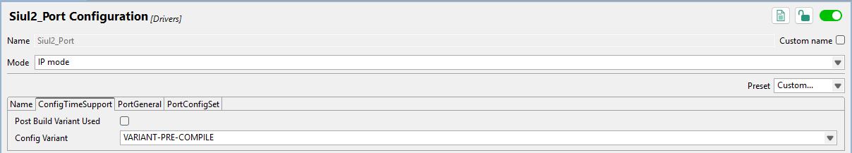

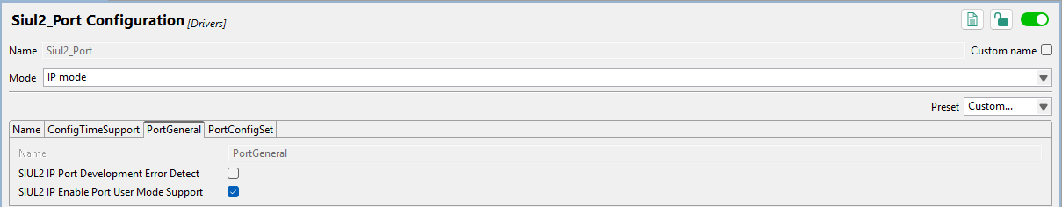

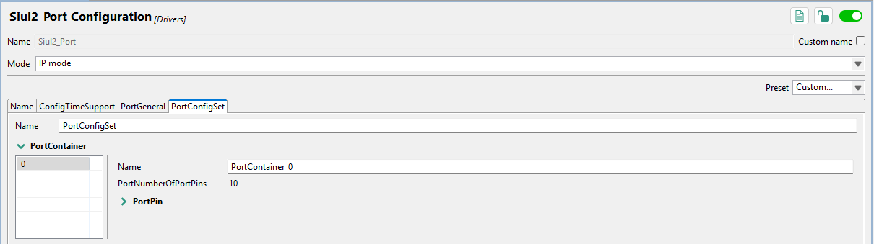

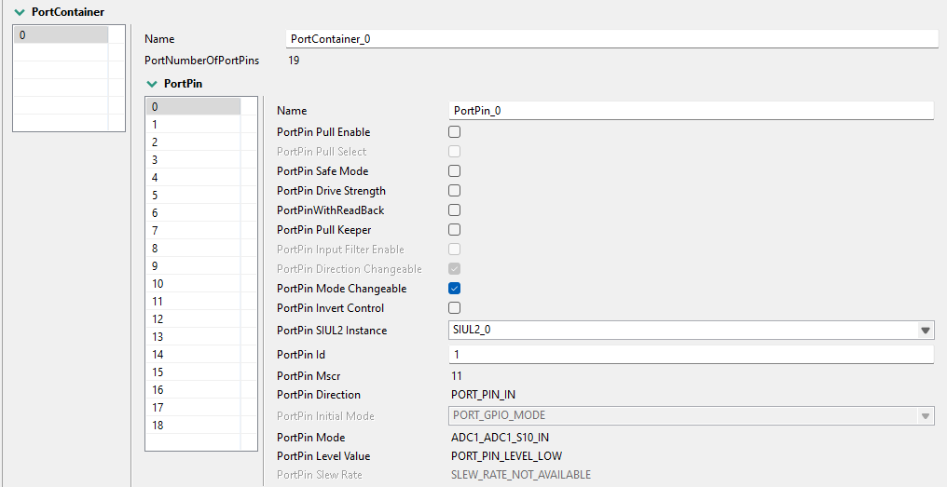

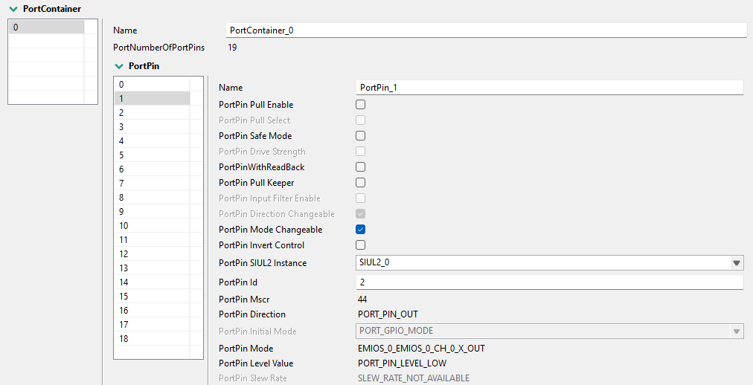

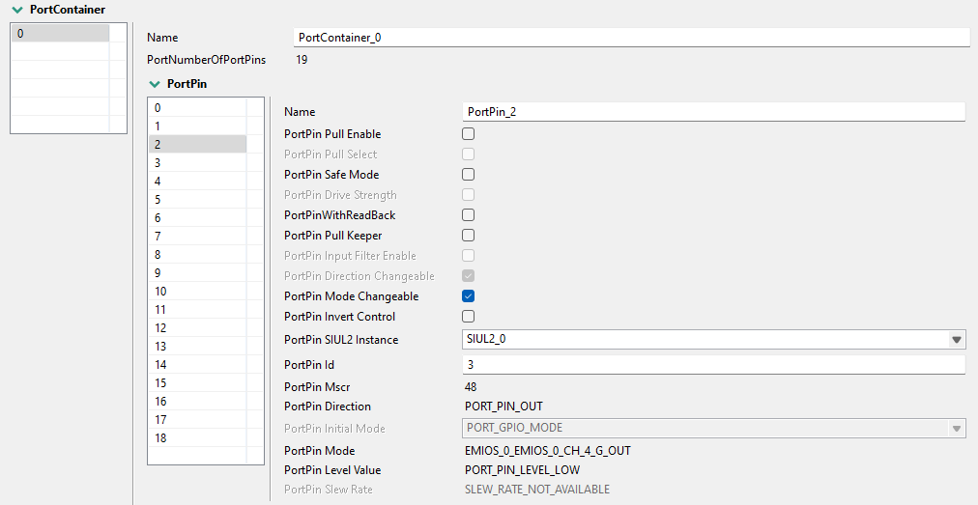

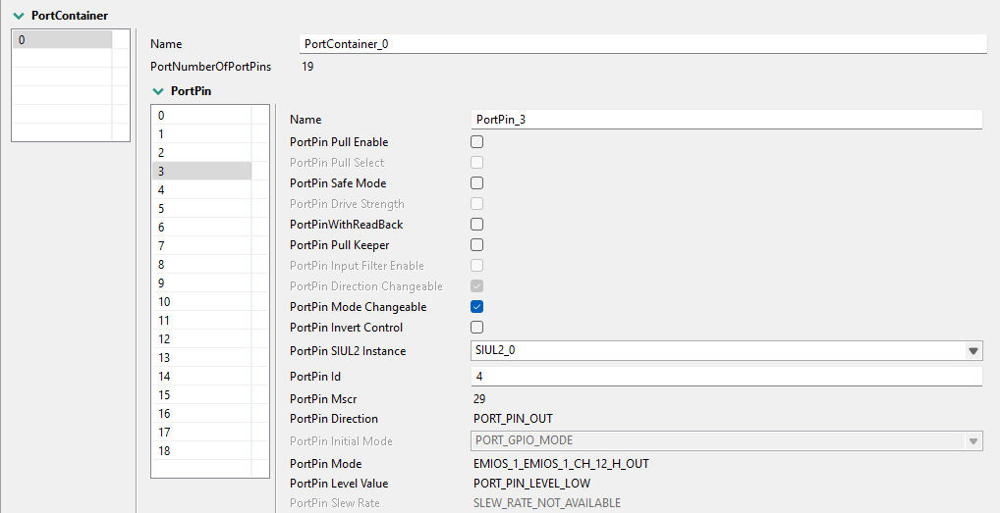

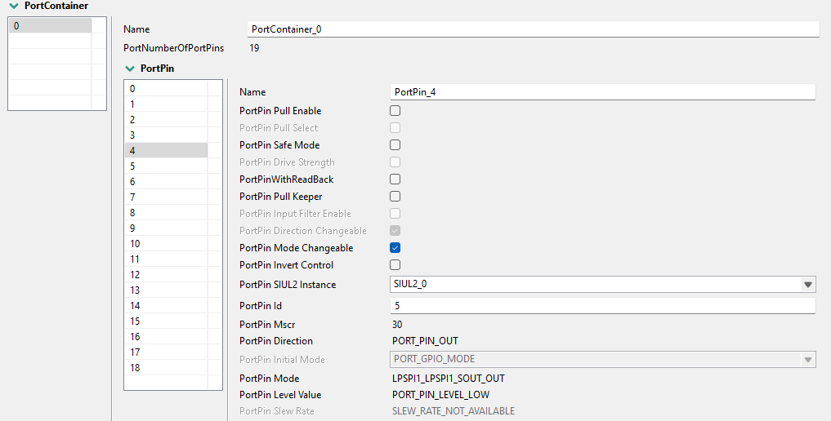

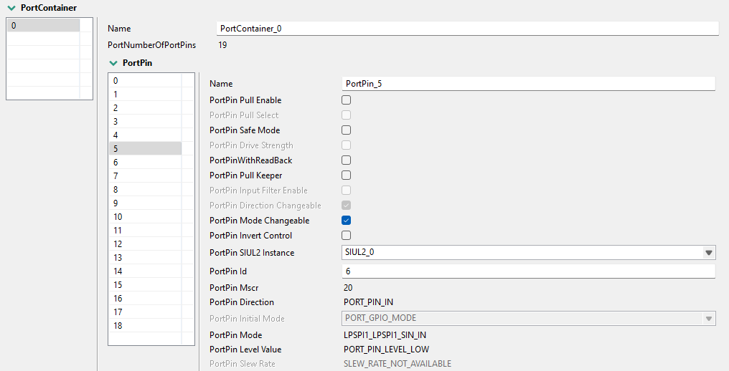

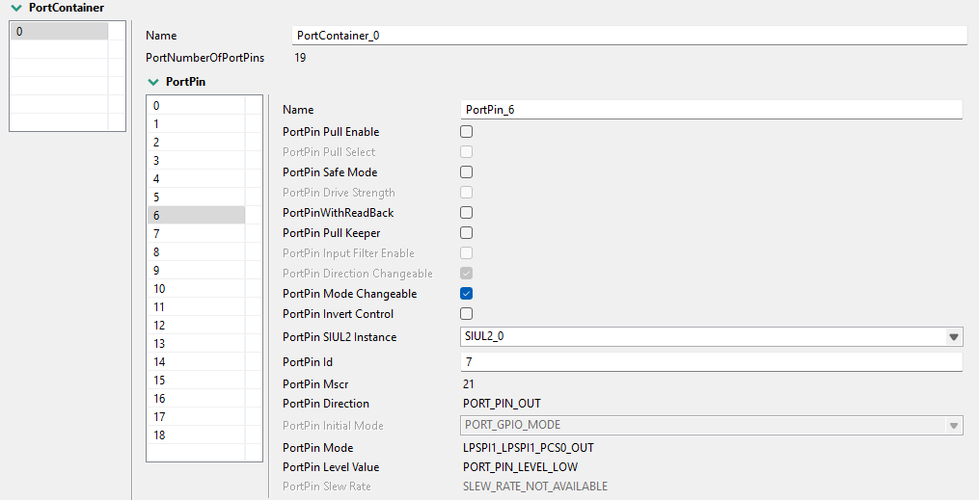

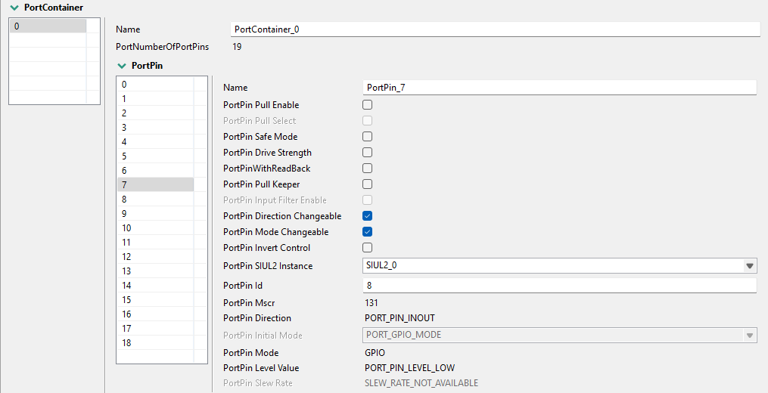

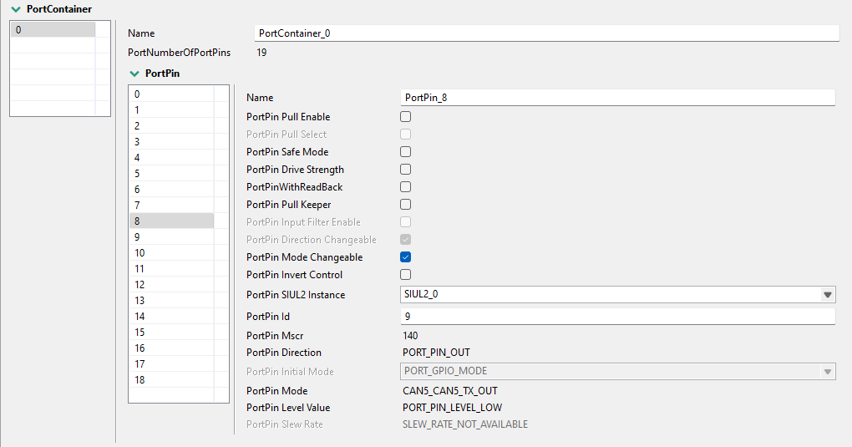

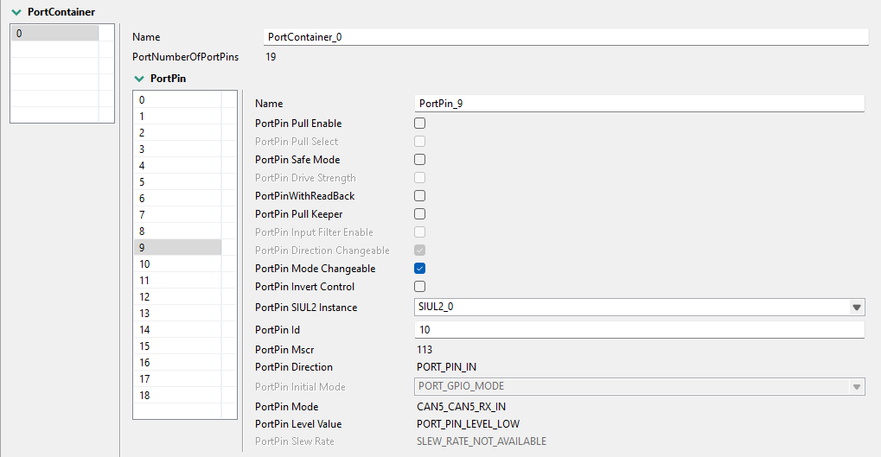

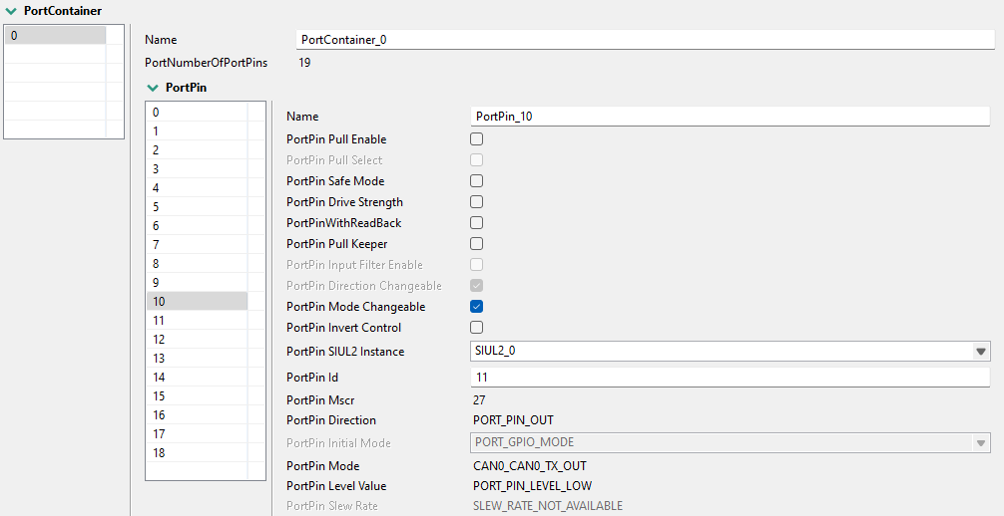

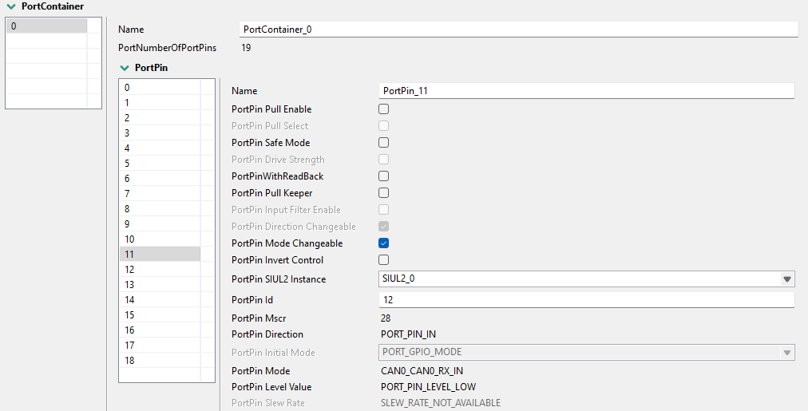

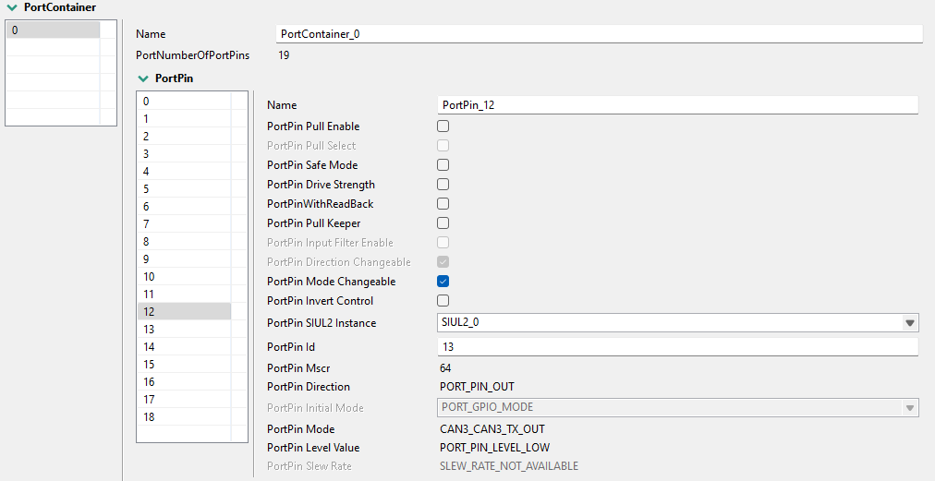

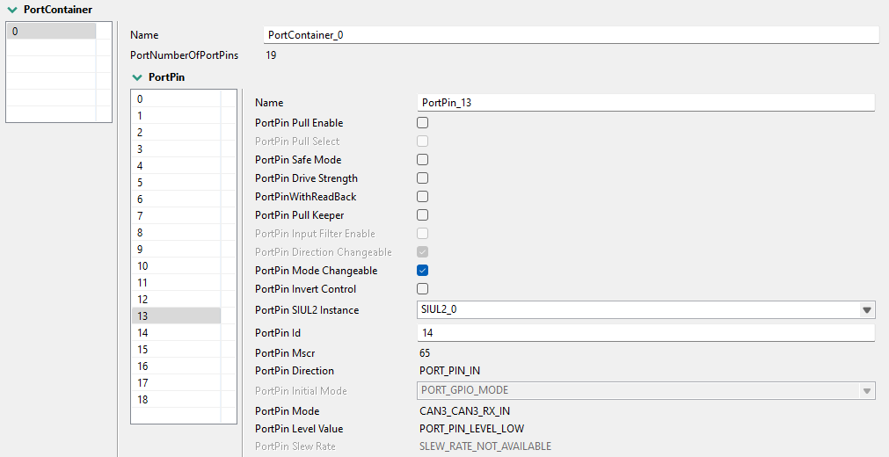

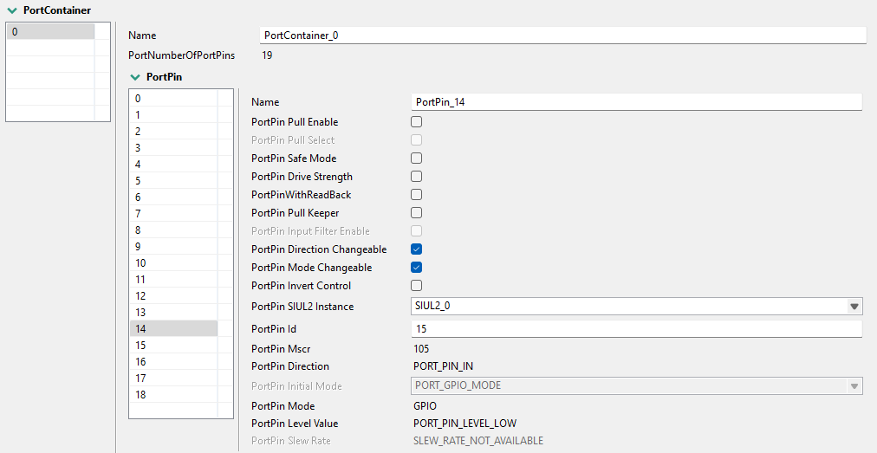

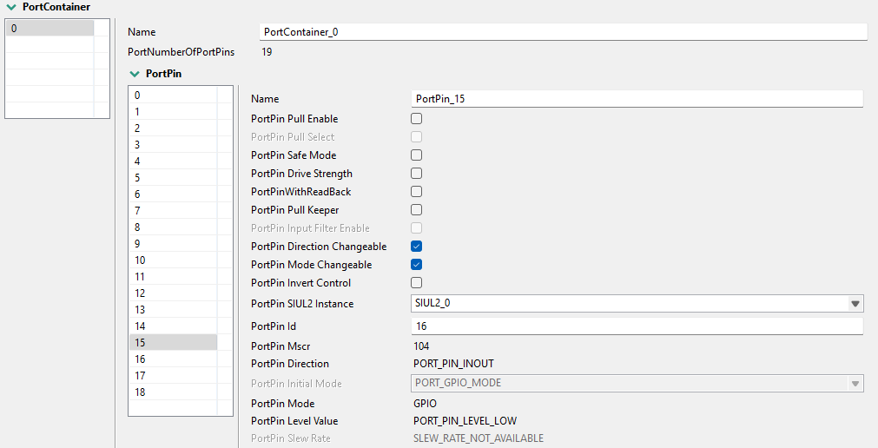

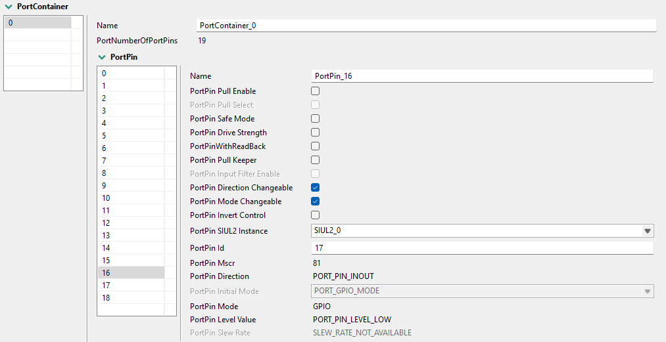

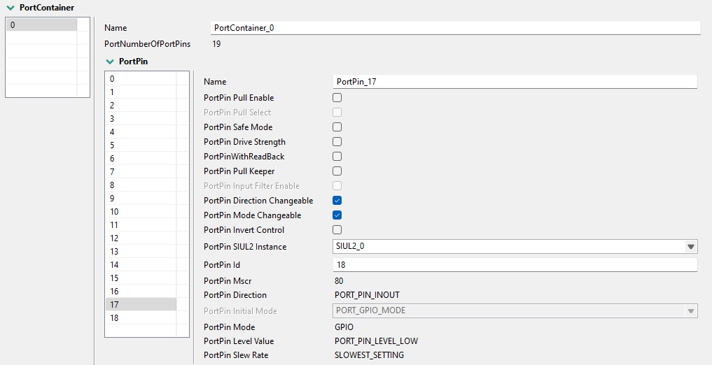

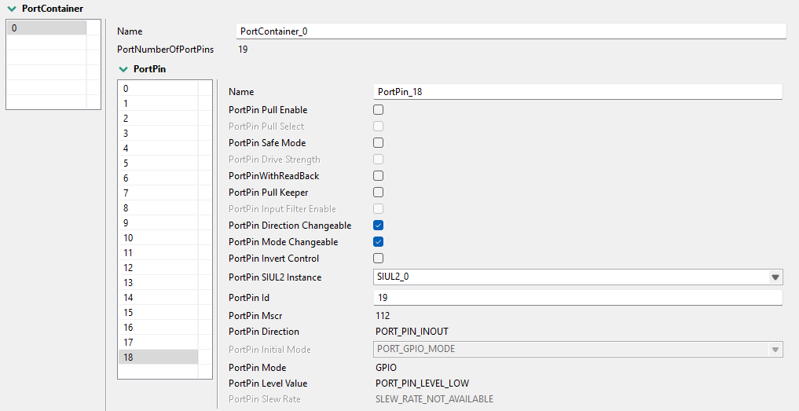

    - Siul2_Icu

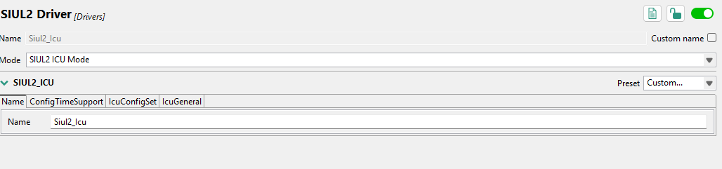

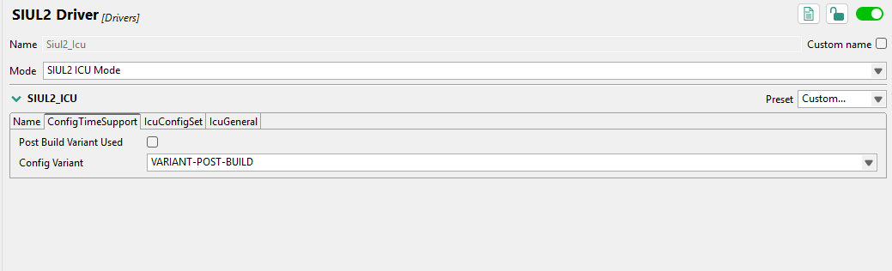

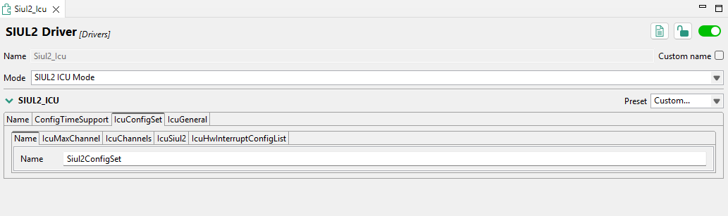

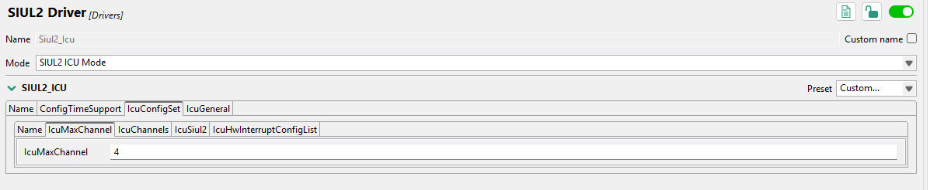

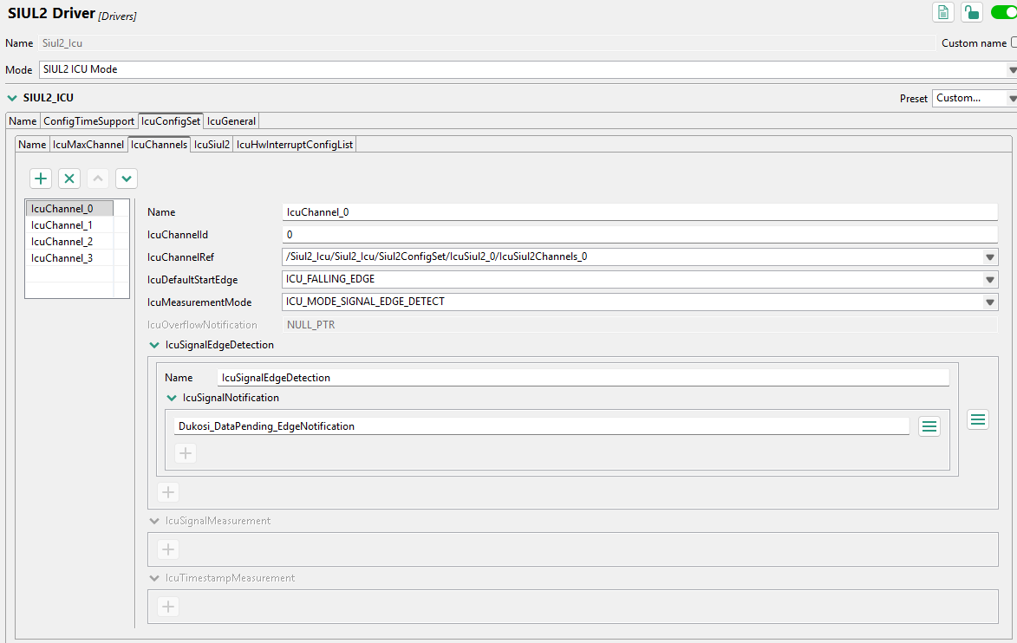

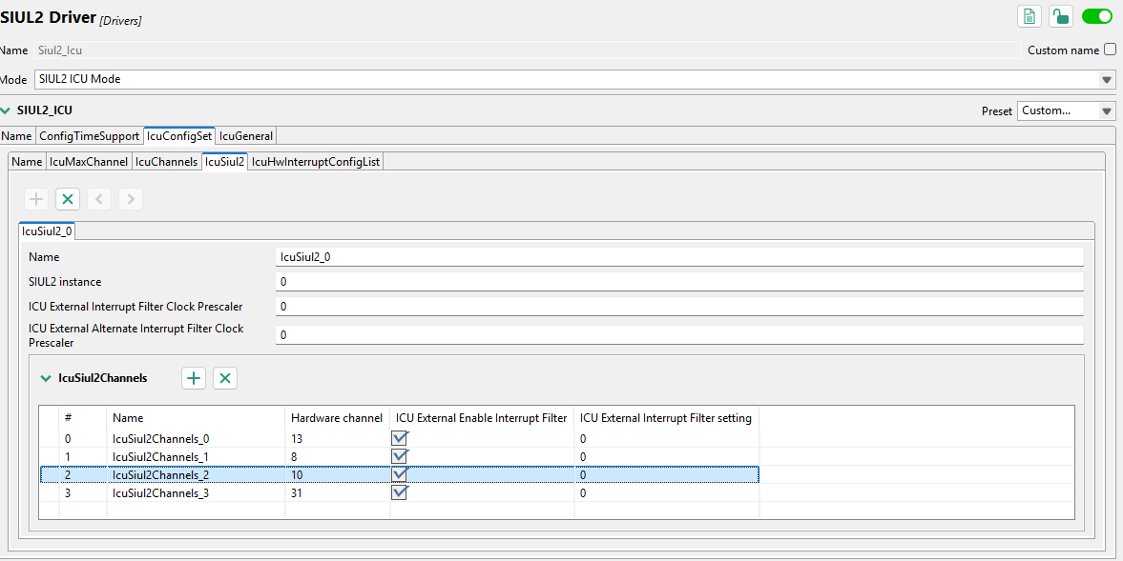

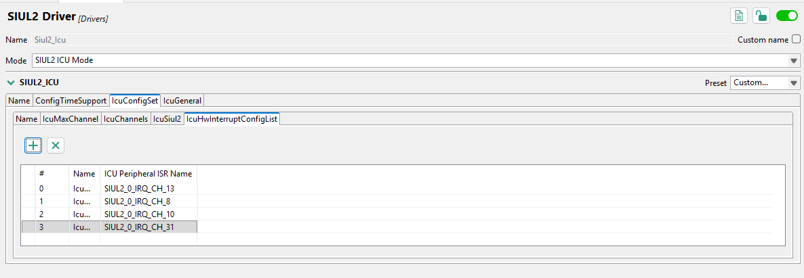

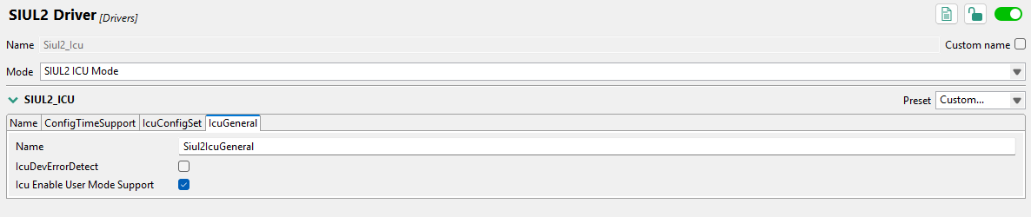

    - Pit

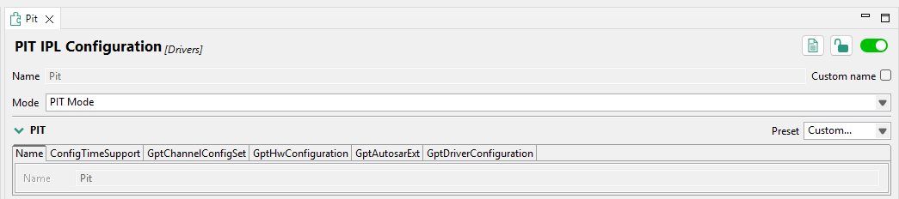

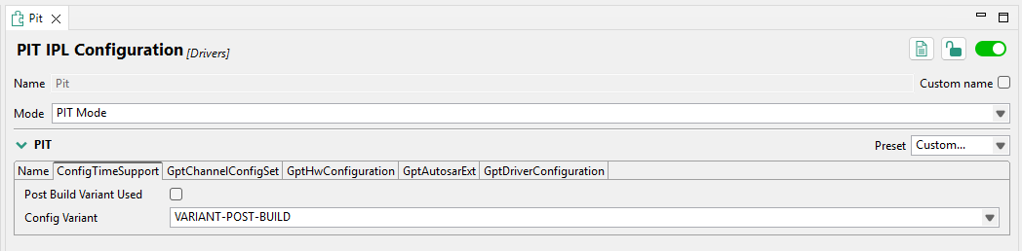

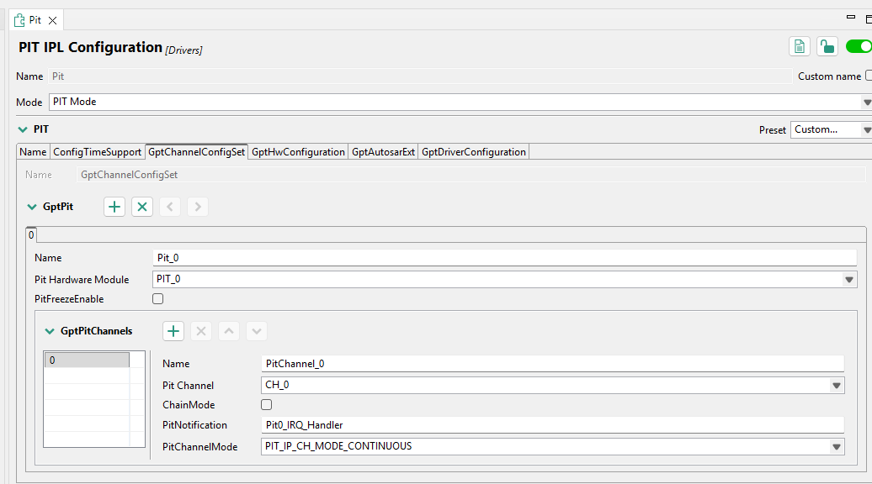

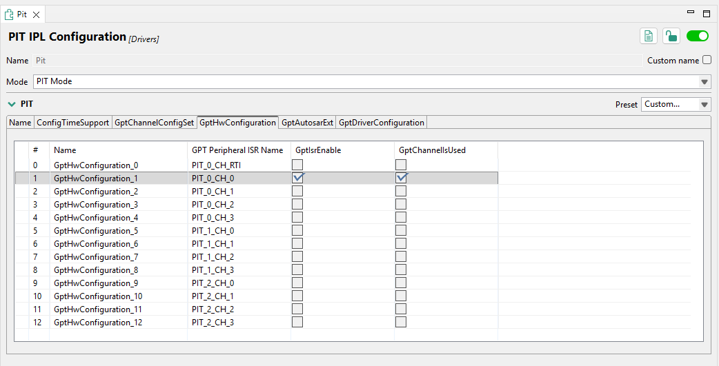

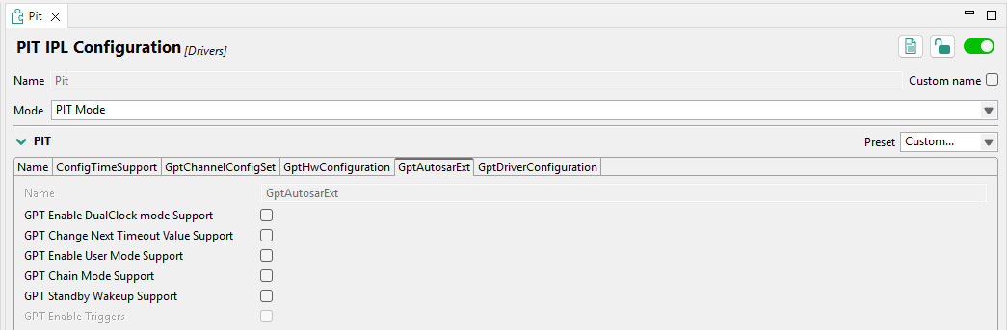

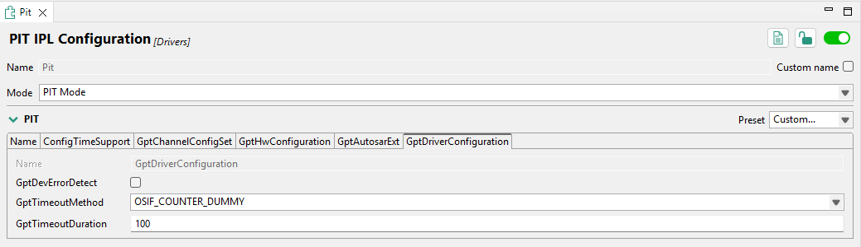
    - ADC SAR

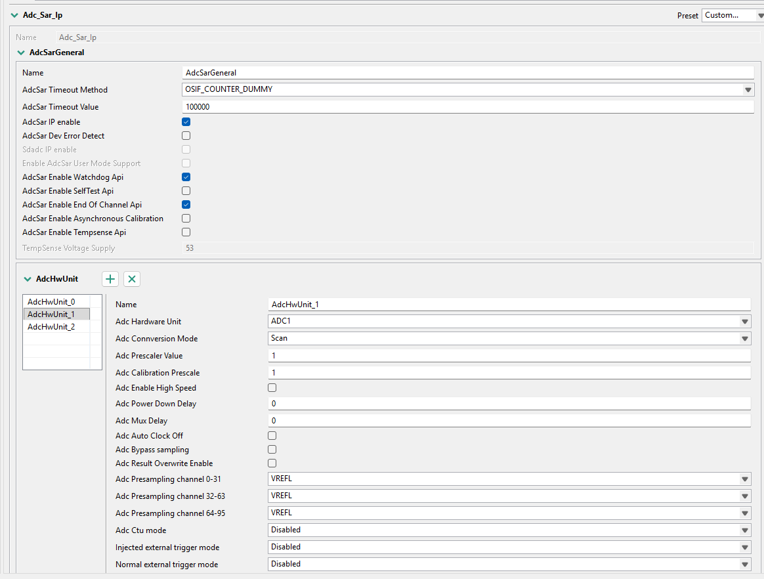
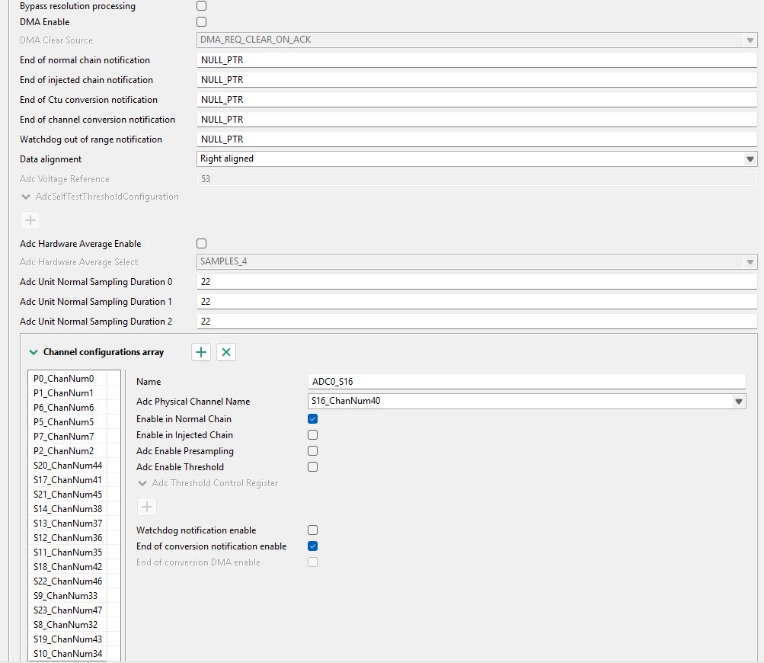

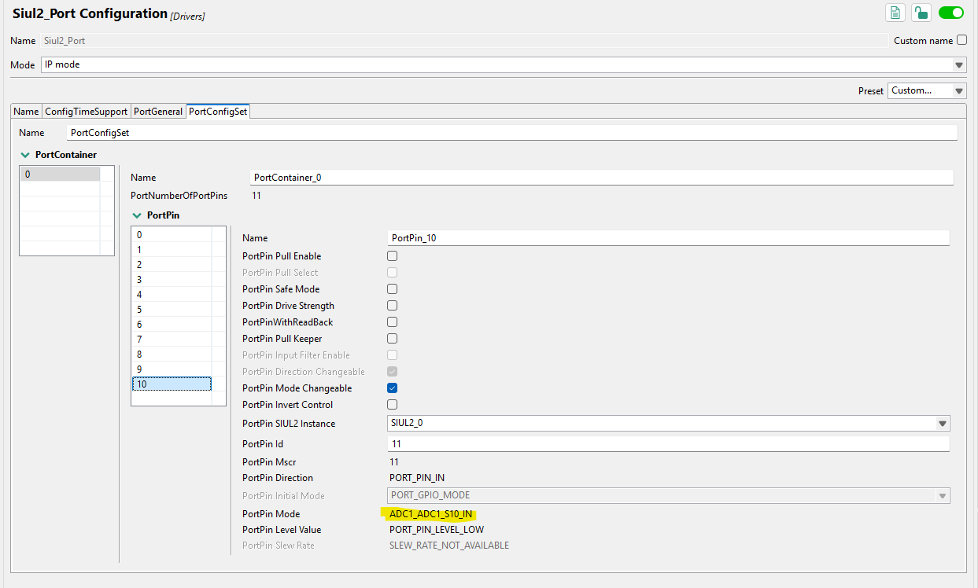

  - Calibrations
N/A

  - Sequence Diagrams
N/A

- Source File List and Description
The following sections outline the source files needed to realize the S32K344-MCAL Component within a target application that becomes linked in a build procedure.

The ABS Development team uses NXP’s downloadable RTD (Real-Time Drivers) SDK. This SDK supports AUTOSAR and non-AUTOSAR applications which target ARM Cortex-M cores and ISO 26262 compliance for all software layers. Please refer to this link to understand more about the SDK:

https://www.nxp.com/design/design-center/software/automotive-software-and-tools/real-time-drivers-rtd:AUTOMOTIVE-RTD

This RTD SDK is integrated into the S32DS IDE where the NXP Configuration Tool may be accessed (*.mex file is a project for this tool). Within the IDE, users may pick and choose the components to add for generation and integration for an application.

The ABS Software Team uses RTD SDK version as follows:
S32K3_S32M27x Real-Time Drivers ASR R21-11 Version 6.0.0

This can be downloaded on NXP’s site if a developer has a user account with NXP established.

  - Source Files
Below is an image that illustrates the directories involved with the component. Since the MCAL Component is primarily generated files, further detail will be implored into this where necessary.
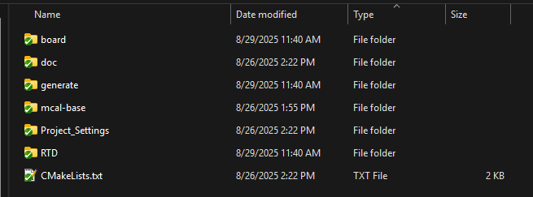

    - Directory: board
The ‘board’ directory contains generated files that configure the GPIO (SIUL2) pins and board-specific information.

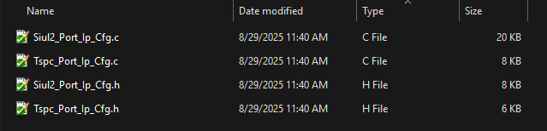

    - Directory: generate
This directory contains source files that configure how the (static) driver sources are to be employed. For instance, a configuration that sets up specific CAN or SPI peripheral settings exist here. Most of the time, these configurations are in a const structure of some sort where the data is directly aligned with the settings in the NXP Config Tool GUI. There will be an ‘include’ directory for header files and a ‘src’ directory for the const structs.

    - Directory: mcal-base
The ‘mcal-base’ directory contains files that are used by all RTD files. These are base RTD SDK files that are placed here to have all developers reference these files in a common location of this repo.

    - Directory: Project_Settings
The ‘Project_Settings’ folder has several MCU specific settings. This directory contains the linker script for a target application to use when it constructs a file to flash. Also, startup code is contained here which includes basic system initializations along with an interrupt vector table that can be modified to add ISRs as needed by a target application. These files are only generated once the project is initially constructed; a typical generation process will not recreate these. Hence, these may be modified in other versions of the MCAL component.

    - Directory: RTD
The ‘RTD’ directory contains the static files that are “the drivers” of the S32K344 SoC. These files are 100% generated and should not be modified for any reason. As developers include more peripherals in the NXP Config Tool, these files will be added as necessary. Likewise, if peripheral components are removed, the static files here will also be removed from the generation process.

  - CMakeLists.txt
This file will be used by the target application to integrate the S32K344-MCAL Component into it. There should not be much reason to modify this file since the sources are again, primarily generated and the CMakeLists.txt file will “glob” the sources (i.e., *.c, *.s and *.h files) it needs to build the component.

- Build and Test
The process to generate the S32K344-MCAL Component sources can be achieved in a few steps. It is important to follow these as to not have difficulties working with the NXP Config Tool which is part of the S32DS IDE. The following steps must be followed to generate successfully:

- Check out the ‘develop’ branch (HEAD of ‘develop’) or feature/bugfix that has ‘develop’ as a parent (intentions of this ‘develop’ branch are to not only generate files for releases, but to also “smoke” test if integration will be successful).
- In the root directory of the MCAL Component, run the batch script called ‘prepare-for-generation.bat’. This will delete all files that may exist that are generated and not tracked. As well, it clears out the contents of the ‘src’ folder – which are files that are released (in ‘main’ that are used by a target application).
- In the S32DS Project Explorer window, ensure that the contents are refreshed – very important!
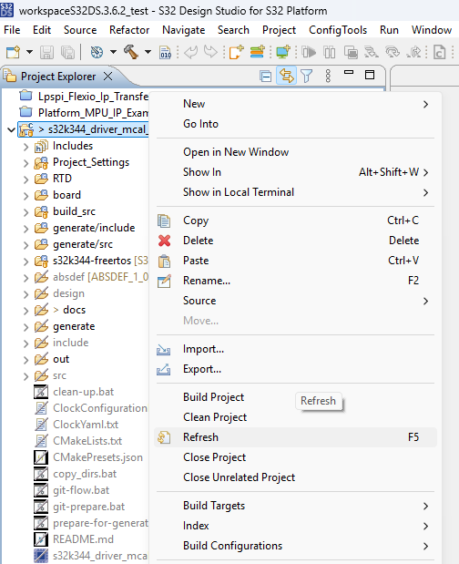
Notice the differences after a refresh:
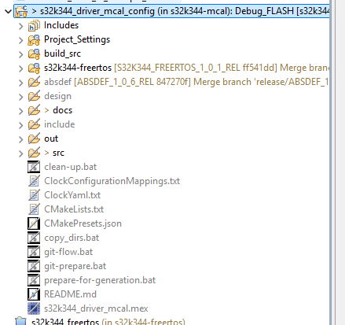
- Make the changes to the drivers in the NXP Config Tool.
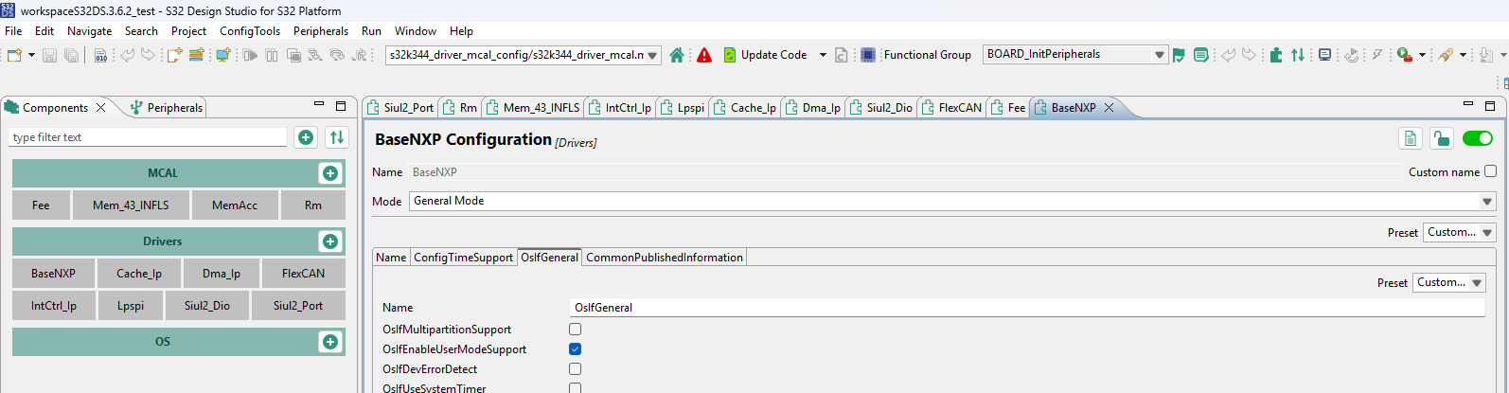
Select the driver to configure and the configurable items will appear on the right-hand side – such as in the image the “BaseNXP Configuration” driver shown above.
- Press the “Update Code” button, and all the needed RTD files (drivers) will be added to the S32DS project along with the generated configuration (driver config).
- Test build the S32DS project. If successful, go to next step. If the build fails, address the issues and find a way to make build succeed.
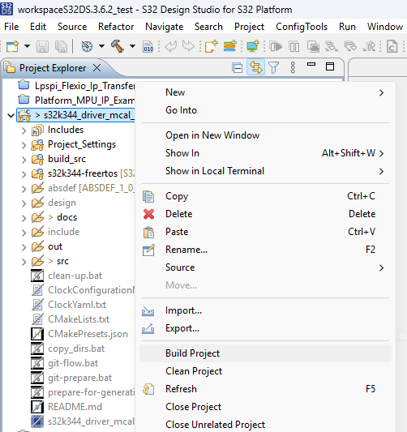
- Back in the root of the MCAL Component, run the batch script called “copy-dirs.bat”. This will copy the generated contents into the ‘src’ folder.
- Optionally, a developer may want to commit the changes if necessary to preserve the work done.
- The final step to verify the configuration is preliminarily acceptable is to build the component via CMake and link it to some generic “main.c” only to be able to do a complete build (i.e., compilation and linking) with the MCAL Component. Again, this must succeed at this point in time, or the chances of success that at the time this MCAL Component is to be integrated into a target application will be low.
- If building the component via CMake is successful, the process to build and test has been achieved successfully. The chances of integration of the MCAL Component succeeding in a target application environment are relatively high.

- Integration Procedure
Latest changes for the S32K344-MCAL Component are available in ‘main’ branch which are tagged with labels per the ABS Configuration Management document. Integration into a target application can be achieved byb following the following steps:

- Add the component as submodule to the application repository with command git submodule add -f https://<user>@bitbucket.org/americanbatterysolutions/<repo_name> from the directory where this component reside.
- Init and update the submodule by running git submodule update --recursive –init
- Specific version of the component can be chosen by running the cmd git checkout <tag/branch/commit> from the submodule directory.
- Make sure all the dependent submodules are present in the application (e.g. S32K344-FreeRTOS for the S32K344-MCAL).
- Ensure that in a target application’s “main” CMakeLists.txt file (this should be in root directory of CMake-managed project) adds the subdirectory of the S32K344-MCAL Component. Also, submodules of dependencies will have their sub-directories added likewise, but the image below illustrates how to add in specifically the S32K344-MCAL Component alongside other CMake objects.
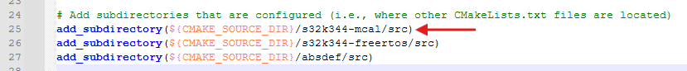
- If all is done correctly, successful building of the target application via CMake should be achieved and the MCAL APIs are linked into the build.

- Resource Consumption
Resource | Usage
RAM | TBD
ROM | TBD
CPU Bandwidth | TBD

- MISRA + BARR-C
N/A

- References
N/A

